The new Folder location is \\DMDVIEW\DRB via windows explorer. Hint: A mapped network drive is the most stable for those adding files. For others, a shortcut will work just fine. If you want to link via a web browser the path is http://dmdview/planning/DRB.
Files will be stored as multi-page PDFs (Minimum 300dpi) per Notice of Decision or Per Infrastructure List, more specific details are below.
Currently Annette, Vanessa, and Angela have permission to add infrastructure lists and Notices of Decisions to the DRB folder on the DMDVIEW server. Angela has administrator privileges to the DRB folders and its subfolders. This is for the ability to rename files if there are errors or append additional versions of the paperwork to the previous PDF.
Example file folder and file names are shown below:
- 1004073
  - InfrastructureLists
    - VolterraVillage_1004073
    - JuanTaboHillsUnit1_1004073
  - NoticeOfDecisions
    - Notice01_PP_VAC_DV_SdwlkDef_SdwlkVar_May2005
    - Notice02_VAC_Dec2005
    - Notice03_DV_Mar2007
    - Notice04_Vac_Jul2007
    - Notice05_ExtSIA_Dec2007
    - Notice06_ExtSdwlkDef_Oct2009
    - Notice07_ExtSIA_Feb2010
    - Notice08_ExtPP_Mar2010
    - Notice09_Vac_Apr2010
    - Notice10_ExtPP_Mar2011
    - Notice11_ExtSdwlkDef_Oct2011
    - Notice12_ExtPP_Mar2012

Abbreviations for Notice of Decisions:
PP = Preliminary Plat
ExtPP = Extension of Preliminary Plat
Vac = Vacation of easement, right of way, etc…
DV = Design Variance
SwlkDef = Sidewalk Deferral
SwlkVar = Sidewalk Variance
ExtSIA = Subdivision Improvement Agreement Extension
ExtSwlkDef = Extension of SIA for deferred sidewalk

Preferred File Naming Rules:
- No spaces
- No special characters (#, $, %, *, -, etc…)
- For dates use the three alpha characters for the month, I.e. use Jan, Mar, Apr, Feb, etc... For the year use the four digit year, I.e. 2014, 2013, etc… For the day use a two digit day, I.e. 03, 12, 08, etc…
- Use Camel Locks to emulate spaces, I.e. ThisFileIsBoring
- Use the underscore ( _ ) when trying to separate aspects of a file name, I.e. PigsFly_2010Mar2014

Revised infrastructure lists will be appended to the previous. Thus the most current should be at the top of the document.
Notice of decisions should be filed individually; I.e. the first Notice of Decision start with the project will start with the name as “Notice01”, “Notice02”, etc…
Note regarding Bookmarking PDFs; at first we can append existing infrastructure lists to previous without bookmarks, but at some point, we may find that bookmarking the versions may be more user friendly. I believe with the most recent on top it should work, and if folks would like to see the previous versions, they will just have to page down manually.

Steps for adding a new Project Folder in the DRB folder:
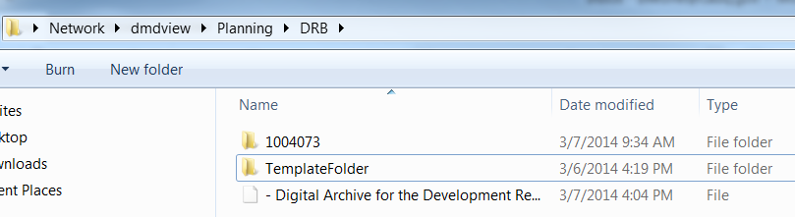
- You will need to map a network drive to the following location: \\DMDVIEW\DRB
- Use the template folder for creating the new project number folder. It has the appropriate subfolders within it.
- Rename the template folder copy to the project number of interest.
- Scan the Infrastructure List or the Notice of Decision into your scan drop folder. This is the workflow scanning service of the Xerox Work center. Scan drop folders are the following paths:
Annette: \\dmdgis\scan\annette_ortiz
Vanessa: \\dmdgis\scan\vanessa_segura
Angela: \\dmdgis\scan\angela_gomez
- Rename the file, as shown above in the examples, and cut and paste into the appropriate subfolder. Note the drop folder is to be used as a temporary staging area, not a permanent storage area. Thus keep your scan drop folder as clean as possible.

  - Work flow Scanning Steps:
- On the Xerox WorkCenter Go to the Services Home button.
- Select Workflow Scanning
- Select your name.
- Pick Layout Adjustment tab for landscape copies, I.e. adjust orientation.
- Go to the Filing Tab for naming the file something other than default, if desired. They can be renamed in the drop folder as well prior to moving to the project folder.

