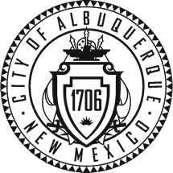

City of Albuquerque
P.O. Box 1293 Albuquerque, New Mexico 87103
Planning Department
Suzanne Lubar, Director
Richard J. Berry, Mayor Robert J. Perry, Chief Administrative Officer
November 3, 2016
__________________________________________________________________________________

SUBJECT: ALBUQUERQUE ARCHAEOLOGICAL ORDINANCE—Compliance Documentation
Project Number(s): 1000032
Case Number(s): 15 EPC-40079; 16DRB-70353
Agent: Joshua Skarsgard
Applicant: Red Shamrock 10, LLC
Legal Description: X-1-A2 as shown on the Amended Plat of Tracts X-1-A1 and X-1-A2, University of Albuquerque Urban Center
Zoning: SU-3
Acreage: 21.22 acres
Zone Atlas Page: G-11

PROVISIONAL CERTIFICATE OF NO EFFECT: Yes __X__ No _____

CERTIFICATE OF APPROVAL: Yes ____ No _____

TREATMENT PLAN REVIEW:
DISCOVERY:

SUPPORTING DOCUMENTATION:
SITE VISIT: n/a

RECOMMENDATION(S):
- PROVISIONAL CERTIFICATE OF NO EFFECT IS ISSUED to allow platting process to continue.
- Archaeological survey required prior to issuance of building permit.

MFSchmader
Matthew Schmader, PhD
Superintendent, Open Space Division
City Archaeologist

