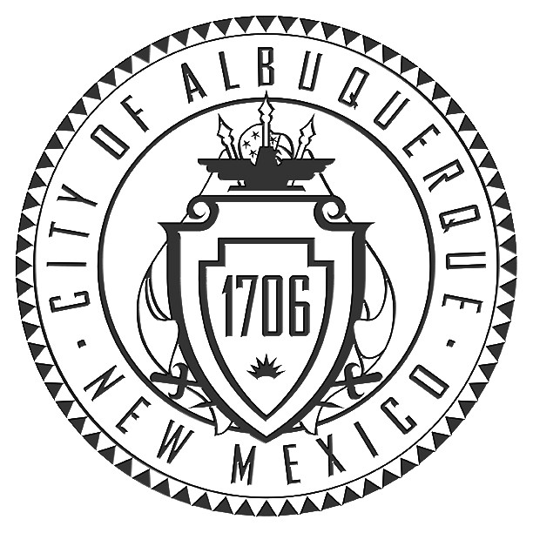
City of Albuquerque
PLEASE NOTE: The Neighborhood Association information listed in this letter is valid for one (1) month. If you haven’t filed your application within one (1) month of the date of this letter – you will need to get an updated letter from our office. It is your responsibility to provide current information – outdated information may result in a deferral of your case.
P.O. Box 1293, Albuquerque, NM 87103

December 14, 2016

Planning Department
Plaza Del Sol Building
600 Second St. NW
Second Floor (924-3860)

This letter will serve to notify you that on December 14, 2016:

Contact Name: CHRIS GUNNING

Company or Agency: DEKKER/PERICH/SABATINI
7601 JEFFERSON ST. NE/87109
PHONE: 505-761-9700 / FAX: 505-761-4222
E-MAIL: CHRISG@DPSDESIGN.ORG

contacted the Office of Neighborhood Coordination requesting the contact names ALL Neighborhood and/or Homeowners Associations who would be affected under the provisions of O-92 by your proposed project at (DRB SUBMITTAL) TRACT A LEGACY @ JOURNAL CENTER LOCATED ON 5151 LANG AVENUE NE BETWEEN HEADLINE POINT NE AND JOURNAL CENTER BOULEVARD NE zone map D-17-18.

Our records indicate that as of December 14, 2016, there were no Neighborhood and/or Homeowner Associations in this area.

If you have any questions about the information provided, please contact me at (505) 924-3914 or via an e-mail message at dlcarmona@cabq.gov or by fax at (505) 924-3847.

Sincerely,

Dalaina L. Carmona
Senior Administrative Assistant
OFFICE OF NEIGHBORHOOD COORDINATION
PLANNING DEPARTMENT

Planningnnona/hoaform(02/18/13)

!!!Notice to Applicants!!!

SUGGESTED INFORMATION FOR NEIGHBORHOOD NOTIFICATION LETTERS

Applicants for Zone Change, Site Plan, Sector Development Plan approval or an amendment to a Sector Development Plan by the EPC, DRB, etc. are required under Council Bill O-92 to notify all affected recognized neighborhood associations PRIOR TO FILING THE APPLICATION TO THE PLANNING DEPARTMENT. Because the purpose of the notification is to ensure communication as a means of identifying and resolving problems early, it is essential that the notification be fully informative.

WE RECOMMEND THAT THE NOTIFICATION LETTER INCLUDE THE FOLLOWING INFORMATION:

- The street address of the subject property.

- The legal description of the property, including lot or tract number (if any), block number (if any), and name of the subdivision.

- A physical description of the location, referenced to streets and existing land uses.

- A complete description of the actions requested of the EPC:

- If a ZONE CHANGE OR ANNEXATION, the name of the existing zone category and primary uses and the name of the proposed category and primary uses (i.e., “from the R-T Townhouse zone, to the C-2 Community Commercial zone”).
- If a SITE DEVELOPMENT OR MASTER DEVELOPMENT PLAN approval or amendment describe the physical nature of the proposal (i.e., “an amendment to the approved plan to allow a drive-through restaurant to be located just east of the main shopping center entrance off Montgomery Blvd.”).
- If a SECTOR DEVELOPMENT PLAN OR PLAN AMENDMENT a general description of the plan area, plan concept, the mix of zoning and land use categories proposed and description of major features such as location of significant shopping centers, employment centers, parks and other public facilities.
- The name, address and telephone number of the applicant and of the agent (if any). In particular the name of an individual contact person will be helpful so that neighborhood associations may contact someone with questions or comments.

Information from the Office of Neighborhood Coordination

The following information should always be in each application packet that you submit for an EPC or DRB application. Listed below is a “Checklist” of the items needed.

[X] ONC's "Official" Letter to the applicant (if there are associations). A copy must be submitted with application packet -OR-

[X] The ONC "Official" Letter (if there are no associations). A copy must be submitted with application packet.

[ ] Copies of Letters to Neighborhood Associations (if there are associations). A copy must be submitted with application packet.

[ ] Copies of the certified receipts to Neighborhood Associations (if there are associations). A copy must be submitted with application packet.

Just a reminder - Our ONC "Official" Letter is only valid for a one (1) month period and if you haven't submitted your application by this date, you will need to get an updated letter from our office.

Any questions, please feel free to contact Dalaina at 924-3906 or via an e-mail message at dlcarmona@cabq.gov.

Thank you for your cooperation on this matter.

* * * * * * * * * * * * * * * * * * * * * * * * * * * * * * * * * * * * * * * * * * * * * * * * * * * * * * * * * * * * * * * * * * * * * * * * * * * * * * *
(below this line for ONC use only)

Date of Inquiry: 12/14/16 Time Entered: 3:15 p.m. ONC Rep. Initials: DC

