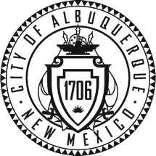

City of Albuquerque
P.O. Box 1293 Albuquerque, New Mexico 87103
Planning Department
Suzanne Lubar, Director
Richard J. Berry, Mayor Robert J. Perry, Chief Administrative Officer
April 4, 2016
__________________________________________________________________________________

SUBJECT: ALBUQUERQUE ARCHAEOLOGICAL ORDINANCE—Compliance Documentation
Project Number(s): #1010546
Case Number(s): 16EPC-40021
Agent: Angela Benson, Modulus Architects
Applicant: Tecolote Resources, Inc.
Legal Description: Portion of Tract A – Coogan and Walters – Southwestern Land
Zoning: C2 (SC)
Acreage: 11 acres
Zone Atlas Page: K-12

CERTIFICATE OF NO EFFECT: Yes __X__ No _____

CERTIFICATE OF APPROVAL: Yes ____ No _____

TREATMENT PLAN REVIEW:
DISCOVERY:

SUPPORTING DOCUMENTATION:
SITE VISIT: n/a

RECOMMENDATION(S):
- CERTIFICATE OF NO EFFECT IS ISSUED (ref O-07-72 Section 4B(2)—extensive previous land disturbance) .

MFSchmader
Matthew Schmader, PhD
Superintendent, Open Space Division
City Archaeologist

