3801 Ellison Dr. NW

# Administrative Amendment Request

## Project #PR- 2019-002507

Transportation Development Comments:

Contact: Jennifer Restrepo, 505-924-3314, [jrestrepo@cabq.gov](mailto:jrestrepo@cabq.gov)

1. Please list the width and length for all existing and proposed parking spaces. Some dimensions are not shown.
2. Please provide width dimensions along one-way drive
3. Please clarify the proposed changes at the NE corner (see below)

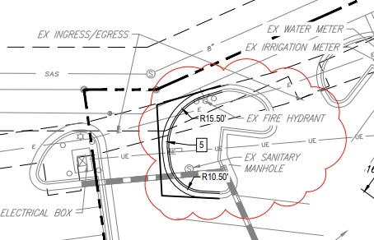

1. The ADA accessible parking sign must have the required language per 66-7-352.4C NMSA 1978 **"Violators Are Subject to a Fine and/or Towing."** Please call out detail and location of signs.
2. The ADA access aisles shall have the words **"NO PARKING"** in capital letters, each of which shall be at least one foot high and at least two inches wide, placed at the rear of the parking space so as to be close to where an adjacent vehicle's rear tire would be placed. (66-1-4.1.B NMSA 1978)
3. All one-way drives shall have “One Way” and “Do Not Enter” signage and pavement markings. Please show detail and location of posted signs and striping.
4. The minimum drive through lane width is 12 feet with a 25 foot minimum radius (inside edge) for all turns.  (A 15 foot radius can be used with an increase in lane width to 14 feet). Please dimension all lane widths and radii. You must meet the 12’ min lane width based on Section 7—4(K)(20) of the DPM.