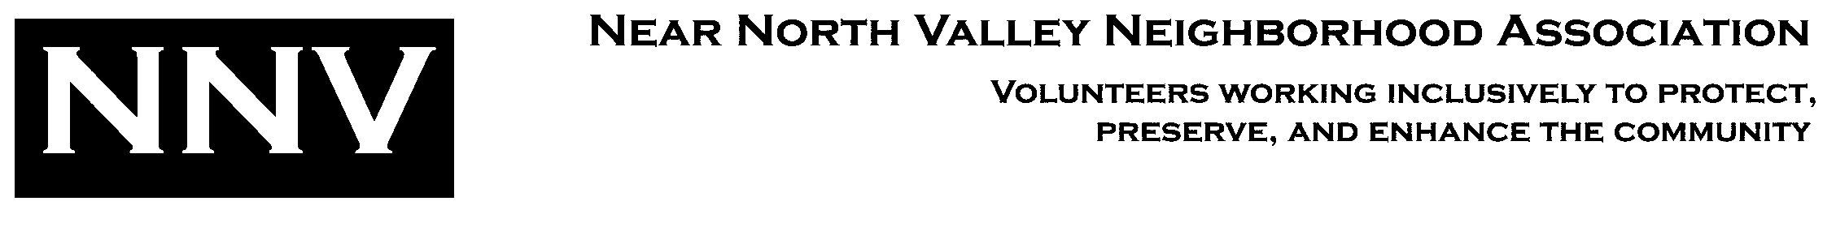

**NNVNA**

**PO Box 6953**

**Albuquerque, NM**

**87197**

Heather Norfleet Vice **President,**

**505-620-4368**

**Joe Sabatini**

**Secretary,**

**505-344-9212**

**NearNorthValleyNA @gmail.com**

**www.nnvna.org**

Copy:

Danny Solares,

Studio Southwest

Mike Canfield, Indian Pueblos Marketing, Inc.

January 10, 2023

Jolene Wolfley

Chair, Development Review Board

600 2nd Street NW

Albuquerque, New Mexico 87102

Sent via email to jwolfley@cabq.gov

Re: Site plan for Phase 3 of Avanyu Plaza at the NW corner 12th Street and Menaul Blvd. NW

Dear Ms. Wolfley,

On December 14th, the Board of the Near North Valley Neighborhood Association heard a presentation by representatives of Indian Pueblos Marketing Inc., Studio Southwest Architects and La Montanita Co-op on their site plan for the third phase of Avanyu Plaza on the former Albuquerque Indian School campus. We noted that 34 individuals attended our Zoom meeting. The presenters showed us site diagrams and elevations and responded to questions from Board members and attendees. The Board did not take any formal action on the request, but comments were favorable about many aspects of the new project.

The presenters requested that we verify that they had met the requirement for meeting with the relevant neighborhood association prior to their submission of their building plan.

Thank you for your consideration.

Respectfully submitted,

Heather Norfleet

Vice President