Mr. Robert Webb
Senior Planner - Development Review Services
City of Albuquerque
(505) 924-3910
rwebb@cabq.gov

November 14, 2023

Mr. Webb,

Per your email on Monday, November 13, 2023, you requested further justification from Gina Kelly’s letter dated September 18, 2023, per 6-4-Z. Please consider this supplemental letter for justification on the changes we have requested.

We were presented with a portion of an Official Notice of Decision dated April 21, 2005 noting that the EPC delegates final sign-off authority of this site to the Development Review Board (DRB). The gentleman providing this notice to the store manager was adamant that we would not be installing the gray and blue scheme previously approved and would maintain the existing colors and elevations as directed in the notice (Page 9, Section 12). Document has been attached.

In an effort to maintain community harmony and compliance with the DRB notice of decision documentation, whether legally binding or not, Walmart opted to forego the original approved elevations and alter the elevation to utilize the existing colors approved for the building with a color pattern which more closely resembled their current store branding. The color legend from the original construction documents was used.

This serves as our justification for the alterations being requested for the current remodel alterations to the exterior elevations of the building, located at: 2266 Wyoming Blvd NE.

Please let us know if this does not specifically provide the justification requested for the alterations requested, as revised from the previously approved Administrative Amendment.

Thank you,
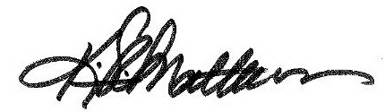
Kevin Matthews
Sr. Project Manager

