2901 Transport Street

# Administrative Amendment Request

## Project # 2023-008546

Transportation Development Comments:

Contact: Jennifer Restrepo, 505-924-3314, [jrestrepo@cabq.gov](mailto:jrestrepo@cabq.gov)

1. Please provide the design details for the proposed emergency gate (see below). A drive pad or curb return design are appropriate here. In the case of a curb return design, make sure to include all radius’. The gate itself will need a 20ft. minimum setback. Include 11ft clear sight triangles at site entrances.

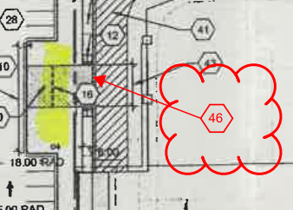

1. Clarify the location of the proposed fencing and it’s pedestrian and vehicular entrances. If fencing goes around existing site entrance please show a minimum 11ft clear sight triangle