1. Both theh AA's that have been submitted did not reduce the parking below the allowable under the prior Site plan requirements.

      The first AA in June altered the depth of some parking stalls, but did not alter the total parkign count.

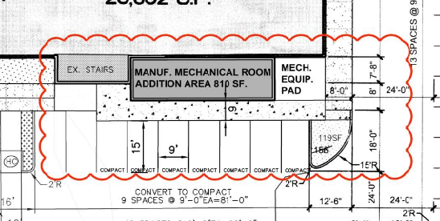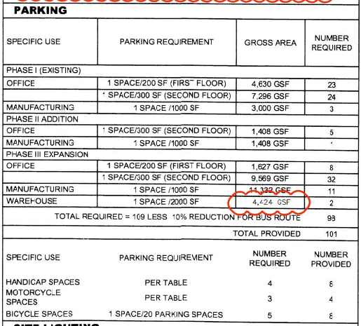

2. If we followed the IDO we could further reduce the parking down to 99 (if we consider the improved Bus Routes and reductions avaialbel under the IDO) and therefore we could also remove an accessible parking stall.  We did not see any reason to alter that much of the site.

This AA is changing a parking island from Landscaping into a pad for the vertical Nitrogen Tank.  We are not reducing the parking in either application.

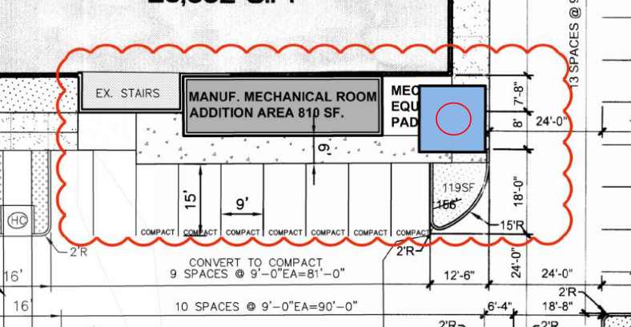

As far as the Landscaping requirements.

The Site Plan was calling for 4,011 sf of Landscaping Required under the prior Zoning requirements.  We are providing (after both Amendments) a total of 8,435 sf.

I looked through the IDO and have computed the following:

We are not in a DT-UC-MS-PT and therefore are required the 15% of Net lot are to be landscaped.

Total Lot Area 87,904 sf (2.018 Acres)

Total Building Area = 34,835sf (foot print area, not include second story)

Net Lot Area = 51,658 sf.

15% requirement = 7,749sf.

Current Provide is still 16,839 sf.

We meet the currrent IDO requirement for Landscaping.

**Screening**

We are currently not including any screening.  We feel that due to teh height of this tank, that adding screenign will draw even more attention.The is all under the Section of Ground Mounted Mechanical Equipment.

I looked in the Definitionsfor Mechnical Equipment (within the IDO).  I could not find a specific definition, so I went to Websters.  And do not feel the tank falls directly into the Mechanical Equipment definition.  We feel this definition is directed to HVAC or Chiller Units that are ground-mounted.  The Nitrogen Tank falls into the processing category.

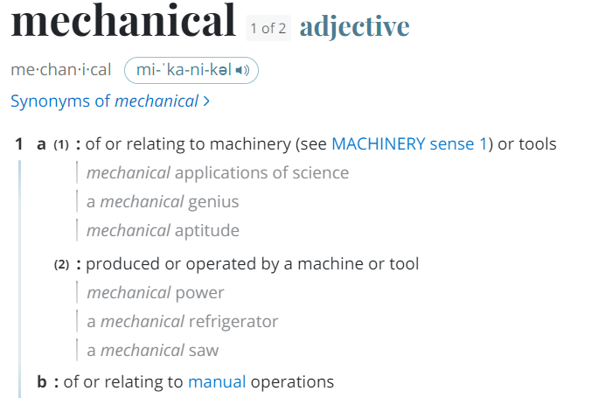  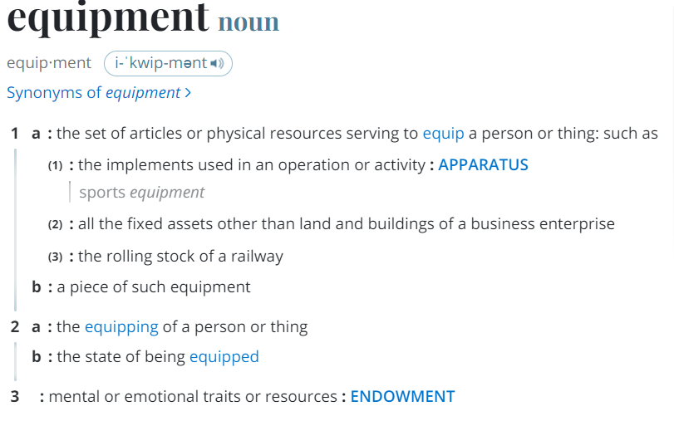

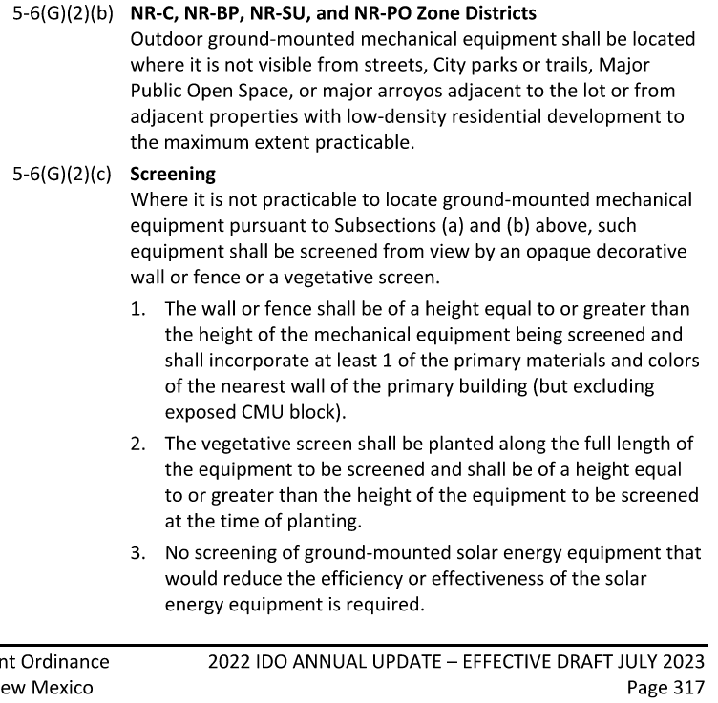

Sorry for the long winded email.  Please call me and we can talk through any specifics.

Cell 505-463-4503

Thanks