1400 Montano Rd NE

# Administrative Amendment Request

## Project # 2023-008561

Transportation Development Comments:

Contact: Jennifer Restrepo, 505-924-3314, [jrestrepo@cabq.gov](mailto:jrestrepo@cabq.gov)

1. Please provide the additional detail sheets (C5, C5.1)
2. Various “Keyed Notes” are not properly labeled (6,8,9,11,12,14,15,16,17)
3. Provide the following widths (see image below)

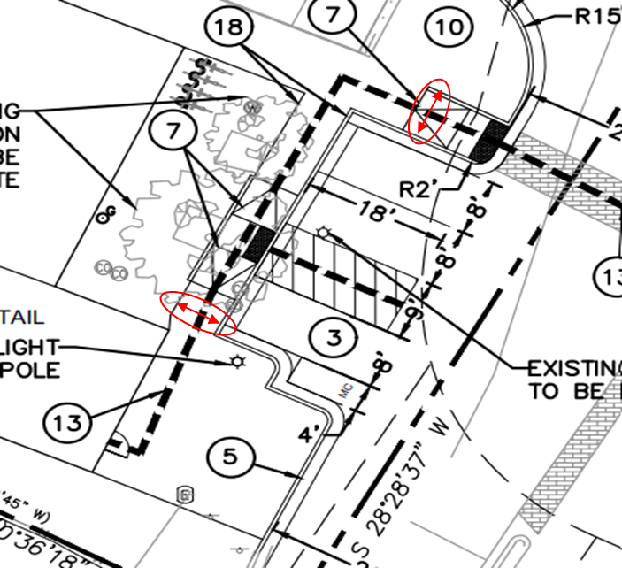

1. The ADA accessible parking sign must have the required language per 66-7-352.4C NMSA 1978 **"Violators Are Subject to a Fine and/or Towing."** Please call out detail and location of signs.
2. The ADA access aisles shall have the words **"NO PARKING"** in capital letters, each of which shall be at least one foot high and at least two inches wide, placed at the rear of the parking space so as to be close to where an adjacent vehicle's rear tire would be placed. (66-1-4.1.B NMSA 1978)
3. Provide sign face details for both ADA and motorcycle parking.