

**City of Albuquerque**

**Development Review Application**

**Permit GP-2024-13382**

**Justification Letter:**

**The** purpose of requesting the addition of a fence around the dock area of the facility at the rear of our suite serves to help us control theft. It is meant to deter vandalism to vehicles and theft of commercial property. With respect to Section 14-16-6-4(Z)(1)(a). A minor amendment described in number 2 and referred to by Table 6-4-4. includes the addition of a fence. The standard revision is for a fence and the purpose of the permit which we have applied for and is number GP-2024-13382. There is no parking affected and the location is in a non-pedestrian area. The existing trash receptacle will be replaced by a rolling receptacle and a new service contract will be signed to move it out of the fenced area. This has been approved by Herman Gallegos.

**All other items on the permit seem to have been met with the exception of the AA.**

Thank you,

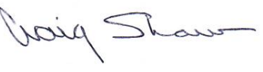

Craig Shaw

WELSCO, dba: Bulldog Energy Solutions