October 30, 2024

Kyle Watson, P.E.

Kimley-Horn

6200 South Syracuse Way, Suite 300

Greenwood Village, CO 80111

Mr. Watson:

After a thorough review of your minor amendment application for the Eastdale Shopping Center, located at 9450 Candelaria Road NE, we have the following comments that must be addressed prior to approval. If any portion of the proposed amendment can stand on its own, we may proceed with approving just those portions and may delay other site plan changes to the future, if desired.

**PARKING & LOADING**

1. Your plan indicates a parking requirement of 246 spaces under the IDO.
   1. Please confirm this is based on the correct square footage of the whole shopping center. The 2015 plan shows a different square footage than this new plan does for the building area.
   2. Note: restaurants or other uses within the building should technically be calculated separately, but we understand this may change over time with different tenants. Updating calculations for the IDO may not be necessary at this time since much more parking is provided than required by the IDO, as well as per the original plans.
   3. Parking calculations should include the two restaurant pads, as well as the former bank that is now a dental clinic. These are all part of the original site plan approval.
   4. The former gas station that was torn down and is now vacant can be excluded as that parking is no longer required and none is provided on that lot at this time (the proposed Burger King has submitted an amendment of their own that is in review).
   5. The original plan allowed for a 10% parking reduction due to transit, which may continue being used.
2. Your letter states there are 629 existing parking spaces, but this appears to have been the parking *required* on the 2015 version of the plan. That plan indicated 791 existing total parking spaces, inclusive of standard, compact, and ADA spaces.
3. Your plan states there are 861 existing parking spaces existing and 920 proposed. Is this inclusive of all types of spaces? Does this include the spaces for the two restaurants and dental clinic such that the entire property and site plan is part of the calculations?
4. Are shopping cart corrals excluded from the parking space calculations pursuant to IDO §14-16-5-5(F)(1)(a)3?
5. The original site and plan began with 858 parking spaces and appears to have proposed to drop to 566 spaces provided once build-out was complete.
6. Minor amendments are generally limited to a 10% change to “Any other numerical standard” [IDO Table 6-4-4]. 920 parking spaces is within this range from the original 858 existing spaces from the 1986 plan. It is a 14% increase in parking from the number listed on the 2015 plan, and significantly more from what was the originally proposed final condition on the 1986 plan.
7. Because there is not a maximum parking requirement for this site, we may allow this increase in parking, but please note that new parking areas may need to meet other newer standards. The paved service area at the southwest part of the site has generally been excluded (as parking) from prior site plan approvals. Formalizing this area as parking may require other site improvements. See landscaping comments below for more.
8. Based on total provided parking across the site, more than 16 ADA spaces are required. Please include the total for the site in your calculations, which show that this is met when including all of the property.
9. Listed bicycle parking requirements are based on the calculation for a grocery store. Only part of the site contains a grocery store use. There may be more than 35 spaces already on the property according to prior approvals, but significantly increasing the total number of car parking spaces may also require additional bicycle parking to be provided.

**LANDSCAPING & BUFFERING**

1. Pursuant to IDO §14-16-5-6(B)(1)(b), expansion of an existing parking lot by 20 spaces or more triggers compliance with IDO landscaping requirements. The proposed parking spaces appear to exceed this threshold.
2. A minimum of 15 percent of the net lot area of each development shall contain landscaping. Please provide this calculation on the landscape plan. The two restaurant pad sites meet this newer requirement, but for the site as a whole it is unclear as the original 1986 plan provided between 16-20% of the paved parking area as landscape, and not all of that landscape was installed.
3. Tree canopies and ground-level plants shall cover a minimum of 75 percent of the total landscape area as measured by canopy width or the area beneath the dripline of the mature size of the actual vegetation. 25% of this coverage must be ground-level plants. Please provide these calculations.
4. Pursuant to §14-16-5-6(C)(4)(k), Shade trees planted approximately 25 feet on-center are required along all required pedestrian walkways. Additional shade trees along pedestrian walkways may also count toward required parking lot trees.
5. See §14-16-5-6(C)(12) for Existing Vegetation Credit allowances that may help cover certain requirements.
6. Trees are generally required along street frontages every 25 feet on center unless specified otherwise in Part 6-6-2 of ROA 1994 (Street Trees). Along street frontages where street trees are required, trees that are planted within 20 feet of the back of curb of the abutting street may fulfill this requirement.
   1. Street frontage lengths on the submitted plan do not appear to account for the entire frontage, but rather only those portions where new trees are being proposed. Please include the entire frontage and calculate provided trees with both new and existing trees that are preserved.
   2. The Candelaria frontage may have sufficient coverage. The Eubank side may need additional trees. It is understood that the Burger King project is adding their own street trees for that portion of the property.
7. Additional buffer landscaping may be required along the western property line pursuant to §14-16-5-6(E)(3) Development Next to a Multi-family Residential Zone District, where feasible.
8. What is the distance from the front property line (Candelaria) to the nearest parking? Screening may be required for any parking located closer than 30 feet from the front lot line. There is an existing screen wall along the Eubank side.
9. At least 15 percent of the parking lot area of lots containing 50 or more spaces, shall be landscaped. This was met by the 1986 proposal with up to 58,659 square feet of landscaping proposed at the time, although not installed. Please provide updated calculations.
10. 1 tree is required per 10 parking spaces. No parking space may be more than 100 feet from a tree trunk. The proposed removal of islands and trees from the center of the parking lot creates a deficiency with this code requirement. Other areas that are already deficient may need to come into compliance. See graphic below showing potentially deficient areas based on approximate tree locations in the proposed plan.

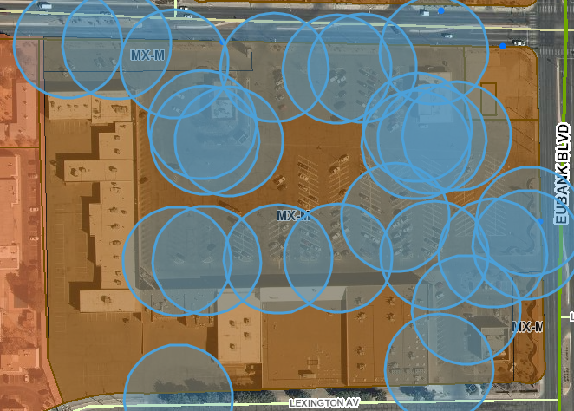

1. In parking areas of 100 spaces or more, the ends of parking aisles shall be defined as landscaped islands no narrower than 8 feet in any dimension. Where you are adding new islands, they meet this standard; however, there are multiple parking aisles without end islands in the main parking lot, and the parking lot at the southwest corner of the property does not have any islands in it.
2. Additional screening for ground-mounted mechanical equipment or service and refuse areas may be required consistent with IDO §14-16-5-6(G) where those facilities are visible from public streets or adjacent lots.

**OUTDOOR & SITE LIGHTING**

1. The City recently adopted new lighting regulations that went into effect on August 3, 2024. Our records indicate that your application was accepted on August 5th, thus it is subject to the new requirements and must comply due to an increase in the number of parking spaces, installation of new luminaires, and/or electrical work on existing luminaires. Please confirm if this is incorrect, as it appears your letter and lighting plan may reference previous regulations.
2. If submitted under the prior regulations, any lighting that does not comply with the new requirements may only exist as legally nonconforming until January 1, 2034. It may be in your interests to install or upgrade any lighting in compliance with the new regulations at this time regardless of applicability.
3. See revised IDO Section 5-8 for full requirements. This property is zoned MX-M, but is adjacent to low-density residential to the northwest, therefore the lighting designation is Lz1.
4. No luminaire specification shall exceed a Backlight, Uplight, and Glare (BUG) rating of G2.
5. Unless specified otherwise in this IDO, luminaires shall be fully shielded or have a U0 rating.
6. Please provide color temperature and color rendering specifications for the luminaires. Outdoor lighting shall have a maximum CCT of 3000K. The minimum CRI shall be 65.
7. Pole heights are now limited to 25 feet. See below for other types of pole mounting heights.

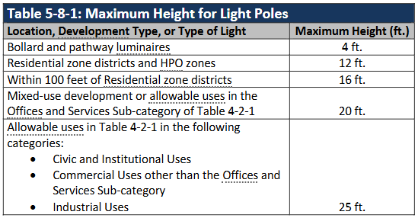

1. Light trespass is limited pursuant to the following table, by lighting designation.

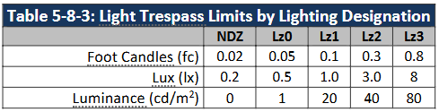

1. Please provide calculations or additional information to support the lighting proposed pursuant to the IDO total lumen allowance for non-residential uses:

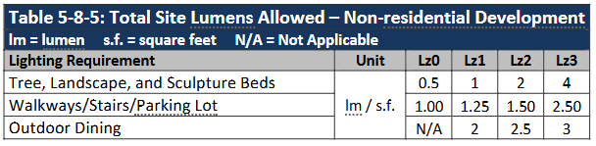

**BUILDING DESIGN**

1. The original site plan approval does not appear to have any specific building design requirements, and no new construction, expansion, or addition is occurring, so compliance with IDO building design standards is not required.
2. Regardless, the proposed façade modifications may meet current requirements, and generally result in an improved quality of design with new materials and colors added from existing.
3. New signage requires separate permit.

Please do not hesitate to reach out if you would like to discuss any of these comments. You may reach me at (505) 924-3825 or by email at [mvos@cabq.gov](mailto:mvos@cabq.gov).

Respectfully,

Michael J. Vos, AICP

Principal Planner and Zoning Enforcement Officer

Albuquerque Planning Department