*HEARING DATE/AGENDA ITEM NO. 9*

*Project Number: PR-2018-001346*

*Application Number: SI-2022-00184*

*Project Name: Whataburger at San Pedro Drive NE and Alameda Boulevard NE*

Request: Major Site Plan Amendment-DRB

**COMMENTS:**

* This application is noted on the current DRB agenda as a Site Plan application, but is actually a Major Site Plan Amendment – DRB application as it’s amending the Site Plan – DRB for PR-2018-001346/SI-2018-00110 approved by the DRB on February 6, 2019. The application must meet the requirements of the governing Site Plan – DRB for PR-2018-001346/SI-2018-00110 as well as the IDO where the governing Site Plan is silent. Notice requirements are the same for the two actions and notice has been met.

Response:

Noted. See revised plan set.

**Update 4/5/2022:**

**DRB signature blocks for each individual DRB member needs to be provided on the Site Plan. A DRB signature block template can be obtained on our website at:**

[**https://documents.cabq.gov/planning/development-review-board/development-review-board-site-development-plan-signature-block.pdf**](https://documents.cabq.gov/planning/development-review-board/development-review-board-site-development-plan-signature-block.pdf)

* Signature blocks for DRB and Solid Waste signatures must be added to the Major Site Plan Amendment – DRB prior to approval.

Response:

Signature blocks added to sheet C2.00

* The Solid Waste signature must be obtained prior to approval.

Response:

Noted.

* The project and application numbers need to be added to the Major Site Plan Amendment – DRB prior to final sign-off from Planning and distribution of the Major Site Plan Amendment – DRB to the DRB members for their e-signatures.

Response:

Project # added to the TTB:

DRB PROJECT NUMBER:  
PR-2018-001346  
SI-2022-00184 - SITE PLAN

* ~~All the sheets in the Major Site Plan Amendment – DRB must be sealed and signed by a design professional licensed in the State of New Mexico.~~

(see comments on next sheet)

* A restaurant is a permitted use in the NR-BP zone. No special use specific standards apply at this site location for the proposed use.

Response:

Noted.

* The Landscape Plan must confirm through depicted calculations that the General Landscaping Standards of 5-6(C) of the IDO are met, the Street Frontage Landscaping requirements of 5-6(D) of the IDO are met, the Edge Buffer Landscaping requirements of 5-6(E) of the IDO are met, and the Parking Lot Landscaping requirements of 5-6(F) of the IDO are met.

Response:

Calculation table revised to refer to ordinance section and street frontage / edge buffer calculations added. Site is an existing commercial development fronting 2 roadways and buffered by commercial drive aisles on the other 2 sides. Alameda Blvd side (N) is beyond 20 ft curb zone and existing vegetation will remain in place for buffer. San Pedro side (W) provides trees where not in conflict with existing utilities. Edge buffer met on East side of development and existing vegetaion buffers South side. Parking lot calcs exceed 10% requirement.

* Per 5-6(C)(4) of the IDO all trees and shrubs depicted on the Landscape Plan must be selected from the Official Albuquerque Plant Palette.

Response:

All plants are proposed from the ABCWUA.org xeriscape plant list

* The Climatic and Geographic Analysis is thorough and informative. Could there be any consideration to reorient the building to have the dining room windows facing the east instead of the west for a preferred solar orientation and better building performance? The orientation of the dining room to the east would provide a preferable occupant experience in terms of lighting and capturing views of the Sandia mountains.

Response:

Moving orientation of the dining room to the east would drastically affect the overall layout. The current building orientation reduces the conflict between the Drive-thru lanes and the existing/proposed parking areas which is preferable to reduce traffic conflict and a more efficient circulation layout.

(see comments on next sheet)

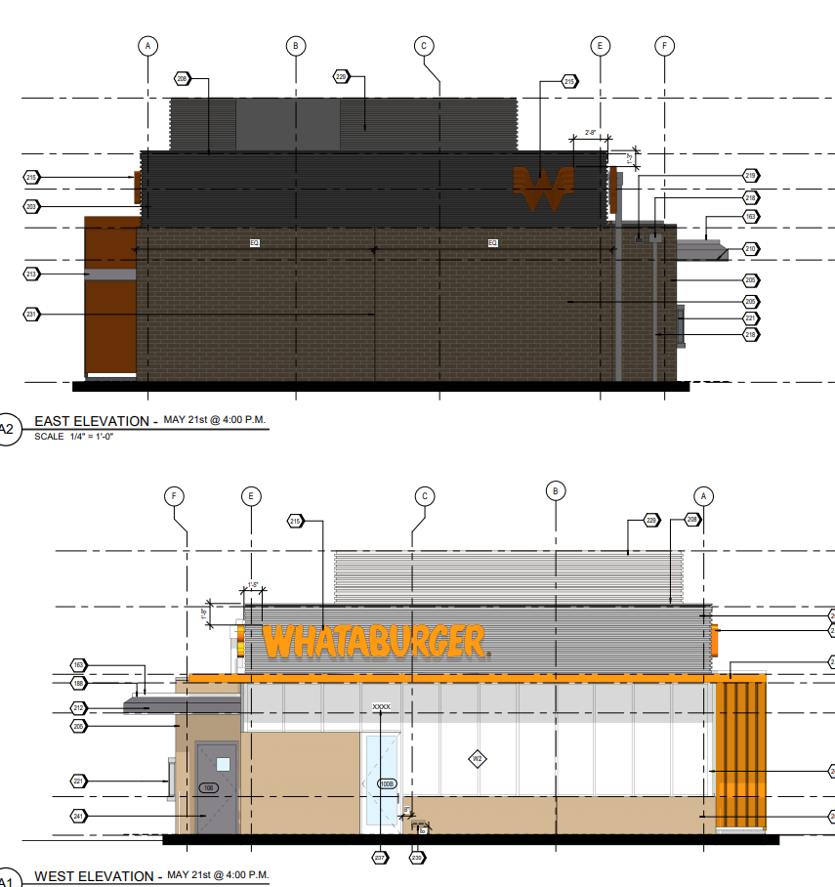

* Did not find in the submittal a comment letter explaining how the Façade Design requirements in IDO 5-11(E)(2) are being met.
* Use Specific Standards for Drive-Thru do apply, per IDO section 4-3-F-4-a.

(see comments on next sheet)

* Please indicate if signage is meeting previously approved Site Plan and/or current IDO standards.

*These are preliminary Planning comments, and there could be additional and/or revised Planning comments for this project.*

*Disclaimer: The comments provided are based upon the information received from the applicant/agent. If new or revised information is submitted, additional comments may be provided by Planning.*

FROM: Jay Rodenbeck/Jolene Wolfley/Robert Webb DATE: 4-5-22

Planning Department