Community comments regarding TIS at San Pedro and Alameda submitted 4/6/22

1. Lacking mention or integration of plans for San Pedro improvements, due to the community June/July 2020.
2. Lacking expressed mitigation option of Right-in right-out channelization, “porkchop”, as suggested by DRB rep at last meeting (min of 40” to provide additional safe space for improved walkability and proper curbing to allow wheelchair traffic).
3. Lacking any mention of (improved) walkability calculations.
4. [Signage needs are not noted re no left turn at the median]
5. Please confirm that allowing a drive thru at this location, with increased traffic of 55% at peak hours pm will effectively limiting/denying the expansion public transportation along Alameda’s route 98 – one of the few east/west transit options.
6. On page 4 it indicates that somehow WBA has the ability to change/influence the signaling at the intersection? Please describe this scenario as it would apply today if needed?
7. The walkway on east is particularly dangerous as it exits into a busy entry way.
8. Distance from driveway C to intersection noted as 230”? Getting into left lane is only 128’, does not appear enough room to maneuver safely to get from the exit to the left lane using a standard of 100ft to change lanes.

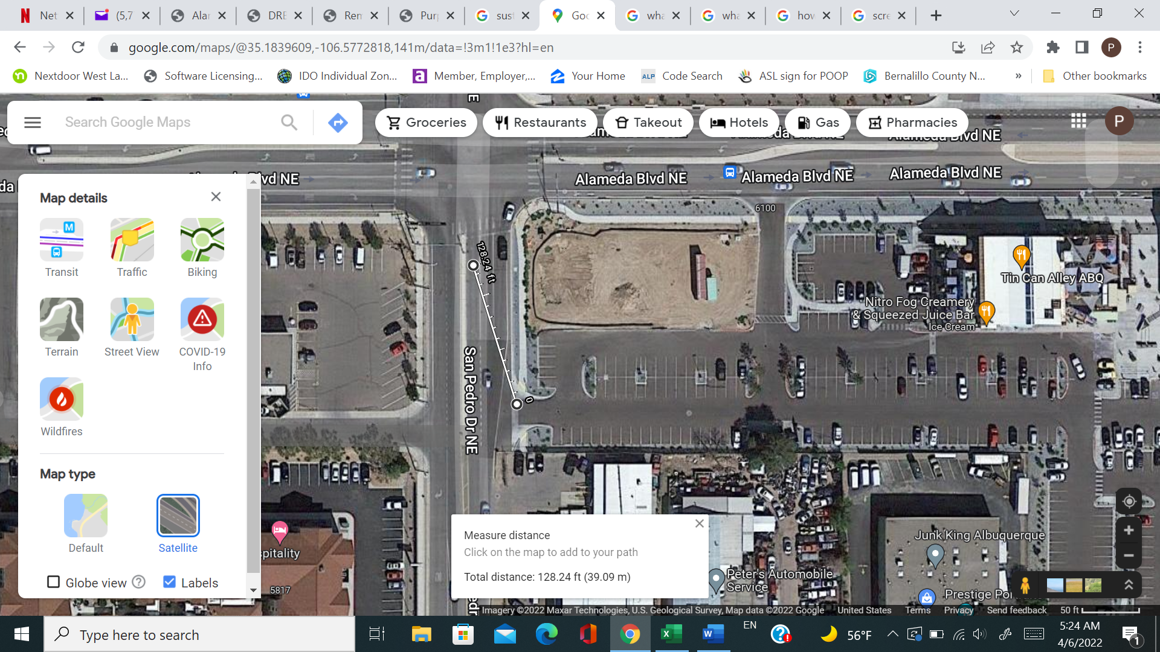

1. [Speed at exit ramp of N-I25 and speeds at Alameda going east need to be reduced to 35?]
2. Please explain how the community is protected in the event that this drive thru closes and is bought out by a chick-filet or a golden pride which are now allowed to operate at higher rates than those used in these calculations?
3. This is not an appropriate site for a drive thru. Please explain who absorbs the risks involved to locate this here in the event of a traffic accident caused by patrons exiting or entering the establishment?
4. Please explain the appeal process for a DRB decision.
5. Please explain the current situation regarding the possible abuse of due process at DRB hearings. (We understand that the authority of the DRB to grant approvals for a site plan without providing a hearing guided by disinterested parties (i.e. the EPC) may constitute an abuse of due process).