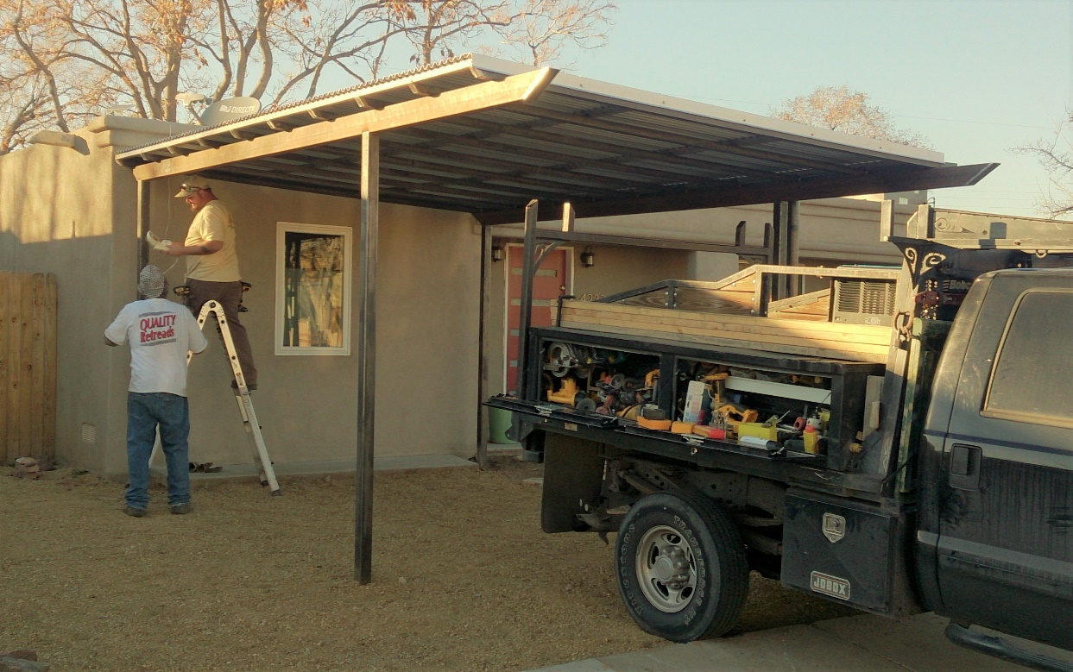

A carport O’Connor Brothers Design Build constructed that is similar to the proposed structure.

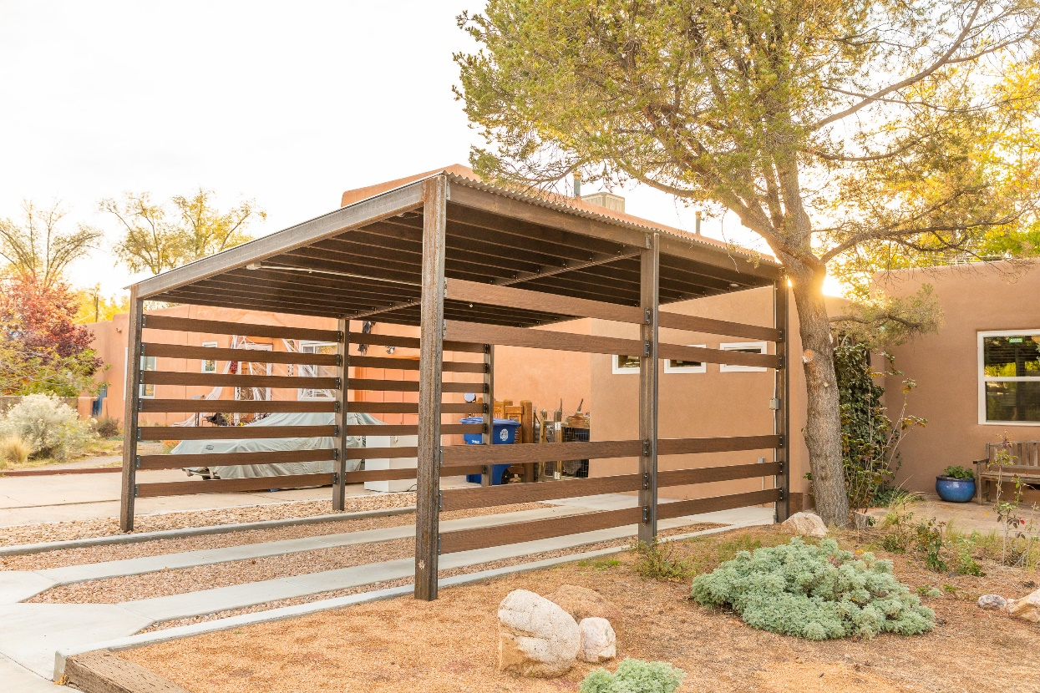

A carport O’Connor Brothers Design Build constructed in the same neighborhood as the proposed structure.