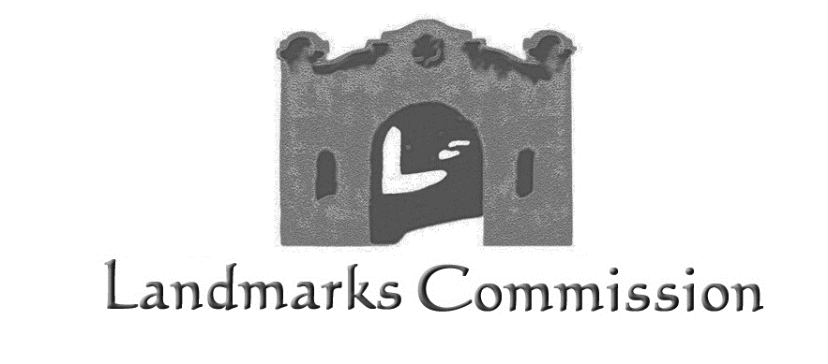


City of Albuquerque Date: September 27, 2021
Planning Department
Landmarks Commission CERTIFICATE OF APPROPRIATENESS
P.O. Box 1293
Albuquerque, New Mexico 87103 Project # PR-2019-002253/LC # SI-2021-01471
JAG Planning and Zoning, agents Old Town Plaza LLC, request approval for alterations at 302-304 San Felipe Street NW, described as Tract B, Block 000, Lands of Casa de Armijo la Placita Markets and Plaza, in the Old Town Historic Preservation Overlay, zoned MX-T. (J-13)

On September 10, 2021 the Landmarks Commission STAFF APPROVED Project # PR-2019-002679/SI-2021-01391, based on the following findings:

FINDINGS for APPROVAL:

- This application is a request for a Certificate of Appropriateness for alterations at 302-304 San Felipe Street NW, described as Tract B, Block 000, Lands of Casa de Armijo la Placita Markets and Plaza, in the Old Town Historic Preservation Overlay, zoned MX-T.

- The property contains several buildings with the primary building facing San Felipe.

3. The alterations proposed include the widening of the sidewalk at the northern end of the building along San Felipe and the relocation of the railing at the same location.

- The relocation of the railing will be between the columns rather than in front of them as is currently the case.

- The change in the sidewalk and railing will create ADA compliant sidewalk clearances in a heavily traveled area of Old Town.

- Section 14-12-8(A) of the Landmarks and Urban Conservation Ordinance states that within the boundaries of a historic zone, the exterior appearance of any structure shall not be altered, new structures shall not be constructed, and existing structures shall not be demolished until a Certificate of Appropriateness has been duly approved.

- This request complies with relevant criteria in the LUCC Ordinance for approval of Certificate of Appropriateness. The change is consistent with the designation ordinance and development guidelines; the architectural character and the historic value of the structure, site and the historic zone will not be significantly impaired or diminished, and the structure or site’s distinguished original qualities or character will not be significantly altered.

CONDITIONS:

1. Applicant is responsible for acquiring any and all additional City of Albuquerque department review and/or permits required for implementation of this project.

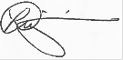
__________________

Historic Preservation Planner, Landmarks Commission

