Dear Development Review Board Members:

My name is Meifen Zhao, and I live on Hampton Street. My house is backing into Signal Street. Normally, every morning I take westbound Signal, then southbound Barstow, then westbound Paseo Del Norte to get on I-25 (shown as the blue route in the map below). This morning, 8/12/2019, nearby Desert Ridge middle school starts (shown as green rectangle on the map), and southbound Barstow was backed up to Alameda for the middle school. I had to take northbound Barstow, then westbound Alameda to get on I-25 instead (the red route). I took a picture of the Barstow and Alameda intersection at 7:58 AM when I was on northbound Barstow (see attached).

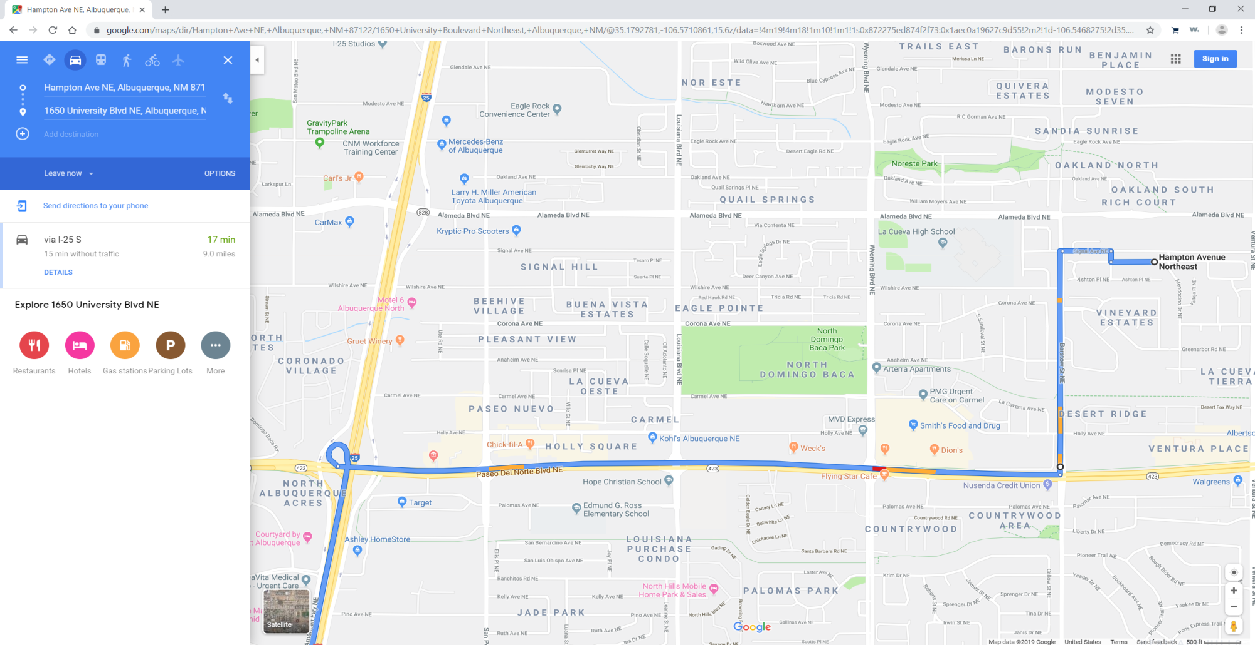

Barstow

Signal

Paseo Del Norte

Alameda

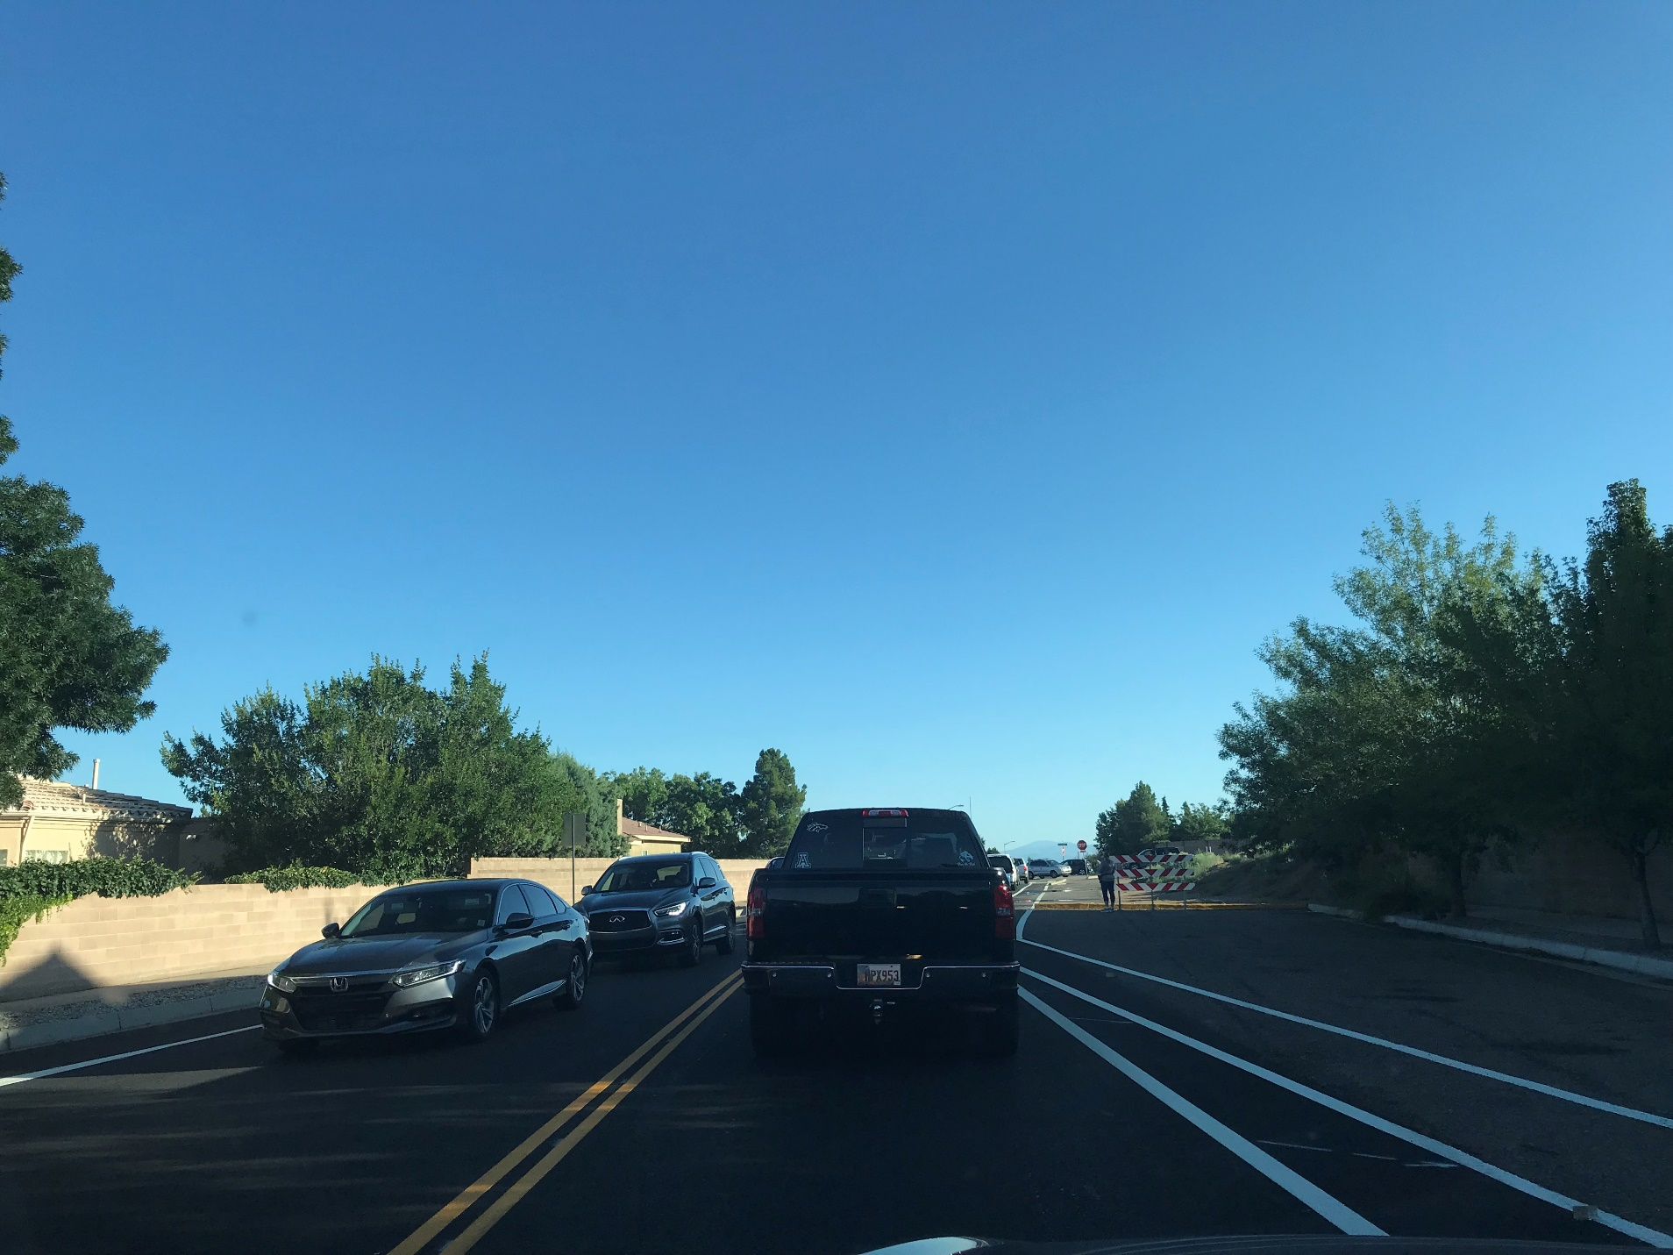

Barstow northbound toward intersection with Alameda 7:58 a.m. Monday, 8/12/19; proposed apartment entrance/exit is just past barricade on right. Please require a traffic study of this area before and after school before approving this project.

Thank you. Meifen Zhao