August 13, 2019

Ms. Kym Dicome, Chairwoman

Development Review Board

Planning Department

City of Albuquerque, Albuquerque New Mexico, 87102

Reference: DRB Project #2019-002496

Site Plan – Alameda Apartments

Dear Ms. Dicome:

I am writing to you out of concern for the apartment project proposed at the southeast corner of Alameda and Barstow. Looking at basic traffic information, the addition of a minimum of 100 plus cars through the area daily during rush hour traffic in the mornings and evenings will make this an even more dangerous situation. The arguments in support of a traffic study are discussed below.

There are now three schools within 0.1 miles of the proposed project, including a new private school, Altura Preparatory School (Altura), which is a kindergarten through 3rd grade elementary school. This school wasn’t considered in the last DRB meeting as it was not known about until after 17 July 2019. As the school is still enrolling, the impact on foot, bicycle and vehicle traffic is unknown. Therefore, I request a traffic study be conducted.

The traffic pattern arising from the new pavement striping on both north and south bound Barstow between Carmel and Alameda is creating unnecessary traffic congestion. First, the administration at Desert Ridge Middle School are completely unhappy with the new pattern. There has always been a right turn lane from north bound Barstow onto Greenarbor Rd. The drop off pattern for Desert Ridge is to turn onto Greenarbor Rd, turn right into the backside of the school, drop off, and then exit on the south side of the school. There is a sign that says right turn only which is confusing parents since the right turn lane has been removed and replaced with only a large bike lane. This is causing delays and results in drivers making some very poor choices.

In just the first two days of school, aside from the long waits, parents driving their children to school are driving along the bike lane, making U-turns in the middle of Barstow and Alameda, and parking in the bike lane to drop off children. Bicyclists are also riding down the sidewalks that have children walking to school due to the striping.

Traffic during high school drop off times are more pronounced on northbound Barstow to Wiltshire with only about a 10 car back up toward Alameda. Most of the traffic is on Alameda {east-west}.

From 0730-0805 quite the opposite occurs. With both the Altura and Desert Ridge schools, traffic on southbound Barstow builds up a queue in excess of 30 cars with wait times approaching 10 plus minutes.

Adding an additional 100 plus cars to this area especially during morning rush hour supports the case for conducting a traffic study. I chose 100 cars because this is a high density project and to be able to afford the $1,300 per month rent as the developer has stated as rent for one bed/one bath apartments, it will require two average Albuquerque salaries.

Enclosed are a few of the pictures I have taken during the morning school rush.

Kind regards,

Tacy Van Cleave

8724 Greenarbor Rd NE

Enc:

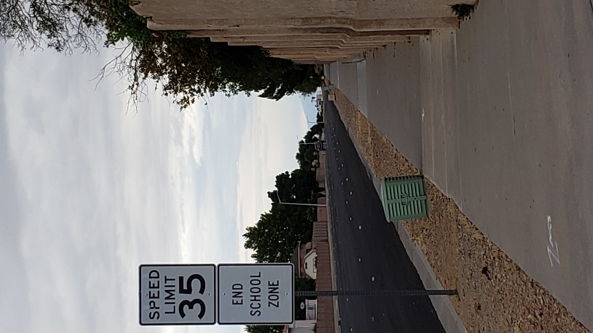

Looking north at Barstow from Desert Ridge Middle School and Greenarbor Rd on 16 July 2019 at 0728.

Looking north on Barstow from Desert Ridge and Greenarbor Rd on 13 August 2019 at 0741. Southbound Barstow is backed up to Alameda.

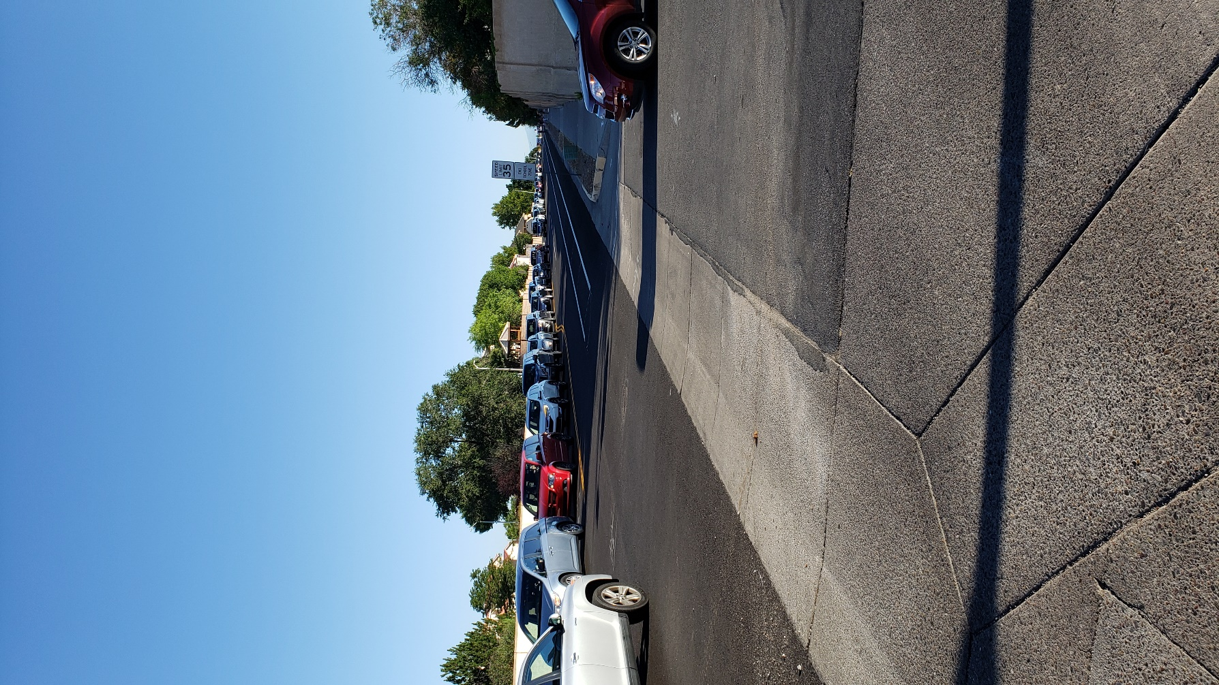

Right turn only sign (no right lane exists now) on northbound Barstow in front of Desert Ridge Middle School on 13 August 2019

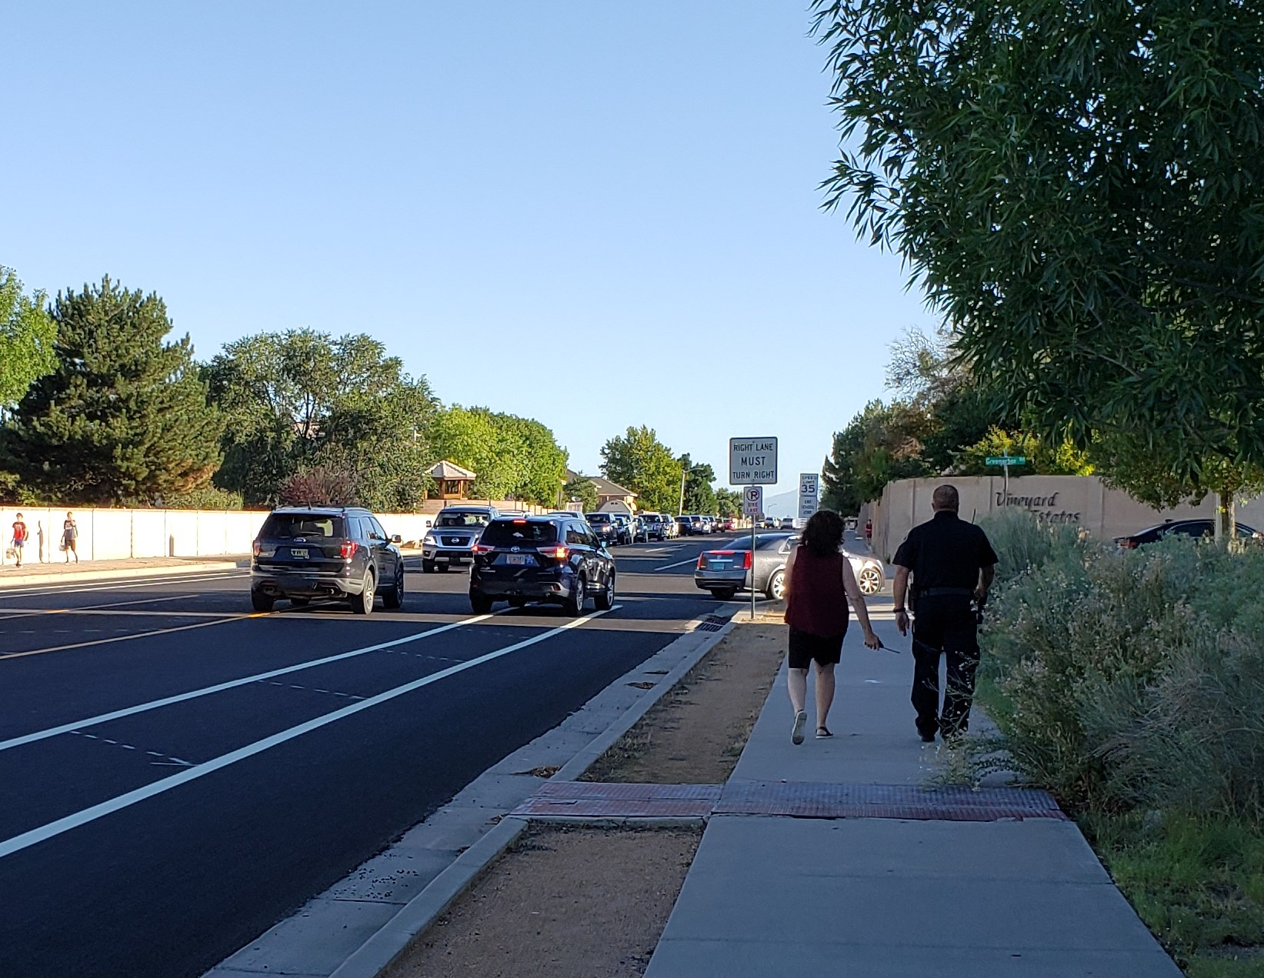

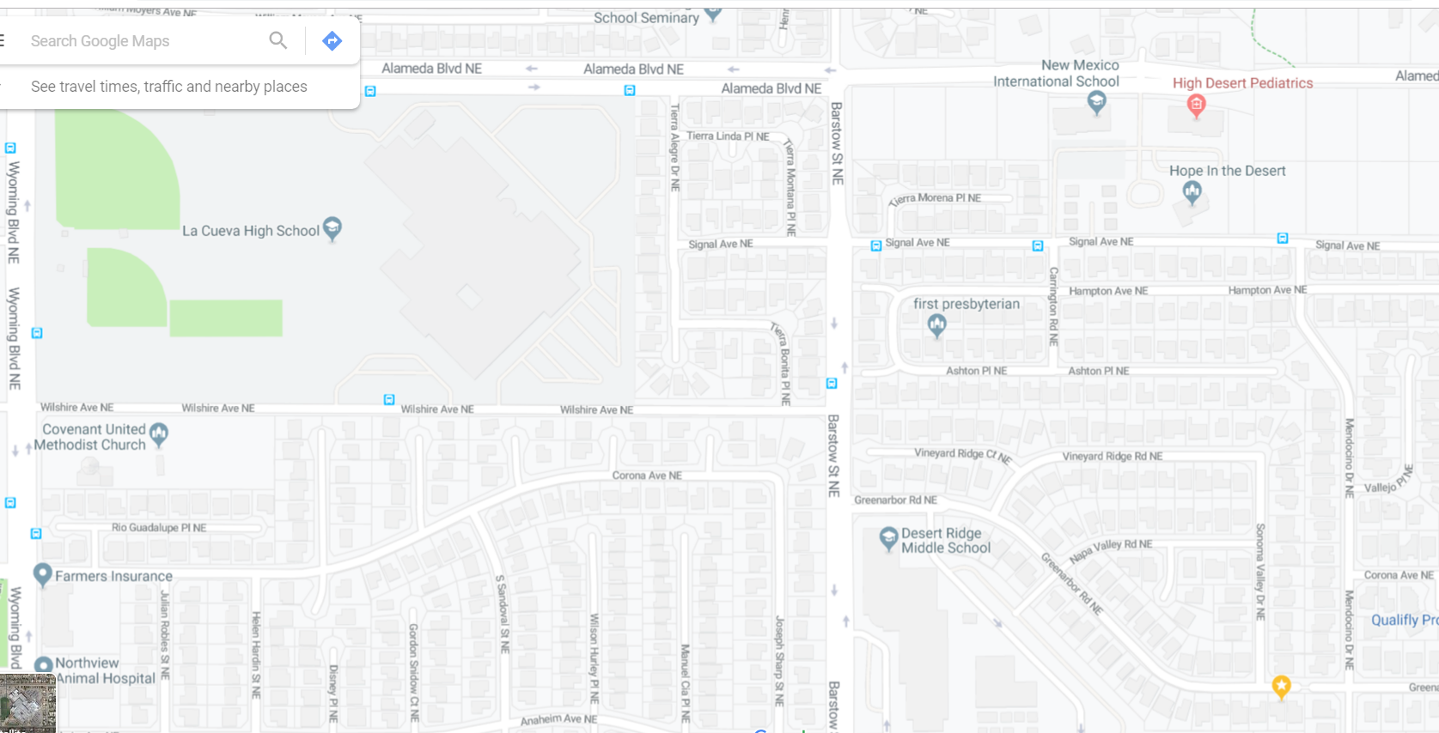Barstow and Alameda Immediate Area Schools. Off of Google maps.