FIRST CLASS MAIL
June 14, 2019

Westside Coalition of Neighborhood Associations
Harry Hendriksen
10592 Rio Del Sol NW
Albuquerque, NM 87114

Re: Neighborhood Association Notification
La Cuentista Subdivision Unit II Offsites (City of Albuquerque Project #709786)
La Cuentista Subdivision Unit II Phase 1 (City of Albuquerque Project #709787)
La Cuentista Subdivision Unit II Phase 2 (City of Albuquerque Project #709788)
Subdivision Improvement Extension (SIA) Extensions

Dear Mr. Hendriksen:

This letter is to inform the Neighborhood Assocations that Wilson & Company, Inc., acting as agents for DR Scott, LLC. and Double M Properties, Inc., is requesting approval for La Cuentista Subdivision Unit II SIA Extensions. The current SIA’s were executed in 2015 for the Offsite Project and 2017 for Phase 1 and Phase 2 Projects. This will be the 3rd Extension for the Offsite Project and the 2nd Extension for Phase 1 and Phase 2 Projects. These extensions will allow additional time to complete the projects and fulfill all of the City of Albuquerque’s requirements for project acceptance.

Attached is a vicinity map showing the location of this project for your reference.

The City of Albuquerque Development Review Board will hold a public hearing on Wednesday, July 10, 2019 at 9:00 a.m. at Plaza Del Sol, 600 Second Street NW, Hearing Room, Lower Level. If you have any questions for the City Planning Staff, please contact the Planning Department at (505) 924-3860.

If you have any questions concerning this project, please contact me at (505) 948-5125.

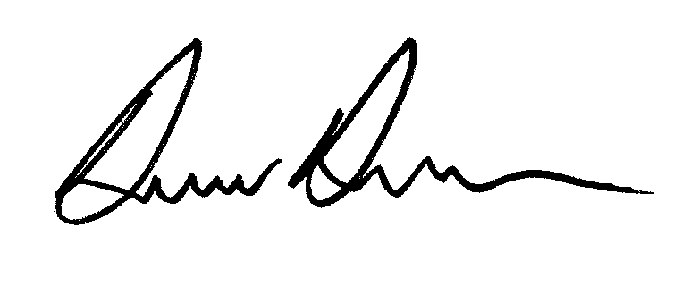
WILSON & COMPANY

Donnie Duneman, PE
Project Manager
Email: dmduneman@wilsonco.com

