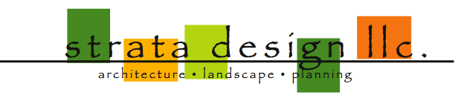
June 2, 2020

Design Review Board
Advance Planning and Urban Design Division
City of Albuquerque, Planning Department

Re: 12000 San Antonio NE – Sketch plan

To Whom It May Concern:

My name is Michelle Negrette, and I am a planner with Strata Design. We have been contracted as the agent for John and Jasmine Pitcher for an amendment to the replat of 12000 San Antonio NE. The client has entered into discussions with Sauvignon to modify the western boundary of the property. The attached surveyed drawings indicate the portions of land that would be involved. The parcels in question have different zoning, however, the amount of land involved in the replat is nominal and should not impact the legal development requirements per the IDO for the respective zones.

We are submitting for sketch plat upon recommendation of Maggie Gould and are interested in learning if there are any unusual requirements with respect to this application that should be considered prior to submitting for replat.

Please feel free to contact me with any questions with respect to this application.

Sincerely,

Michelle Negrette, RA APA
Principal

711 Amherst SE, Albuquerque, NM 87106 505.710.4221

