Good morning,
Thank you for your inquiry.

- We can confirm that a Pre-submittal Tribal Meeting is not required for the subject property pursuant to IDO §14-16-6-4(B). The IDO link is below:
https://documents.cabq.gov/planning/IDO/O-25-73/IDO_2025_Update_Effective.pdf (14-16-6-4(B))
A PDF of the email from Planning staff confirming that a Pre-submittal Tribal Meeting was not required, please log in to ABQ-plan and upload this information in “other documents”

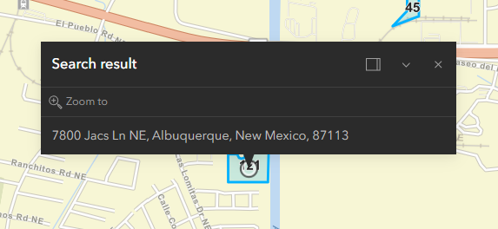

Should you require further assistance, please don’t hesitate to contact me, and/or Annette Ortiz at 505.924-3623.

Thank you,



RENEE ZAMORA
Senior Administrative/Navigator
o 505-924-3358
e rczamora@cabq.gov
cabq.gov/planning

