1. Remove & replace trees marked in red on the site plan (attached). these trees are in very poor health and have structural issues. The tree along eagle ranch is probably in the worst shape of all, and planted too close to the wall.

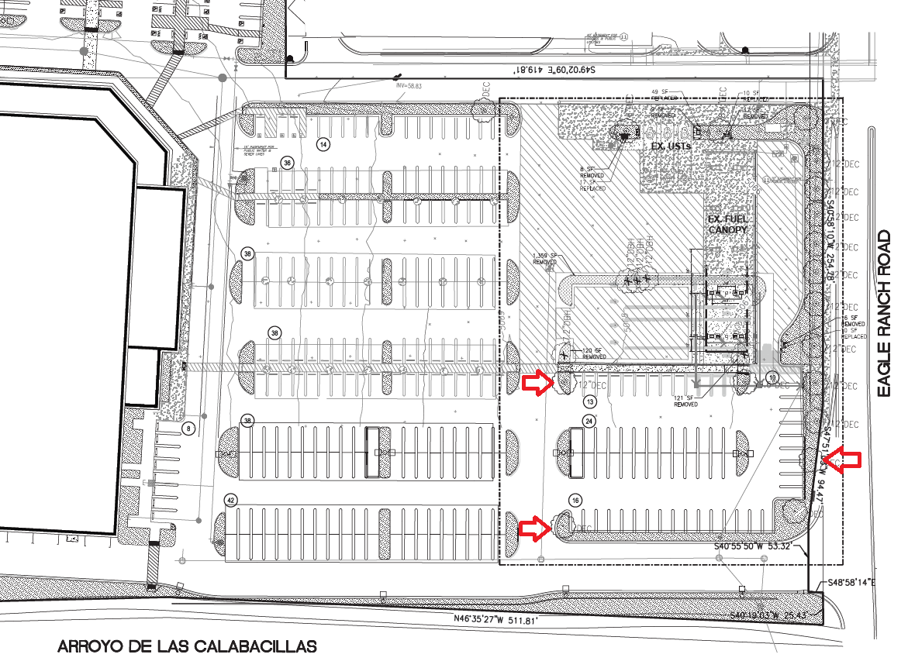

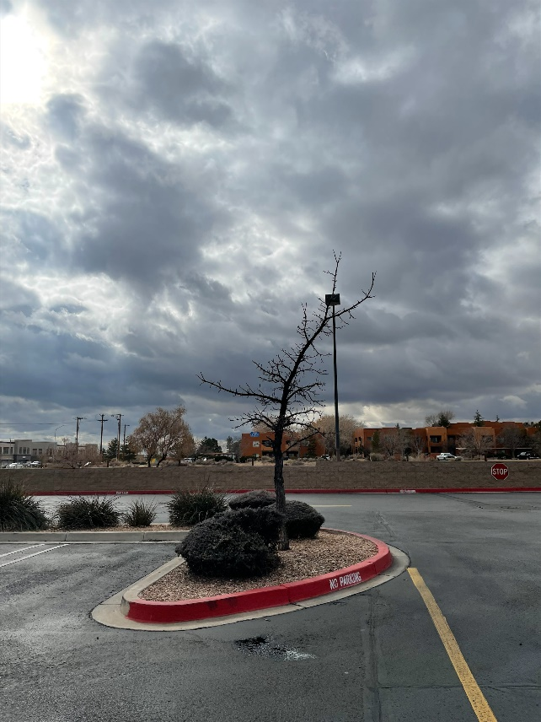 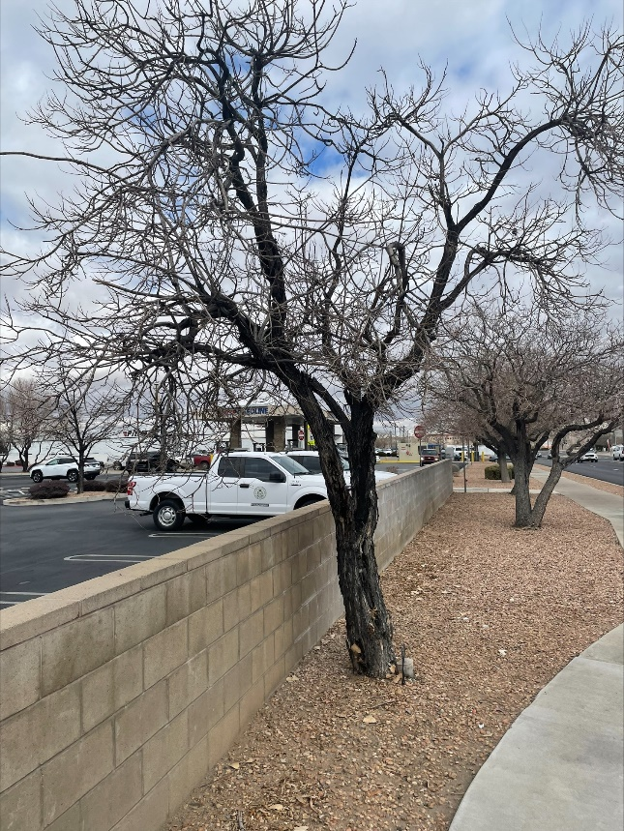

1. Bring the irrigation along eagle ranch Road up to city spec - 3 bubblers per tree. All trees along Eagle Ranch Road need to have irrigation installed. Drip irrigation is not allowed within the Right of Way area per the IDO:

* 5-6(C)(9)(c) Where landscaping is installed in the public right-of-way, the applicant shall install an adequate irrigation system that meets the minimum technical requirements In Article 6-6 of ROA 1994 (Trees, Vegetation and Landscaping) and the DPM, with a separate meter for the landscape area in the public right-of-way, or a separate valve(s) at the property line allowing isolation of the irrigation to the landscape within the public right-of-way. Drip irrigation systems and artificial turf shall not be allowed within the public right-of-way.

1. Trim trees along Eagle Ranch Road per IDO specifications. Some of the trees are overhanging into the road which is not acceptable and it is the owner’s responsibility to maintain these so they are not a hazard. Below ae the relevant IDO codes for your reference:

* 5-6(C)(9)(a) All planting of vegetated material or installation of any landscaping, buffering, or screening material in the public right-ofway shall require the prior approval of the City. The property owner shall be responsible for the maintenance, repairs, or liability for all the landscaping placed in or over the public right-ofway.
* 5-6(C)(9)(b) Any trees that overhang a public sidewalk or Major Public Open Space shall be trimmed to maintain an 8-foot clearance over the sidewalk. Any trees that overhang a public street shall be trimmed to maintain a 9-foot clearance over the street surface.

