DEVELOPMENT REVIEW BOARD APPLICATION

Albuq

Effective 4/1/2019



City of

uerque

|  |  |  |
| --- | --- | --- |
| *Please check the appropriate box(es) and refer to supplemental forms for submittal requirements. All fees must be paid at the time of application*. | | |
| SUBDIVISIONS | * Final Sign off of EPC Site Plan(s) *(Form P2)* | * Variance for Carport within setback(s) *(Form V)* |
| * Major – Preliminary Plat *(Form P1)* | * Amendment to Site Plan (Form P2) | * Vacation of Public Right-of-way *(Form V)* |
| * Minor – Preliminary/Final Plat *(Form S2)* | MISCELLANEOUS APPLICATIONS | * Vacation of Public Easement(s) DRB *(Form V)* |
| * Major - Final Plat *(Form S1)* | * Extension of Infrastructure List *(Form S1)* | * Vacation of Private Easement(s) *(Form V)* |
| * Amendment to Preliminary Plat *(Form S2)* | * Amendment to Infrastructure List (*Form P1*) | PRE-APPLICATIONS |
| * Extension of Preliminary Plat *(FormS1)* | * Temporary Deferral of S/W *(Form P2)* | ☒ Sketch Plat Review and Comment *(Form P2)* |
|  | * Sidewalk Waiver *(Form V)* |  |
| SITE PLANS | * Variance to IDO *(Form V)* | APPEAL |
| * DRB Site Plan *(Form XX)* | * Variance to DPM *(Form V)* | * Decision of DRB *(Form A)* |
| BRIEF DESCRIPTION OF REQUEST | | |
| A SUBDIVISION OF FOUR LOTS ON AN EXISTING 0.5059 PARCEL KNOWN AS LOT 2, BLOCK 16 SANTA BARBARA SUBDIVISION. THIS AREA IS A PRIVATE COMMUNITY THAT BEGAN AS A PLANNED UNIT DEVELOPMENT AND HAS BEEN CONVERTED, OVER TIME, TO AN R-T ZONE STANDARD  LOT PROJECT. ALL STREETS ARE PRIVATE EASEMENTS WITH MAINTANANCE ESTABLISHED BY THE SANTA BARBARA HOMEOWNERS ASSOCIATION. THIS SUBDIVION LOT IS OWNED BY THE ASSOCIATION AND HAS PREVIOUSLY USED AS A PRIVATE PARK, NOW VACATED AS SUCH. THE PROPOSED BUILDER AND DEVELOPER IS THE RACHEL MATTHEW DEVELOPMENT CORPORATION, C/O/ MR. STEVE NAKAMURA.. | | |
| A PRE-APPLICATION REVIEW WAS REQUESTED AND STAFF COMMENTS ARE INCORPORATED, FOLLOWING THE IDO AND DPM REQUIREMENTS | | |

|  |  |  |  |  |
| --- | --- | --- | --- | --- |
| APPLICATION INFORMATION | | | | |
| Applicant: RACHEL MATTHEW DEVELOPMENT CORPORATION AND THE SANTA BARBARA HOMEOWNERS ASSOCIATION C/O ELISA CARDENAS, AGENT | | | | Phone: (505) 792-4663 M: (505) 892-9664 |
| Address: 2600 AMERICAS ROAD, SUITE 103 | | | | Email: [steve@rachelmatthewhomes.com](mailto:steve@rachelmatthewhomes.com) |
| City: ALBUQUERQUE | | State: NEW MEXICO | | Zip: 87124 |
| Professional/Agent (if any): THE SANTA BARBARA HOMEOWNERS ASSOCIATION C/O ELISA CARDENAS, AGENT  COMMUNITY SCIENCES CORPORATION C/O CLIFF A. SPIROCK PLS (AGENT FOR APPLICATION) PO BOX 1328, CORRALES, NM 87048  MR. STEVE W HERNANDEZ P.E. (AGENT FOR CIVIL ENGINEERING SERVICES)  Development Managing Consultants, 9320 Menaul Blvd. NE Suite D, Albuquerque, NM 87112 | | | | Phone: (505) 880-7013 M: (505) 569-0123  (505) 897-0000 M. (505-250-1227 [CASPIROCK@COMMUNITYSCIENCES.COM](mailto:CASPIROCK@COMMUNITYSCIENCES.COM)  (505) 296.7100 M: (505)  [228.1401steve@dmcnm.com](mailto:228.1401steve@dmcnm.com) |
| Address: 5051 JOURNAL CENTER BLVD., SUITE 200 (ELISA CARDENAS) | | | | Email: [ELISA.CARDENAS@COLLIERS.COM](mailto:ELISA.CARDENAS@COLLIERS.COM) |
| City: ALBUQUERQUE | | State: NEW MEXICO | | Zip: 87109 |
| Proprietary Interest in Site: AGENT AND REPRESENTATIVE FOR THE SBHOA ASSOCIATION AS THE OWNER | | List all owners: THE SANTA BARBARA HOMEOWNERS ASSOCIATION | | |
| SITE INFORMATION (Accuracy of the existing legal description is crucial! Attach a separate sheet if necessary.) | | | | |
| Lot or Tract No.: LOT 2, | | Block: BLOCK 16 | | Unit: |
| Subdivision/Addition: SANTA BARBARA SUBDIVISION | | MRGCD Map No.: N/A | | PLAT OF LOTS 1-24 (INCLUSIVE) BK 94C PG 8 (FILED 01/07/1994) |
| Zone Atlas Page(s): D-16 | Existing Zoning: IDO R-T | | | UPC Code:10196316840521901 |
| # of Existing Lots: 1 | # of Proposed Lots: 4 | | | Proposed Zoning: N/A |
| LOCATION OF PROPERTY BY STREETS | | | | |
| Site Address/Street: 7300 SANTA BARBARA RD NE | Between: RANCHO DE PALOMAS RD NE | | and: LOT 1, BLOCK 16 | |
| CASE HISTORY (List any current or prior project and case number(s) that may be relevant to your request.) | | | | |
| A PRE-APPLICATION (PART) REQUESTED 10/7/2021, STAFF COMMENTS EMAILED IN LIEU OF MEETING (BY S. HERNANDEZ PE) | | | | |

DEVELOPMENT REVIEW BOARD APPLICATION

Albuq

Effective 4/1/2019



City of

uerque



|  |  |  |  |  |  |  |
| --- | --- | --- | --- | --- | --- | --- |
| Signature: BY AGENT: Cliff A. Spirock PLS | | | | Date: NOVEMBER 26, 2021 | | |
| Printed Name: | | | | * Applicant or ☐ Agent | | |
| FOR OFFICIAL USE ONLY | | | | | | |
| Case Numbers | Action | Fees | Case Numbers | | Action | Fees |
|  |  |  |  | |  |  |
|  |  |  |  | |  |  |
|  |  |  |  | |  |  |
|  |  |  |  | |  |  |
| Meeting/Hearing Date: | | | | Fee Total: | | |
| Staff Signature: | | | Date: | Project # | | |

**FORM S2: SUBDIVISION OF LAND – MINOR ACTIONS**

***Please refer to the DRB minor case schedule for meeting dates and deadlines unless noted differently below. Bring original Mylar of plat with property owner’s and City Surveyor's signatures on it to the meeting. Your attendance is required.***

A **Variance – DRB for the Bulk Transfer of Land** requires application on Form V in addition to this FORM S2.

***>> INFORMATION REQUIRED FOR ALL MINOR SUBDIVISION APPLICATIONS***

Interpreter Needed for Hearing? _NO if yes, indicate language:

x A Single PDF file of the complete application including all documents being submitted must be emailed to [PLNDRS@cabq.gov](mailto:PLNDRS@cabq.gov) prior to making a submittal. Zipped files or those over 9 MB cannot be delivered via email, in which case the PDF must be provided on a CD. PDF *shall be organized* with the Development Review Application and this Form S2 at the front followed by the remaining documents *in the order provided on this form.*

X Zone Atlas map with the entire site clearly outlined and labeled

X **SKETCH PLAT REVIEW AND COMMENT**

X Letter describing, explaining, and justifying the request

X Scale drawing of the proposed subdivision plat (7 copies, folded)

X Site sketch with measurements showing structures, parking, building setbacks, adjacent rights-of-way and street improvements, if there is any existing land use (7 copies, folded)

* **MAJOR SUBDIVISION FINAL PLAT APPROVAL (requires published notice, heard on the DRB Major Case Schedule)**

Letter describing, explaining, and justifying the request

Copy of recorded IIA

Proposed Final Plat (7 copies, 24” x 36” folded)

Design elevations & cross sections of perimeter walls (3 copies)

Landfill disclosure and EHD signature line on the Mylar if property is within a landfill buffer

DXF file and hard copy of final plat data for AGIS submitted and approved

* **MINOR SUBDIVISION PRELIMINARY/FINAL PLAT APPROVAL**

Letter describing, explaining, and justifying the request per the criteria in IDO Section 14-16-6-6(I)

Sites 5 acres or greater: Archaeological Certificate in accordance with IDO Section 14-16-6-5(A)

Form DRWS Drainage Report, Grading and Drainage Plan, and Water & Sewer Availability Statement submittal information

Required notice with content per IDO Section 14-16-6-4(K)(6)

Office of Neighborhood Coordination Public Notice Inquiry response

Proof of emailed notice to applicable Neighborhood Association representatives

Proposed Preliminary / Final Plat with property owner’s and City Surveyor's signatures on the plat prior to submittal (7 copies, folded)

Sidewalk Exhibit and/or cross sections of proposed streets (3 copies, 11” by 17” maximum)

Site sketch with measurements showing structures, parking, building setbacks, adjacent rights-of-way and street improvements (to include sidewalk, curb & gutter with distance to property line noted) if there is any existing land use (7 copies, folded)

Landfill disclosure statement per IDO Section 14-16-5-2(G) if site is within a designated landfill buffer zone

Proposed Infrastructure List, if applicable

DXF file and hard copy of final plat data for AGIS submitted and approved

* **MINOR AMENDMENT TO PRELIMINARY PLAT OR INFRASTRUCTURE LIST**

Letter describing, explaining, and justifying the request per the criteria in IDO Section 14-16-6-4(X)(2)

Original Preliminary Plat, Infrastructure List, and/or Grading Plan (7 copies, folded)

Proposed Amended Preliminary Plat, Infrastructure List, and/or Grading Plan (7 copies, folded)

***Note: Any application that does not qualify as a Minor Amendment in IDO Section 14-16-6-4(X) must be processed as a Major Amendment. See Form S1.***

|  |  |  |
| --- | --- | --- |
| ***I, the applicant or agent, acknowledge that if any required information is not submitted with this application, the application will not be scheduled for a public meeting or hearing, if required, or otherwise processed until it is complete.*** | | |
| **Signature:** S/ SIGNATURE ON FILE WITH ORIGINAL | | **Date:** NOVEMBER 26, 2021 |
| **Printed Name:** CLIFF A. SPIROCK PLS FOR RACHEL MATHEW DEVELOPMENT | | * Applicant or X☐ Agent |
| **FOR OFFICIAL USE ONLY** | | |
| Case Numbers: | Project Number |  |
|  | |
|  | |
|  | |
| Staff Signature: | |
| Date: | |

Revised 2/6/19

Date: November 26, 2021

To: The City of Albuquerque, Development Review Board Via e-mail with application for Sketch Plat Review

From: Cliff A. Spirock, PLS, agent for Rachel Matthew Development Corporation Subject:Letter accompanying Application

Project: 7300 Santa Barbara Road NE

Lot 2, Block 16, Santa Barbara Subdivision

Ladies and Gentlemen of the Development Review Board:

This project requests a 4 lot minor subdivision on an existing Lot 2, Block 16, Santa Barbara Subdivision (Plat filed January 7, 1994, Bk 94C Folio 8). The site is bounded by the Domingo Baca Arroyo 70’ RW to the South and includes a 20 ‘ Drainage Easement (City) on the west. To the east is a platted lot (Lot 1, Block 16). To the north is a private street, Santa Barbara Road NE, which is owned by the Santa Barbara Homeowner’s Association (SBHOA), located within a platted 30’ easement. The street easement includes a 10’ gas and water easement and adjacent to the south street line is a 12’ utility easement.

The water system is a master meter private utility. This utility and the street is owned and maintained by the Association. All other services (gas, communication, electric are within platted easements).

The subject lot is owned by the SBHOA Association and is contemplated for sale and development by Rachel Matthew Development Corporation who intends to complete the infrastructure guarantee, transportation and preliminary and final plat process. It is subject to the IDO R-T Zone. The existing private park facilities (parking, shuffleboard, walkways and recreation facilities) will be razed and the entire property developed as residential lots.

The existing street sidewalk and curbs (stand-up and roll-over) will be rebuilt in accordance with the DPM. A 6’ sidewalk clear area incorporating a 4’ physical sidewalk is proposed. A front setback to the proposed garages is shown as a 20’ minimum as required by the code. However, private covenants prescribe a 20’ minimum garage setback from the sidewalk area. A 26’ minimum front garage setback is thereby shown. A 5’ side yard setback and 15’ rear yard setback are shown as typical RT IDO Zone minimums. The sideyard setback on proposed Lot 2-D (west end) is 20’ minimum to accommodate the existing 20’ drainage easement encumbering that area.

Existing curb and 4’ walk at east end Existing curb and 4’ walk at west end

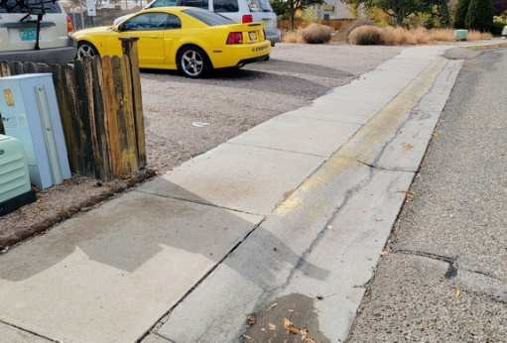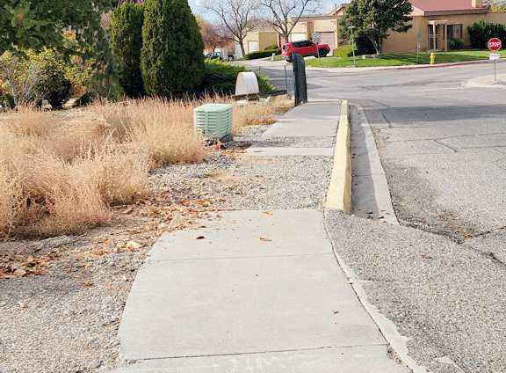(to be replaced) (to be replaced)

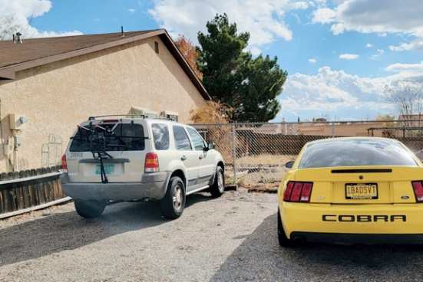In addition to the plat for subdivision, it will be requested that an existing 12’ access easement burdening the easterly end of Lot 2 be vacated (by the Association, on the plat of subdivision).

The photo at right shows the easement area now in use as a parking area. There is no dominant tenement indicated on the plat which created the easement, therefore the SBHOA can vacate as the servient tenement of the easement

We have included with the application a supplementary sheet to the proposed platting indicating hypothetical layout of R-T detached units, their setbacks and development conditions affecting the infrastructure design.

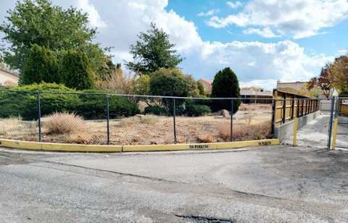Of particular note is the curbing and inlet to the existing drainage rundown. Careful driveway locations and increased setbacks are shown in the hypothetical sketches to facilitate driveway cuts and walkway grades to conform to the DPM requirements and IDO for access and circulation standards (sidewalks and handicapped ramp).

Clear sight triangles will be maintained.

Photo at left: Drainage rundown to the Domingo Baca Arroyo from Santa Barbara Road NE

MX-L

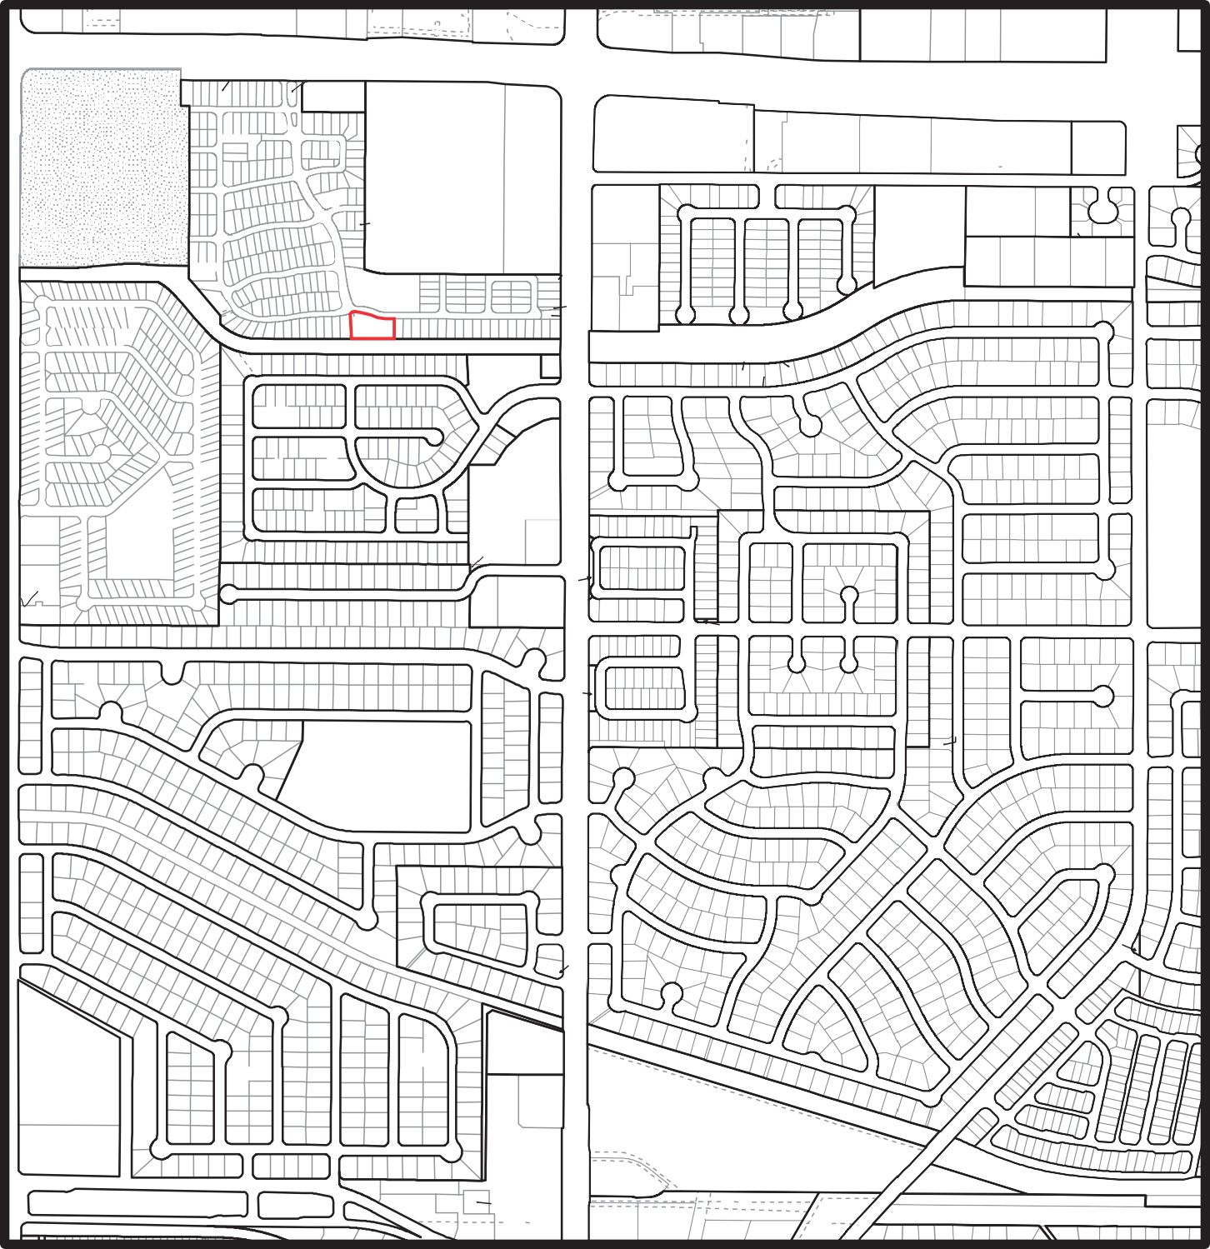

1A2A1

1A2A2

1A3A

1A4

MX-L

1005130

1008086

(!10

22A

1003532

1008069

21A

MX-L

VILLAGE

1000242

1000249

MX-T

(20

12A

SP-99-194 A

PASEO

1000946

A

5A

1000163

MX-M

1A

6A 7A

8

MX-M

CITY RESERVOIR SITE

TRACT 2

(UNIT 3)

1001749

LA CUEVA

OFFICE PARK PD

MX-T

AUTO PARKING LOT PARK (PRIVATE)

R

DEL

FEDERAL

10

QUAIL

1

(!1

6

7

-T 1 HOLLOW

PD A RANCHO DE PALOMAS

MANUFACTURED HOUSING

MX-L

NORTE

3 SANTA 1

(PRIVATE)

(!2 7

1

R-T 7

NORTH ALBUQUERQUE ACRES 1008952

1004622

HERITAGE

4 6 TURTLEDOVE LA

15

8

RA

(21 28A

MORNINGSTAR

MX-T

1004564

22A1

11

3 1 !(6

10

DR

1 !(10 4 8

C

O

H

C

N

TRACT A UNIT A

1002112

AT PALOMAS

A B

COUNTRY WOOD DR

(!21

NORTH ALBUQUERQUE ACRES

MX-L 3

18A

AVIATION

ARY

A

(!3

4 6

23 R-T

16 A

B

LA

16 (!11

R-T

12

B NR-SU C

PALOMAS

1008257

23A

TRACT A UNIT A

AV

SP84351

1

BLVD

PALOMAR

PALOMAR CT

A/DRAINAGE ROW

G

3A 1A 9A

EAGLE

CA

N

(!7

1A 21

17

DE

LA

S P - - 8 2 - - 8 1

9

MX-T

R-T 1 95

R-T

86

DR

WOODHAVENDR

12 14

10 1

R-T

HERITAGE HILLS

R-1C 78

POTOMAC CT

!(4

6A

R-T 19A

COUNTRYWOOD

RD R-ML

MX-T 8

ADMINISTRATION 4A

DR

DR

B

W

S P - - 8 6 - - 2 0 7

H

ITE

B

10A

S - - 8 5 - - 1 8 1

1

SP-86-208

P

A

2A

3A

4

L

O

X1A 1

SP-99-142

X1A 2

31 32

51 52

70 71

SP-82-121

!(22

7A 6A 5A 4

75

22

24

GOLDEN

O

13

S P - - 9 7 - - 1 4 6

21

DOMINGO BACA ARROYO DRAINAGE ROW

(PRI

A

D

E

E

14

CH

I

C

K

!(8

R-T 28

LA

1

R-T

7

M

A

S

12A

SP-86-208

5A 6A

COCKA TOO LA

CHICKADEE LA 5A

BLUE JAY LA

!(22

1002716

SP86-264

X1B 1

X1B 2

R-T

COUNTRY

R-T

WOODRIDGE

WOODWIND

S-84-18

R-T

R-T

79

WOODLEAF

B2A

21 NR-PO-A

SP-87-211

17

81

37 R-1C

L

I

B

E

Y

RT

ST

5 R-MC 19

BARBARA

18 (!9

P

DR (PRIVATE)

13

)

E

T

A

V

LL

I

RW

OO

LA

P

12 R-T

A

BA

N

A

S

(

SP86-209

(!13

4 5

!(14

WREN LA

(!15

WOOD

78

TRAIL

GATLING

|  |  |  |
| --- | --- | --- |
| 35 NORTH HILLS | | |
|  | R-MC | 9 |

A 14

R-T 24

SANTA 8A

2A

1A 10A 1 8 1A

PROPOSED ROW EXTNSN

MX-T 62 36

25

I

H

W

R-MC

BLVD

RD

14

L D - - - 7 3 - - - 4 6 3

(!3

(!2

(!17

S - - 9 3 - - 2 6

RBARA

2 R-T

TA

V-93 -58

RD

!(16

(PRIVATE)

20

X1B 3

21

X1B 4

22 41

42 61

LOMA (!29

R-1C

1 (UNIT 5)

1 1

SPRINGFIELD

28 DRAINAGE

1 3

EASEMENT

BARBARA

DOMINGO BACA DR

21

R-1C

A

W

O

R

E

G

INA

DR

9 R-1C 17

PIONEER

17 36

(PRIVATE)

R-MC 29

18 25-P1

R-1A

SITER-1A

A

NR-PO-A

44-P1

R-1A

1A 2A 3A 4A

!(29

SP-77- 343

7A 8A 9 10 11A

12A1

13A1

14A 15

!(29

(UNIT 9)

!(27

25

E

18 40

1 MOBILE

E

R

R-MC

RD

LASTER

S P - - - 7 7 - - - - - - 3 4 3 R-1C 1

REMINGTON

21

9 (!4 17

DR

R-MC

R-1A

PHASE 1

4-P1

AV KRIM

SP-77-556 1

23

RD

A

U

G

O

I

W

S

R

DR YEA

26 25

R-MC

E

L D - - - - - 7 3 4 6 3

LOMAS

1A 10 1

B

AV

ST

R

NR-PO-A

18 19

17 18

32 DEL

13 1

R-1C 22

19

R-MC

35

HOME 18

CARDIFF AV

A

P

76-P1

22-P1

45- P1 21- P1

S

S - - 9 2 -

S

1

2

- - 2

E

A

P L

O

138-P1

75- P1

R-1A

68- P1

146-P1

67- P1

R-1A

60

-P1

A

1-P1

PA

AS

M

85-

P1

2A

2

(!32

82-P1

R-1A

SP-77-426

R

K

84-P1

R-1C

!(33

MIDGE

8

R-1C

E

T

I

H

ST

22

JEMEZ

B

20 R-1C

S

T

R

CT

E

1A 24

25A

SP-87-258

Y

(!26

R-1C

G

14

!(1

31 14

CARBINE CT 38 DR

SPENCER

30

PHAS

ALOMA

137 -P1

81-P1

P

93-P1

4

52- P1 13- P1 M A PARK AV

53- P1 12- P1

O

-P1

R-1A 61

7A SP-77

-502

5A 6A 5

!(32

(!30 6 ER

13 9 1

G

ST

DR

S

P

R

EN

(!28

9

R-1C

DR

45 R-MC(!5

NORTH HILLS SHOPPING CENTER

(PRIVATE)

8

CAPITAN AV

PARK

MX-M

6A DUMAS DR

13

P L

A

SPRENGER

10 (!25

18

HERITAGE HILLS

10

ST

7

ADELE PL

1 1 PARK

132 -P1

133 -P1

BLVD

PARKPHASE

E 7 R-1C

25 1 R-1C

!(31 9

R-1C

(UNIT 3)

NORTH HILLS

A

104-P1

101-P1

98-P1

1

1A

LD-73-463

(UNIT 1)

R-MC

SHARPS RD

1

RECREATION SITE

S-92-21

R-1

A

R-MC

BROWNING

R-MC

R-1A

STORRIE PL

36

GALLINAS

106 - P1

AV

168-P1 147 -P1

S P - - 9 1 - - 9 1

PL

S

94-P1

MX-M

A

R-1

97-P1

O

LA MARIP

107-P1

100-P1

VO 79-32

R-1A

29A

BRITTANY AV

39 40

7

COPPERFIELD DR

R-1A

9

IRWIN

ST

ST

1 LOMITA !(8 R-1B 10 13

ST

ST

RD

TINA

1

ST

NORTE(!

24

DR

9 25

CALLOW

DENNIS CHAVEZ

R-1A

R-1C

103-P1

2A1 !(

NORTH HILLS

PL

R-1A

S-92-21

PHASE 5

157-P1

158-P1

S-92-1

PHASE 3

116-P1

115-P1

(SP8098)

A

LD-73-121

28 R-1A 20

(!5

5 7 5 11

18 R-1C 10

SP-86-304 6

R-1B

COPPERFIELD

(!7

JANIS DR

SP-88-79 6

(!7

MICHAELS

PL 4 8 12

ELEMENTARY SCHOO

2B1

RD

7 R-MC

19

15 16

R-1C

MANOR

1 1007246

B1A

B1B NR-PO-C

11 19

S - - - - 9 1 2 0

!(6

20A SP79

12 R-1C 21

SAVAGE DR

SCOTTS

NORTH

ARGYLE AV

10 R-1A 1

R-1B

248

21A

R-1B

ADDN

!(23

R-1C

3A 11

R-MC

26 20

R-1C

38 MX-M

50 1

1 11

1 22

16 15

17 20 11 1

1 R-1C

13 R-1C

!(10

27 SP-75-204

28A 29A

32 R-1C

SAN FRANCISCO

KEYSTONE

NR-PO-C

1

R-1B

DR SAN FRANCISCO

RD SAN FRANCISCO

SAN FRANCISCO

1

33 42

51

R-T

8 15 16

22 23

29 30

1 17 1

7 R-1C 1 1

1

R

ST

1 10A

CLASSIC AV

36

RD

ST

DR

17 R-1B

(UNIT 8A)

!(2

-1C

R-1C

SP-83

!(12

28

1

4)

IT

R-1

C

34 R-T 41

R-T

18A

12

19A 20

33

ROBERTS

SAN

FRANCISCO

26

R-1C 8

12 9

R-1C

53 8

58

56

!(11

-47

9A 46

DR

(UN

RAYMOND

29 17

DR

NR-PO-C A

1

ST

SP--86--18

25 PARK 33

KEYSTONE

(!2

SP-78-242

11

!(3

ACRES 1

!(4

!(22

!(23

SAN MIGUEL CT

19 R-1C

LOS LUNAS

R-1B

14

6

IRONSIDE

1

R-1C

RD

SHANNON ST

1

R-1C

HERITAGE HILL

24 R-T

1

ADDN

14 B

10 (!1 1

!(24

(UNIT 1)

LOMA

(!17

GILL

SAINT CLAIR

7 44

49

R-1C

7

LOMA DEL NORTE

8

11A SP-75

NR-PO-A

LOMA DEL NORTE PARK

R-1C

(!16

VAC ORD 79-32 13

(!1A

13 1

1

R-1B

9 R-1C !(2

D

D

E

Y

8

1 1 9

20

10 8

JEMEZ

VO 78-49

9

26

RD

R-1C 1

13 23

CAPULIN

12 35

BARSTOW

1 R-1C

R-1C

R-1C

R-1C

(!14 13

-217 12A

(13

7 16

10

BURKE

9

11 R-1C 4

LOMA 9

DEMING CT

9 10

O

R

E

OT

(!3A

!(14

1 R-1C

AV

(!15

7

20 (UNIT 8) 25

LOMA DEL NORTE

R-1C

1 R-1C

COULSON

1 27

ST

8

DEL

DERICKSON

33

R-1C

20 21

25

RD

31 R-1C !(15

FRIEDA ST

15 R-MH

43

39

38 40

!(2 23

8 11

1A

D

SP-77-215

A

LOM

WYOMING

R-1C

2A 12

L

E

3

NOR

4

TE

8

DEL

(!5A

R-1C

R-1C 1

AV

22

5

19 1

EDDY

34 13

14

R-1C 10

6

R-1C

PORTALES

MOSQUERO

AV

1

(!16

15 18

19

AV

32

!(1

C

A

M

I

R

R

E

M

31

19

24 !(4

!(1

26 9 RD

11 10 7 6

R-1C

DR

NORTH ARROYO DEL PINO

LE DE ORO

LOUISIANA

DR

R

E

20 24

CALLE DE COBRE

R-1C R-1C 11 18

9 R-MH 12 1

R

R-1C

R-MH

26

WINANS

!(6

1 10

9

(!7 10

6A !(17

21

GILL

R-1C

6

20

(!5

26 11

22

10

!(3

(UNIT 4A)

8

4

CALLE DE PLATA

CURRY

1

L

(!1

A

C

8

7

RY

U

C

AV

R-MH

36 8 R-1C

!(8

UNION

17

AV

1

SP-75-267

14A

NORTE

11

OTERO

(UNIT 7)

C

O

L

9

F

R-1C

A

X

5A

!(18 4A 3A

2A

11 R-1C

1

1 2A

N

O

M

W

O

L

RD

R

O

T

I

1 (UNIT 1)

F

Y

MA

R-T

R-1C

30

H

T

U

O

M

Y

P

L

1

PATRICIA

R-1C

(UNIT 1)

R-1C

(!4

(!8

46

ST

45

R-1C

AV

!(2

2

R-MH

1

!(9

33

14

19

RUIDOSO

10

SP-76-90

15A

CT

11

15A

10

(!20

C

U

R

R

5

Y

I

N

(!19

1 28

AV

SP------76 458

20 1

AV

31

R-T

ST

1

R-T

30

R-1C (6

MX-L

SP-86-203 9

DR

DR

|  |
| --- |
|  |
|  |
| (2 |
|  |
|  |
|  |

9 9 10

36 8

DR

DR

ST

32

LOMA

A1B1

32

R-1C

RUIDOSO

16A 17

R-1C

18

MALAGA

19

C

(!21 4

R-1C

A

P

U

L

ADDN

14 R-1C 1

35

36 110

R-1C

ST

109

BARSTOW

ACADEMY

R-T

H

G

I

E

L

R HE

AC

112

A1-1

7 7 NORTE

8

DR

R-

C

R-1

9

R-1C

C

R-1

MX-M

DEL

MX-M

S P - - - 9 9 - - - 1 3 3

!(9

8 9

10 1

21

NORTH ARROYO DEL PINO

15A

17

AV

16A

SP-80-410

20

(!9

AV

RUIDOSO

1

R-T

142 143

141 R-T

DELLA

S-84-4

138

113

DR

108

RD

85 84

ST

R-T

(UNIT 2)

1C

(!3

R-1C

!(6

(!7

3

A2B1A

SP84-78

137

LOMA DEL NORTE (UNIT 5A)

18

R-1C

RD

47 132

RD

EMILY

R-T

R-T

R-T

WREN WALK

HOLLIS

R-T

SP-84-73

LESLYNNE

S-84-4

NORTE

CINDY

JOYCE

MERLE

LEONA

ORALEE

124

10 48

R-T

131

R-T

NORTH

MX-L

A2-1

1 13

1 43

1 55

1 18

1 15

DR

MX-L

1000331

AA1A 1

PARROT RUN

RTH A

51 52

R-T

123 97

96 74

RD

A

Y

SP-86-203

KRISTA

OY

R

R

O

RR

R-1C 23

SAN ANTONIO

17

1 (!9

5

R-1C

49 R-1C

B2A1

41

ADDN 42

B2A2

SAN ANTONIO

CENTER

AA1A 2

MX-M

MX-T BB SP-77-98

NORTH

N

O

R-T 73

1

NO

O

PIN

L

E

D

O

E

D

O

ACADEMY A PD

ARROYO

BLVD

(UNIT 17) SAN ANTONIO

PD E

ACRES

DRAI

N

A

G

E

SP-91-170

1

F

PD

WYOMING SUBSTATION

S P - - 8 9 - - 1 13

MX-L

CHERRY

C1A5A 1

I

P

L

SP-93-164

R-1C

LOMA DEL NORTE ADDN

B

NR-PO-A

4

!(1

R-T

PINO

1

ASHLEY LANE TOWNHOMES

SP-90-113 C1C2

C1C1A C1C1B

2

(UNIT 3)

26

C1A1A

C1A2A

SP-94-34

MX-L

(UNIT 1)

A1A

1 CHERRY !(1 R-1C 9

R-1C15 1

CHERRY

For more details about the Integrated Development Ordinance visit: htt p://[www.cabq.gov/planning/codes-policies-regula](http://www.cabq.gov/planning/codes-policies-regula) ons/integrated-development-ordinance



**IDO Zone Atlas**

**May 2018**

2 3 4 5 6 7 8 9 10 11 12 13 14 15 16 17 18 19 20 21 22 23

A

A

B

B

Zone Atlas Page:

**D-19-Z**

C

C

D

D

Easement

V V

Escarpment

E

E

Ø Ø Ø

F

F

Petroglyph Na onal Monument

G

G

H

H

J

K

§¨

J

Areas Outside of City Limits

**40**

K

L

L

Airport Protec on Overlay (APO) Zone

M

M

N

±

N

P

§¨

P

**IDO Zoning information as of May 17, 2018**

**The Zone Districts and Overlay Zones are established by the**

**Integrated Development Ordinance (IDO).**

Q

**25**

Q

Character Protec on Overlay (CPO) Zone

Historic Protec on Overlay (HPO) Zone

R

S Gray Shading

T Represents Area Outside

U of the City Limits

R

S

T

U

View Protec on Overlay (VPO) Zone

Feet

0

250

500

1,000

V

V

Ø

Ø Ø Ø

V V

Ø

V V

***Rio Grande***

CJ

SITE

**LEGAL DESCRIPTION** :

Lot 2 of the "Plat of Lots 1-24 (Inclusive) Block 17 Being a replat of Tract E-1 and Lots 1 and 2, Block 16 togerther with the vacated portion of Rancho de Palomas NE (V-93-59) , Albuquerque, New Mexico, July 1993" as the same are shown and designated on the plat thereof recorded in the office of the County Clerk, Bernalillo County, New Mexico on January 7, 1994 in Plat Book 94C, Page 8 as document No. 94003225.

**PRELIMINARY PLAT**

## LOTS 2-A, 2-B, 2-C AND 2-D, BLOCK 16 SANTA BARBARA SUBDIVISION

BEING A REPLAT OF LOT 2, BLOCK 16 SANTA BARBARA SUBDIVISION

SITUATE WITHIN

PROJECTED SECTION 18, T.11N., R.3E., N.M.P.M., TOWN OF ALAMEDA GRANT

CITY OF ALBUQUERQUE

BERNALILLO COUNTY, NEW MEXICO DECEMBER 2021

**VICINITY MAP**

not to scale

ZONE ATLAS MAP

###### D-19-Z

**PURPOSE OF PLAT:**

The purpose of this plat is to combine one (1) existing lot into four (4) new lots, to grant specific drainage and utility easements as shown, and to vacate an existing private access easement as shown hereon, all in accordance with the by-laws, private covenants and maintenance obligations for the Santa Barbara Homeowner's Association (original declarants Rancho de Palomas Ltd. and Realty Marketing Services, recorded Bernalillo County, June 8, 2010 as document 86-6883 including applicable and subsequent annexations, revisions and amendments to same).

**SITE DATA:**

FEMA Map Number Zoning

No. of Existing Lots No. of Lots Created Total Area

35001C0137G

R-T

1

4

0.5059 acres

**DISCLAIMER**

In approving this plat, Public Service Company of New Mexico (PNM) and New Mexico Gas Company (NMGC) did not conduct a title search of the properties shown hereon. Consequently, PNM and NMGC **DO NOT** waive or release any easement or easement rights which may have been granted by prior plat, replat or other document and which are not shown on this plat.

Public Utility Easements shown on this plat are granted for the common and joint use of:

1. Public Service Company of New Mexico (PNM), a New Mexico Corporation, (PNM Electric) for installation, maintenance, and service of overhead and underground electrical lines, transformers, and other equipment and related facilities reasonably necessary to provide electrical services.
2. New Mexico Gas Company (NMGCo) for installation, maintenance, and service of natural gas

lines, valves and other equipment and facilities reasonably necessary to provide natural gas services.

1. Lumen Technologies for the installation, maintenance and service of such lines, cable, and other related equipment and facilities reasonably necessary to provide communication services.
2. Comcast for the installation, maintenance and service of such lines, cable, and other related equipment and facilities reasonably necessary to provide Cable services.

**FREE CONSENT:**

The undersigned owners and proprietors of the properties represented hereon do hereby certify and affirm that this replat is created with our free will and consent in accordance with our expressed wishes and desires.

by

Date

Acting Secretary for: SANTA BARBARA HOMEOWNERS ASSOCIATION (SBHOA), a New Mexico corporation, as an official authorized act by their Board of Directors.

The principal office of the corporation is located at 7800 Rancho

de Palomas, NE, Albuquerque, NM 87109. The mailing address of the Association is Post Office Box 93636, Albuquerque, NM 87109.

**ACKNOWLEDGEMENT**

State of New Mexico)

County of )SS

Project Number:

Subdivision Application Number:

**PLAT APPROVAL**

UTILITY APPROVALS

PNM Electric Services date

New Mexico Gas Company date

Lumen Technologies Inc. date

Included is the right to build, rebuild, construct, reconstruct, locate, relocate within the easement, change, remove replace, modify, renew, operate and maintain facilities for purposes described above, together with free access to, from, and over said easements, with the right and privilege of going upon, over and across adjoining lands of Grantor for the purposes set forth herein and with the right to utilize the right of way and easement to extend services to customers of Grantee, including sufficient working area space for elecric transformers, with the right and privilege to trim and remove trees, shrubs or bushes which interfere with the purposes set forth herein. No building, sign, pool (aboveground or subsurface), hot tub, concrete or wood pool decking, or other structure shall be erected or constructed

The foregoing instrument was acknowledged before me this by:

Notary Public:

My commission expires:

**SOLAR NOTE:**

day of ,2021

Comcast date

CITY APPROVALS

City Surveyor date

on said easements, nor shall any well be drilled or operated thereon. Property owners shall be solely responsible for correcting any violations of National Electrical Safety Code by construction of pools, decking, or any structures adjacent to or near easements shown on this plat.

Easements for electric, transformers/switchgears, as installed, shall extend ten (10) feet in front of transformer/switchgear doors and five (5) feet on each side.

No property within the area of this plat shall at any time be subject to a deed restriction, covenant, or

binding agreement prohibiting solar collectors from being installed on buildings or erected on the lots or parcels within the area of the proposed plat. The foregoing requirement shall be a condition to approval of this plat for subdivision.

**TREASURER'S CERTIFICATION:**

Parks & Recreation Department date

City Engineer date

**NOTES:**

* 1. The basis of bearings is the line between the two found property corners indicated and also referenced to AGRS Station "Heaven" as measured with the "Trimble VRS Now" GNSS RTK Virtual Reference System. Bearings are New Mexico State Plane, Central zone, NAD83. Distances are ground distances. Elevation Datum is NAVD88.

Bearings and distances shown in ( ) are per record plat of Lots 1-24, Block 16 (Bk. 94C-Pg.8)

* 1. Documents used (on file at Bernalillo County Clerk unless noted):
     1. Plat of Lots 1-24: BOOK 94C PG. 8 REC: JAN. 7, 1994
     2. Plat of Tract F: BOOK C3 PG. 121 REC: July 24, 1986
  2. Plat of Lots 1-20, Block 16: BOOK 92C PG. 206 REC: September 22, 1992
  3. By-laws, Declaration of Covenants, Amendments and Annexations as provided by the Santa Barbara Subdivision Association.
  4. Ground Leases, conveyances and descriptions recited in the Declaration of

This is to certify that all taxes due and payable have been paid in full for year 2021 pursuant to New Mexico statute 78-38-44.1

LOT 2, Block 17: 101906316840521901

Bernalillo County Treasurer's Office: by: date: _

**SURVEYOR'S CERTIFICATION**

I, Cliff A. Spirock, New Mexico Professional Surveyor No. 4972, hereby certify that this plat was prepared from an actual ground survey performed by me or under my supervision, that I am responsible for this plat and that this plat is true and correct to the best of my knowledge and belief. This plat conforms to the minimum standards for surveying in New Mexico as adopted by the New Mexico Board of Registration for Professional Engineers and Surveyors and to the City of Albuquerque Subdivision Ordinance.

AMAFCA

ABCWUA

Traffic Engineer, Transportation Department

Environmental Health Department

ORB Chair, Planning Department

date

date

date

date

date

Covenants as provided by the Santa Barbara Subdivision Association (circa 1986) recorded in Bernalillo County, New Mexico as documents 86-11980 Page 945,

86-683 Pages 498 through 596 and document 91089915.

* 1. These properties are located in Zone X , areas of minimal flood hazard per FEMA Flood Insurance Rate Map 35001C01137G, effective date 09/26/2008, as shown on this plat.
  2. All known easements of record are shown on this plat. The 12 foot Private Access Easement at the easterly line of Lot 2, Block 16, is hereby vacated by the servient tenement, the Santa Barbara Homeowners Association. No dominant tenement is

Cliff A. Spirock

New Mexico Professional Surveyor No. 4972

Date

**SUBMITTED AS A SKETCH PLAT FOR REVIEW AND COMMENT**

## PRELIMINARY PLAT

rn

**LOTS 2-A, 2-B, 2-C AND 2-D, BLOCK 16**

**Santa Barbara Subdivision, Albuquerque, NM**

z

0ec

disclosed or referenced by the prior plat of record or known to the Association.

* 1. All references to this land (Lot 2) being a "Private Park" are hereby voided.

DWG PATH: F:\N679-RMH Oevelopment\N0679-01·860 P PLAT 11_2021 CAS.dwg

w GPS, TIO /

"

D

0

* 1. All roadways serving the subdivided properties are Private Street and Roadway Easements granted and accepted by prior platting.

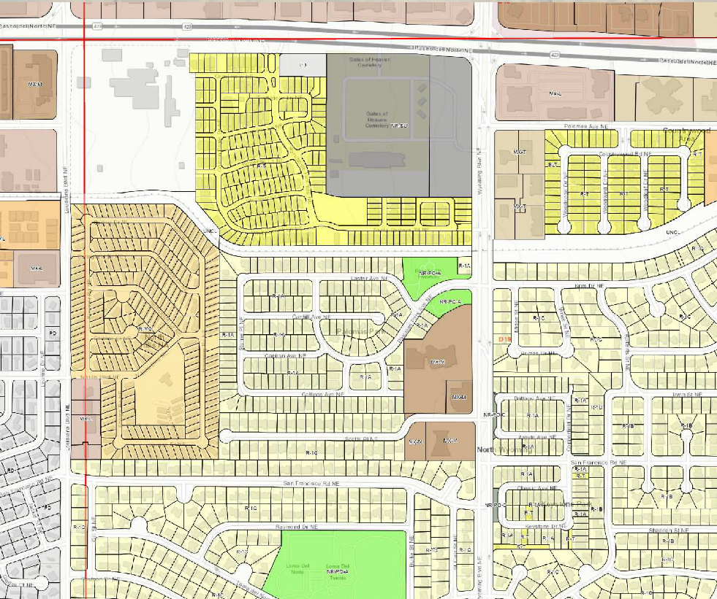

Cceoted 11/24/2021

Last Re11.

**SCALE,** 1" 20'

I" CREW: LRC

< DRAWN, CAS

D

0 JOB NO,N679-01-860

N

n

V

z

Community 1

**ces** of

oration

2

Land Surveying (505) 897.0000

|  |  |  |  |  |  |  |  |  |  |
| --- | --- | --- | --- | --- | --- | --- | --- | --- | --- |
| AGRS MONUMENT 16-D1   "HEAVEN"  LONG: -106'33°41.7862  /0 (AGRS)  LAT: 35'10'26.953 (AGR  NMSP-C NAD83 (UsF):  C) 'ox;, Y=1,518,799.515 X=1,547,297.145  **\r,.%** ti: ORTHO. HT: 5378.235  o'J; COMB. G-G: 0.9996558  CONV: -0'10'46.2"  /  /FND "X"  POINT ON THE RETURN OF LOT 22, BLOCK 17  --..  --..  --.. **A** *//v66o*  --.. '*V66o <64<"*  *<6'<7..WJ*  ***8,<j*** o *(80,/··9j;-. .J:Y*  *u/s Ot:: -Bo')* . --..  *8 "1 1.* --..  - *'fvGs* --.. --..  --..  --..  --..  --- --..  --..  --..  --..  ------ (UIS -tt-------i-- --- VENANTS), 26' SHOWN  **NE. (30' PVT. ROAD EMT.)**  U11L t_M1 1 - - - 7 r--- ------- ------- -. ---------------------------------------------------  '2' ---- I 1 ------- _ S89°45'30"E FOUND "X" OcNu1 GAS & WATER EMT. (EXIST)  (S89°40'37''E) ,  ----- I I - - - - - -! ------- ------- ---4000' El ----, --------  I : I I_ 1 -- ------- : -- -- _ (40:00') 7 UTIL EMT. (EXIST)  z **z** I I \ 1co ol ------- -  I -------------------------  **0** (") ------------- I NEW 4' WALK SHOWN (WITHIN 6' CLEAR SPACE)  N ....>. 1 ::.::\ lci EXISTI I bl -- ..._ -- 0 "" **LO** r--  o I Iu 101 LOT 2, BLOCK 16 (") -- -- - 7NI I I **0)** en  "l **N** °" 1 1 I 101 (0.5059AC) 10L0 I ----I ·.....1. ----1 1--I**-.:::I'**  -..JIN  - wI I I- **0 2 D z** 1..- 0) 0 I cch **0)**  c.q 0)(J) I bi L T - 1 ......IOI O !1- fil [l_ LOT 1 LOT 3  lwl 0.1652AC. 1c2[l_l LOT2-C I l I LOT2-A : sit=, 94C-008 BLK 16  LOT 4 LOT 3 I I f- :10I1 \ \ 1 **LOT2-B** \QQ\ lw:=;\::s:: Santa Santa Barbara  l I *2* !Ul '-"1 **0.1260 AC.** I **0 1087 AC** t=,t=, **0.1047** AC.1 ;ii **w** Barbara Subd Lots  SANTA BARBARA BLOCK I w lo10 I I'-''-' . . l::s::l::s:: I lw I • LOT 4  17 LOTS 1 - 24 FILED I I w *2* <( <( I ::s::1 ::s:: I u u rN w Subd Lots 1-20  12I \ \ ;i1;i \ \ 1 \Ul 1-24 FILED  01-07-94 ....>. C) 12 w w m ml I- I- 1wuw **-.:::I"**  ....>. <( 1 I IUl I \1- 1- \w w\ ;;: FILED 09-22-92  VOL 94C FOLIO 8 3 **CO** - Z 1- w *U*w*l* bi bi l \0 8 01-07-94  *a,* • *Ul Ul* u *Ul*  i:,., ....>. <( VOL 92C,  I o-::: lI I *U*o*l* l*U*o*l* \ w\ w\ \wo lwo \ I<i>(;=,:\LO I **Z** i;; VOL 94C FOLIO 206  I I : L - - - _jLO I L - - - - J o ol *Ul* I *Ul* ' I - I FOLIO 8  I 0  *to* LO **"**(fl**t**I (fl **'**- - - - J N  I N  I : **15' REAR SETBACK 15' REAR SETB CK 15' REAR SETBACK- "'15' REAR SETBACK**  I , I **57.61' 48.00' 48.00' 48.00** ! ,  -..:..- --------@- - - --- - - - - - - @ - - - - - -  **N89°59'10"W** DOMINGO BACA ARROYO **201.60'** LEGEND  (N89'54'17"W) (70' R/W) (201.60')    **CITY VARIANCES OR DEVELOPMENT CONDITIONS REQUESTED:** DOMINGO BACA ARROYO (70' R/W) | | | | | | | | | |
| 1. THIS EXISTING SUBDIVISION IS SERVED BY A PRIVATE STREET SYSTEM WITHIN EASEMENTS 4. THE REQUIRED CLEAR SIGHT TRIANGLE WILL BE PROVIDED AT ALL NEW DRIVEWAYS.   CREATED BY PREDECESSOR PLATS. THE STREET "SANTA BARBARA ROAD NE" IS LOCATED ON A NO STREET INTERSECTIONS ARE CREATED.  30 FOOT ACCESS EASEMENT INCLUDING A 10' GAS AND WATER EASEMENT AND AN ADJACENT 7' EASEMENT FOR UTILITIES. THE REQUEST IS FOR NO EXPANSION IN WIDTH OR TYPE OF ACCESS (PRIVATE STREET REMAINS).   1. UTILITY SERVICE IS BY PRIVATE PROVIDERS (CATV, POWER AND COMMUNICATIONS). WATER SERVICE IS BY THE ABCWUA WITH MASTER METER(S). THE REQUEST IS FOR NO CHANGE IN PROVIDED SERVICES. 2. THE SIDEWALK ABUTTING THE SUBDIVISION LOT IS AN EXISTING 4 FOOT CONCRETE WALK. IT IS REQUESTED THE NEW WALK CONTINUE WITH A 4' WIDTH (TO BE INSTALLED BY THE   DEVELOPER). NOTE: RECORDED COVENANTS REQUIRE A 20' SETBACK FROM THE PHYSICAL **SUBMITTED AS A SKETCH PLAT FOR REVIEW AND COMMENT**  SIDEWALK.ACCORDINGLY, AN ADDITIONAL GARAGE SETBACK LINE IS SUGGESTED AT 26' FROM  THE STREET EASEMENT. |  | *r* |  |  |  |  | **PRELIMINARY PLAT**  **LOTS 2-A, 2-B, 2-C AND 2-0, BLOCK 16**  Santa **Barbara Subdivision,** Albuquerque, NM | | |
| 6,=  Q  ir  0  --  I"  0  -cz | --  :i-N- | -.-,-- | --  ,-"-OJ | -  'O" |
| DWGPATH: F:\N679-RMH Development\N0679-01·860 P PLAT 11_2021 CAS.dwg | | |
| GPS: TIO | Community  ces  oration  Land Surveying  60 (505) 897.0000 | 2  2 |
| Ccected: 11/24/2021  Lost Rev. |
| SCALE: 1 "= 20' |
| CREW: LRC |
| DRAWN: CAS |
| B NO.· N679-01-8 |
|  |

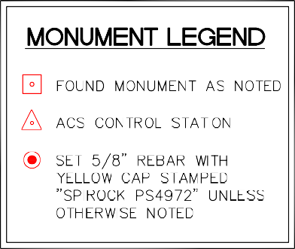

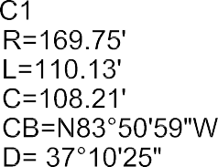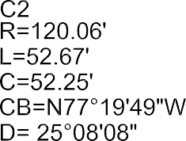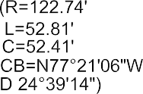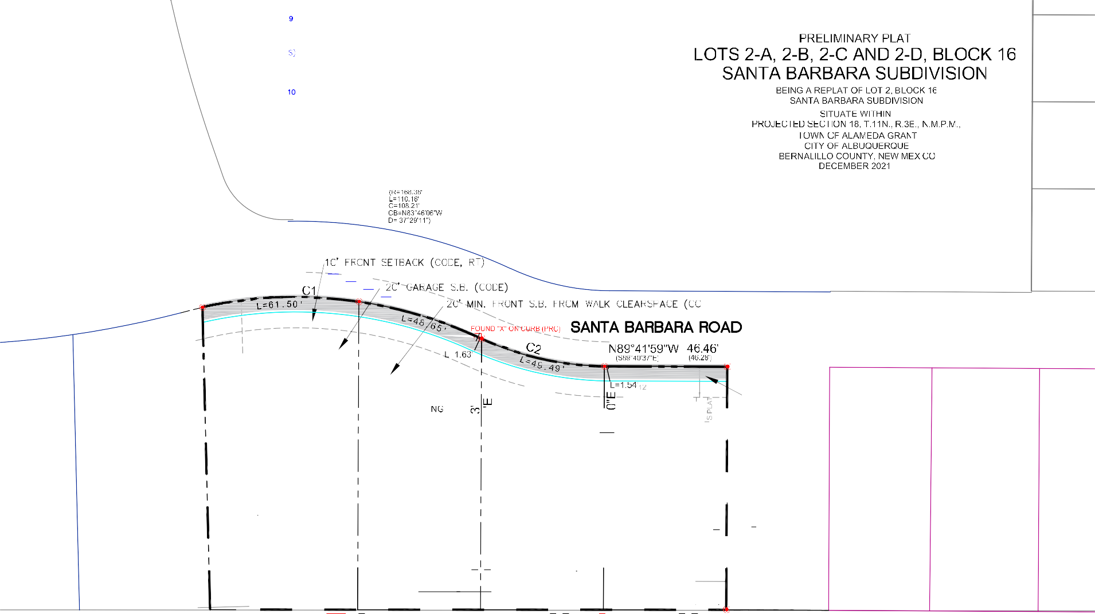

u

b.(o

b. <;) • ...,,,

" r:,:<':>'

*I* [<)').)

*'V*

G FND "X"

Lr\ I. *J-.J* IV *LU,,J,.J....J* \r\'vl\.J)

NMSP-C NAD83 (UsF):

Y=1,518,799.515 X=1,547,297.145 ORTHO. HT: 5378.235

COMB. G-G: 0.999655810

CONV: -0·1O' 46.2"

C1

PRELIMINARY PLAT

## LOTS 2-A, 2-8, 2-C AND 2-0, BLOCK 16 SANTA BARBARA SUBDIVISION

BEING A REPLAT OF LOT 2, BLOCK 16 SANTA BARBARA SUBDIVISION

POINT ON THE RETURN OF LOT 22, BLOCK 17

0

0

0

0

I

r-­ m ro

R=169.75' L=110.13'

SITUATE WITHIN

PROJECTED SECTION 18, T.11N., R.3E., N.M.P.M., TOWN OF ALAMEDA GRANT

CITY OF ALBUQUERQUE

BERNALILLO COUNTY, NEW MEXICO DECEMBER 2021

- -

20 0

10 20

,_ LO 0

LO

'--"

0u

-

><

U11l [M1. (Lf\S1J

\ *i*

SCALE: 1"= 20'

.-

**ROAD EMT.)**

10' GAS

- ..

FOUND "X" ON CURB

7' UTIL EMT.

(EXIST)

& WATER

EMT.

.(.EXIST)

# z

*[fl*

.....:l

0u

# z

-

0

E-<

LOT 4 LOT 3

SANTA BARBARA BLOC

17 LOTS 1 - 24 FILE

01-07-94

VOL 94C FOLIO 8

(WITHIN 6' CLEAR SPACE)

LOT 3

BLK 16

Santa Barbara Subd Lots

1-20

FILED 09-22-92 VOL 92C, FOLIO 206

LOT 4

0

P-.

0u

*[fl*

zu

-

#### u

*[fl*

>-<

-

E-<

HYPOTHETICAL 33.7' X 60'+ (LOT 2-D) EXTENDED PAD POTENTIAL - STD. 5' SIDE SETBACKS (INCL. DRAINAGE)

HYPOTHETICAL 33.7' X 54.4' PAD WITH 1500+

S.F. LOWER FLOOR FOOTPRINT INCL. GARAGE STD. 5' SIDE SETBACKS

DOMINGO BACA ARROYO (70' R/W)

LEGEND

SIGN

M FIRE HYDRANT

WwV WATER VALVE

@ SAS MANHOLE

* UTILITY PEDESTAL

WATER METER

'D...-, POWER POLE

0 TELECOM TRANSFORMER

**e** BOLLARD

*

SPIGOT

GAS METER RETAINING WALL

PAGE: SUPPLEMENT 1

# z

**NOTES:**

SUBMITTED AS A SKETCH PLAT FOR REVIEW AND COMMENT

**EXISTING CONDITIONS AND**

0

u

**THIS IS NOT A BOUNDARY SURVEY OR A RIGHT-OF-WAY SURVEY.**

PLAT REFERENCE: Lot 2 of the "Plat of Lots 1-24 (Inclusive) Block 17 Being a replat of Tract E-1 and Lots 1 and 2, Block 16 togerther with the vacated portion of Rancho de Palomas NE (V-93-59) , Albuquerque, New Mexico, July 1993" as the same are shown and designated on the plat thereof recorded in the office of t'4@ County Clerk,

**HYPOTHETICAL R-T ZONE DEVELOPMENT**

LOTS 2-A, 2-B, 2-C ANl'J 2-D, BLOCK 16

Santa Barbara Subdivision, Albuquerque, NM

APPARENT PROPERTY CORNERS, RIGHT-OF-WAY LINES OR PROPERTY LINES AS SHOWN ARE DERIVED FROM RECORD SURVEY PLATS,

Bernalillo County, New Mexico on January 7, 1994 in Plat Book 94C, Page 8 as document No. 94003225.

1. SITE WAS MEASURED BY "TRIMBLE VRS NOW" GNSS VIRTUAL REFERENCE SYSTEM. BEARINGS

DWG PAll,

GPS

F:\N679-RMH Development\N0679-01-860 P PLAT 11_2021 CAS.dwg

RIGHT-OF-WAY MAPS, OR DEEDS REFERENCED HEREON AND ARE NOT GUARANTEED OR TO BE RELIED ON FOR THE ESTABLISHMENT OF PROPERTY LINES.

ARE NEW MEXICO STATE PLANE BEARINGS, CENTRAL ZONE NAO 83.

1. ORTHOPHOTO IMAGE COURTESY OF MRCOG (2018)

DATE, 11/24/21

SCALE, 1" 20' CREW LRC

Community

ces

oration

RACHEL MATTHEW DEVELOPMENT

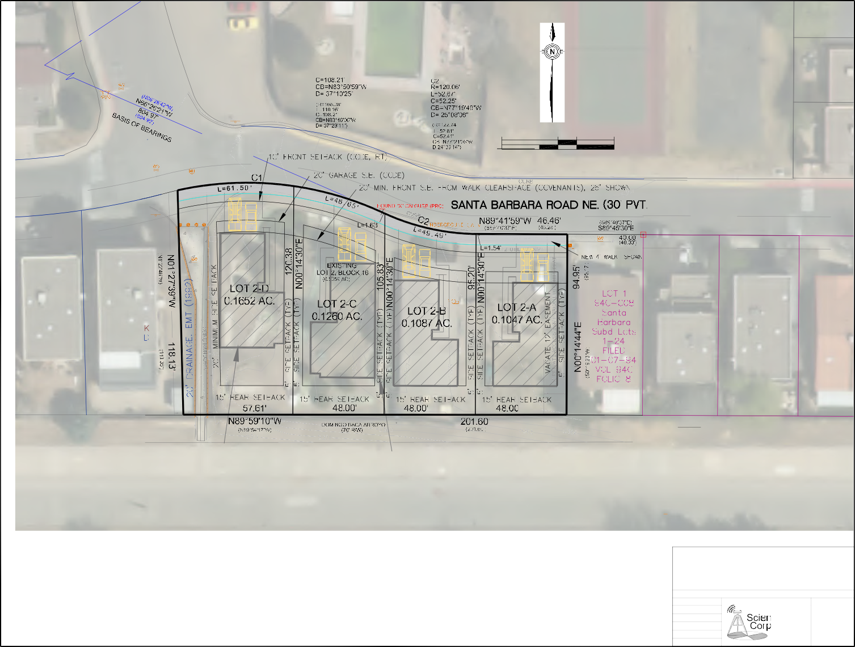DRAWN,

JOB NO.

CAS

Land Surveying

(505) 897.0000

CORPORATOIPN



August 17, 2021

Corrales, New Mexico 87048

Rachel Matthew Family of Companies 2600 Americas Road Suite #103

Rio Rancho, New Mexico 87124

Subject: Letter Authority for surveying and consulting services, Santa Barbara proposed subdivision, Albuquerque, New Mexico

To whom it may concern:

Please be advised that Community Sciences Corporation, Corrales, New Mexico is under an on-going contract with Rachel Matthew Development and Desert Sage Custom Homes. As part of this engagement, we have been retained to provide our services on: Santa Barbara Subdivision, Albuquerque, New Mexico.

Information on our Professional Liability Insurance and other coverages can be provided upon request.

If you have any questions, please call me at (505) 897-0000 or our president, Clifford F. Spirock at the same number.

Respectfully,

Cliff A. Spirock, Board Chairman NM PLS #4972

Cc: Elisa Cardenas, Rachel Matthew group

PRE-APPLICATION REVIEW TEAM (PRT) MEETING NOTES

PA# 21-221 Date: 10/26/21 Time: N/A (sent via email to )

Address: 7300 Santa Barbara Rd NE

*AGENCY REPRESENTATIVES*

Planning: Catalina Lehner (clehner@cabq.gov) James Aranda (jmaranda@cabq.gov) Zoning/Code Enforcement: Angelo Metzgar (ametzgar@cabq.gov)

Fire Marshal: Antonio Chinchilla (achinchilla@cabq.gov) or call 505-924-3611 (if needed) Transportation: [Jeanne Wolfenbarger (jwolfenbarger@cabq.gov](mailto:JeanneWolfenbarger(jwolfenbarger@cabq.gov) )

Hydrology: Ernest Armijo, P.E. (earmijo@cabq.gov) Solid Waste: Herman Gallegos (hgallegos@cabq.gov)

Water Authority: David Gutierrez - [dggutierrez@abcwua.org](mailto:dggutierrez@abcwua.org) or call 505.289.3307; 505.241.9630

*PRT DISCUSSIONS ARE FOR INFORMATIONAL PURPOSES ONLY!*

*THEY ARE NON-BINDING AND DO NOT CONSTITUTE ANY KIND OF APPROVAL.*

*Additional research may be necessary to determine the exact type of application and/or process needed. Factors unknown at this time and/or thought of as minor could become significant as the case progresses.*

*REQUEST:* 4 Dwelling Units +- 2,000 SF.

*SITE INFORMATION:*

Zone: R-T Size: Approx. 0.50 acre

Use: Residential- Townhouse Overlay zone: N/A

Comp Plan Area of: Consistency Comp Plan Corridor: N/A

Comp Plan Center: N/A MPOS or Sensitive Lands: X Flood zone

Parking: 14-16 5-5

Landscaping: 14-16 5-6 Use Specific Standards: Allowable Uses, Table 4-2-1

MR Area: North Albuquerque Street Trees: 14-16 5-6(D)(1)

Dimensional Standards: 5-1-1: Residential Zone District Dimensional Standards

*Neighborhood Organization/s: District 4 Coalition Neighborhood Associations, North Wyoming NA

*\*This is preliminary information only. Neighborhood Organization information is only accurate when obtained from the Office of Neighborhood Coordination (ONC) at* [*www.cabq.gov/neighborhoods.resources.*](http://www.cabq.gov/neighborhoods.resources)

*PROCESS:*

Type of Action: 6-5(G) Site Plan- Administrative

Review and Approval Body: Staff Is this a PRT requirement? No (Table 6-1-1)

*PRT NOTES FORM-UPDATED 032420.DOCX PAGE 1*

PRE-APPLICATION REVIEW TEAM (PRT) MEETING NOTES

PA# 21-221

Address: 7300 Santa Barbara Rd NE

Date: 10/26/21

Time: N/A (sent via email)

*NOTES:*

See the Integrated Development Ordinance

https://documents.cabq.gov/planning/IDO/IDO-2019-Effective-2020-11-02.pdf

Download Forms & Applications

https://[www.cabq.gov/planning/online-forms](http://www.cabq.gov/planning/online-forms)

New Public Notice Forms

We have created forms for all email/mailed public notice and for Pre-submittal Neighborhood Meetings. Please complete these forms for public notice:

* Neighborhood Meeting - <http://www.cabq.gov/planning/urban-design-development/neighborhood-> meeting-requirement-in-the-integrated-development-ordinance
* Public Notice - <http://www.cabq.gov/planning/urban-design-development/public-notice>

Records requests

To request a site plan and/or Notice of Decision, please use ABQ Records web page: https://[www.cabq.gov/clerk/public-records](http://www.cabq.gov/clerk/public-records)

Please include the site’s address and the Case Tracking #s (see Zoning Comments) in your request.

Requests to Inspect Public Records

Any person may submit their request to inspect public records to the Office of the City Clerk by clicking on the following link to request records using our ABQ Records portal. https://cabq.nextrequest.com/

This enables us to respond to requests in the order in which they are received. Plus, it's a better way to share large files.

File Submittal

For Administrative Amendments, DRB, EPC, hydrology and traffic submittals, e-mail electronic files to [PLNDRS@cabq.gov.](mailto:PLNDRS@cabq.gov) For questions about an application submittal or the submittal process itself, please contact Jay Rodenbeck at [jrodenbeck@cabq.gov](mailto:jrodenbeck@cabq.gov) and/or to Maggie Gould at [mgould@cabq.gov.](mailto:mgould@cabq.gov)

For other questions, please contact the Planning representative at the top of the PRT Notes.

For Building Safety Plan Review, contact Building Safety at 924-3963. Website: https://[www.cabq.gov/planning/building-safety-permits](http://www.cabq.gov/planning/building-safety-permits)

*PRT NOTES FORM-UPDATED 032420.DOCX PAGE 2*

PRE-APPLICATION REVIEW TEAM (PRT) MEETING NOTES

PA# 21-221

Address: 7300 Santa Barbara Rd NE

Date: 10/26/21

Time: N/A (sent via email)

Zoning Comments PRT 21-221

PROPERTY INFORMATION

* Address: 7300 Santa Barbara Rd. NE
* Lot: 2 Block: 17
* Subdivision: Santa Barbara
* Type: Consistency
* Calculated GIS Acres: 0.50
* IDO Zoning: R-T
* Old Zoning Designation: SU-1
* Old Zoning Description: PRD
* Old Zoning Category: Residential

CASE HISTORY

* N/A

ALLOWABLE USE(S)

* Dwelling, townhouse-Permissive use

USE SPECIFIC STANDARDS

* 4-3(B)(5)

DEFINITIONS

* Dwelling, Townhouse- A group of 3 or more dwelling units divided from each other by vertical common walls, each having a separate entrance leading directly to the outdoors at ground level. For the purposes of this IDO, this use is considered a type of low-density residential development, whether the townhouses are platted on separate lots or not. See also Development Definitions for Low-density Residential.
* DEVELOPMENT STANDARDS
* N/A

APPLICANT’S QUESTIONS

* Please refer to IDO 14-16-2-3(D)(2) for development standard.

PROCESS

6-5(G) Site Plan- Administrative

*As always, if you have specific questions pertaining to zoning and/or development standards you are encouraged to reach out to the zoning counter at (505) 924-3857 option 1.*

*PRT NOTES FORM-UPDATED 032420.DOCX PAGE 3*

PRE-APPLICATION REVIEW TEAM (PRT) MEETING NOTES

PA# 21-221

Address: 7300 Santa Barbara Rd NE

Date: 10/26/21

Time: N/A (sent via email)

Transportation Development Comments

PRT 21-221 (Santa Barbara Road NE.)

Information for Site Development – Transportation Development

For additional information contact Nilo Salgado (924-3630) or Jeanne Wolfenbarger (924-3991)

General Comments for private street (If applicable):

Curb Cuts

* Follow DPM guidelines for residential curb cuts.
* Location of drive with respect to intersection depends on classification of the street. (See attached table.) Classification of street is according to the Long Range Master Plan developed by MRCOG.

Clear Sight Triangle at Access Points and Intersections

* Clear sight triangle (See attached hand-outs.) Nothing opaque should be in the triangle.

Private Site and Parking Lot Design

* Shared access/parking agreement is required if access/parking is shared with parking lot adjacent to site. (This can be established on a plat if submittal of a plat is required or by an agreement.)
* Existing driveways that are not being used are required to be removed and replaced with standard curb and sidewalk to match existing.

Traffic Studies

Platting and Public Infrastructure Requirements for Roadways

* When submitting to DRB, all public roadway improvements that are required shall be shown on an infrastructure list. Public improvements must be included on a public work order set of drawings.
* All public/PRIVATE roadway facilities must be within public right-of-way including the entire width of the public sidewalk, all public curb ramps, overhead utilities, traffic signals and lighting, etc.
* Curb and sidewalk are required along entire frontage of property. Follow IDO/DPM for specific width requirements.
* Depending on site’s use of an adjacent alleyway and on type of use for proposed site, alleyway improvements are required. This would include paving and/or proper right-of-way dedication to meet current width standards.
* For any private access easements on plats, all beneficiaries and maintenance responsibilities must be listed.
* Due to sight distance concerns and to construct sufficient curb ramps, right-of-way dedication is required to add curves to corners of properties at intersections if they are not already developed. See Table 23.3 of the DPM.

*PRT NOTES FORM-UPDATED 032420.DOCX PAGE 4*

PRE-APPLICATION REVIEW TEAM (PRT) MEETING NOTES

PA# 21-221

Address: 7300 Santa Barbara Rd NE

Date: 10/26/21

Time: N/A (sent via email)

* Any private structures that are located within public right-of-way such as fences and walls shall either be removed or else a revocable permit with the City is required in which an annual fee is paid per year, based on square footage of the encroachment.

*If you would have additional questions or would like to schedule a follow-up Zoom meeting please contact Diego Ewell at* [*dewell@cabq.gov*](mailto:dewell@cabq.gov)

*PRT NOTES FORM-UPDATED 032420.DOCX PAGE 5*

c--

l I

i ,,1,

***'1¥c..-8(1)***

_11- *.t*

.. 1

......,,<;, "" ,...,a

,..

J._j

"'°"'

SU•I

Ln=fl.

irr

-.

**Rf1** l'A'xI'ffil' RfIEASE IIPROll\[,

R.tilic *SeclfkE* Cl::lq:a"f of *1'e,i* l'1e-.dro ooes *hera::rj* ceJ.ea9e, waive, q.a.tcl.airo arrl discmr.ge its rig-c, title arrl

in:emst in tre wsenrts {grabrl bf s;rioc plat, aplat oc dn.nat:) sonto be llinll:Erl en this plat.

RJILIC Sl'RV1IB <OHN!i *CJ!* N;W l'EXlCD Sj

### PLAT OF

*LOTS 1 THRU 24*

**ft** ' •'),I <n

V\11't..t,.r1 e,

0(1\' .1) =--

### (INCLUSIVE), BLOCK 17

r ........

1!

ti

1

1 aEPLAf

" 1, SV•I

1=-=

........

SU-•

**tEha1.f oc** said axpxaticn.

*BEING A REPLAT OF TRACT E-1* & *LOTS 1* &

SlfflE *CJ!* **N;W** ltlXICD_ ) ffi

<Il.NIY *CJ!* EBUILIUO.I .

**'lhe** fux,::pirg instnaatt W3S l:iefu:e ma en this *'faf* of= '1933' bf

;of Ire f\hli.c Secv:ioo Ck:nµr:ly of **N,w** M:,,dro, a l'e,11'£,rlcn O::qxJcaticn, en

### SANTA BARBARA SUBDIVISION WITHIN PROJECTED SEC.19,T.11 N,R.4

### E.,NM.P.M.

*2, BLOCK 16*

N fH

CJ I M080LE

Pk-,?ll PARK

*_!l* • I

*w-,*

Omniss:im expices -----------

N:x:aryE\blic

### TOGETHER **WITH** THE VACATED PORTION OF RANCHO DE PALOMAS N.E. (V-93-58)

*ALBUQUERQUE, NEW MEXICO*

:> '' of New Mexico } SS

*c ::Jr:iy* of Bernalillo

Tl11s instrument was filed for recoro on

I 11 - ·-·---•

-

"'l

JVW

### JULY, 1993

LJ·"t .......

R*Ir·*. r

•·• !;

,._., ":)!; UN.IT 1

1

...,... -,,-M ::.:.

AN - ',7r,,cj Ol/_C.

/i o·c1oc;.;-?,-m Recorded ,n Voiil

oi rt·cords of saio County Fc1io

jJ· :·- ·.

*w•.*

· *.JJ?.UI* MJ

LEGAL DESCRIPTION:

*sq:*2.,

"0,).JooA,•.J. Clerk & Reeo,der

I -

*-<:)* , .• , ···- · TTT.l 8

- *§- i*

U±LUJ 111 M 111 l:J- ,

***N.,;S,*** *P-19*

SUBDIVISIOO DATA:

*1..* DRS No.

2. Zone At"'l_as_I=-nd-.e-x--:,No:--.-:::D--1"9;<---

1. Gross Subdivision Acres 2.7107
2. Total No. of Lots created 24.

A certain parcel of land situate within the Elena Gallegos Grant in projected Section 19, Township 11 North, Range **4** East, N.M.P.M., City of Albuquerque, Bernalillo County, New Mexico, being **a** replat of Tract E-1 of SANTA BARBARA SUBDIVISION, as the same is shown and designated on the plat thereof, filed in the office of the County Clerk of Bernalillo county, New Mexico, on January 21, 1986 in Volume C-29, Folio 85, Lots 1 and 2, Block 16 of SANTA BARBARA SUBDIVISION, as the same is shown and designated on the plat thereof, filed in the office of the county Clerk of Bernalillo County, New Mexico, on September 22, 1992 in Volume 92C, Folio 206, together with th_evacated portion of Rancho De Palo111as, 11.E v, acated by ordinance No. V-93-58, **said** tract of land being more particularly described as follows: Beginning at the Northeast corner of the parcel herein described, whence "NGS" Sta. "HEAVEN, 1969 bears N, 15 deg. 46' 08" E., 1166,60 feet distance,said corner being common to the Northwest corner of Lot 3, Block 16, SANTA

APPROVALS :

'"" oo.

- ;&.

TRAFFIC ENGINEER

P***G***AIU; A***n***ND***J***. ***fJf':::t rus***

*II*

-- .0:T.::y *Cierk*

***ltt:>i-9J***

DATE

*II-&- q.3*

DATE

1. Total mileage of Privated 5Ei'eets 6. Talcs No. 93081816140451

NOTES:

created 0.0

BARBARA SUDDIVISION, as the same is shown and designated on the plat thereof, filed in the office of the county Clerk of Bernalillo County, New Mexico, on September 22, 1992, said corner also being **a** point on the Southerly Right-of-Way line of Santa Barbara Road, N.E.; thence runnings. oo deg. 19' 23" w., 94.96

DATE

***--94***

1. Basis of bearings: Santa Barbara Subdivision, filed 1/21/86, V. C-29, F. 85.
2. Distances are ground distances.
3. Searings are grid.
4. Boundary corners set or found as f1hown hereon, lot corners to be set within one year of plat approval.
5. Plat shows all easements of record.

DISCLOSURE STATEMENT: The purpose of this plat is to subdivide Tract E-1 into 22 lots, to replat Lots l & 2 Block 16, to vacate a portion of Ranchos De Palomas, N.E. and to vacate and

create easements as shown hereon.

feet distance along the Westerly boundary line of said Lot 3 to the Southeast corner of the parcel herein described, said corner being **a** point on the Northerly Right-of-Way line of the Domingo Daca Arroyo; thence N. 89 deg. 54' 17" **W.,** 683.19 feet distance along the Northerly Right-of-Way line of the Domingo Daca Arroyo to **a** point of curve; thence 190.62 feet along **a** curve to the right having **a** radius of 248.70

feet, **a** central angle of 43 deg. 54' 55'', and **a** chord bearing and distance of N. 67 deg, 56' 50'' w.,

185.99 feet continuing along the Northerly Right-of-Way of the Domingo Daca Arroyo to **a** point of tangency; thence N. oo deg. 08' 23'' E,, 44.25 feet distance to an angle point; thence N. 41 deg. 101 03'' w., 224.15 feet distance to an angle point; thence N. 00 deg. 08' 23" E., 170.00 feet distance to the Northwest corner of the parcel herein described, said corner being **a** point on the Southerly Right-of-Way line of Dobwhite Lane, !l.E.; thence s. 89 deg. 51' 37" E., 102,94 feet distance along the southerly

Right-of-Way line of Bobwhite Lane, ?LE. to **a** point of curve; thence 39.27 feet distance along **a** curve to

the right having **a** radius of 25.00 feet, **a** central angle of 90 deg. oo• OO", and **a** chord benring and

·5@1ecu

j;. l,o.

PROPERTY MANAGF.MENT

i

A. Mn.A.F.C.A. *vf*

*r'*

CI

DATE

*'l-14-,.,*

DATE

*I -5'-";1*

DATE

l

*{- S'-C,1*

DATE

RU.JC mn.:tIY **eA'Ht:NIS** en this plat *ace* as **SDi'l arrl** fuc **the** =

**arrl** *pint* use of: 1. R.tilic Secvioa Cl:opn/ of ***l'e,i*** l'exi.<D fuc the inst.all­

atial, aainbnaroe, arrl service of a..e:hB:J arrl electrial lines,

l:alnsfi:xm:c,, fOl,es arrl *arrt* otner a:pipm:t, fixt:u:e:;, st:r.U'.:t:lre9 arrl

distance of o. **44** deg. 51' 37'' E., 35.36 feet distance to **a** point of tangency, snid point being on tl1e Westerly Right-of-Way line of Whippoorwill Lane, N.E.; thence s. 00 deg. 08' 23" w., 114.01 feet distance along the Westerly Right-of-Way line of Whippoorwill Lane, N.E. to **a** point of curve; thence 122.93 feet distance along **a** curve to the left having **a** radius of 217.76, **a** central angle of 32 deg, 201 39", and **a**

chord bearing and distance of s. 16 deg. 01• 56'' E,, 121,30 feet distance along the Westerly Right-of-Vay

,/- c ,_,,_,

celat.a:1 fa::ilities oo: ry to (X1'lllida electrial secv.ioe. 2. U.S. lies!:

line of Whippoorwill Lane, n.E. to **a** point of tangency; thence s. 32 deg, 121 16'' E,, 70.81 feet distance

PU S VICE OF **NEW** C()"

DATE

fur the jn&aJJatim, aaintaure, arrl secv.ioe of all b.riErl arrl aecial

O'JIIIU'li.cat:im lines arrl cther relal:a:3 8'.}Ii[DB't ard fa:::i.tit:im r nbly

,.. ry to (X1'lllida CX'Jlmnicatiai secvioee, :i.rx:lu:nn;J bJy mt limita:I

to gcam perlastal.s arrl clcaxes. 3• .J:nas IntercBhle fuc tre in­ sit:allatim, DBints'eroe, arrl serive of s.rlt lines, at:,l.e, ard cther laten 8'.}D[IIB'C arrl facilities cau:.:.:blt ,.. ry to (X1'lllida at:,1e *'N* secv.ioe. Jn:.luirl is the ri\j:E to b.tild, cetui.ld, <X:retr:u::t, i:ea::n­

along the Westerly Right-of-Way line of Whippoorwill Lane, N,E, to **a** point of curve; thence 66,16 feet distance along **a** curve to the left having **a** radius of 99.76 feet, a central angle of 37 d g. 59' SO'', n1 **a** chord bearing and distance of 51 deg, 12• 11" E,, **64.95** feet along the Southerly Right-of-Way line of Whippoorwill Lane, H.E. to **a** point of curve; thence 102,75 feet distance along **a** curve to the left having **a** radius of 325.86 feet, **a** central_angle of 18 deg. 031 59'', and a chord bearinif and distance of s. 79 deg. 14' 06" E,, 102.32 feet distance along the southerly Right-of-Way line of Whippoorwill Lane, N.E.;

thence 114,05 feet distance along **a** curve to the left having **a** radius of 529,14, **a** central angle of 12

- -vtj*c:::Cl i._*

.1WP.ST

,.

*P _*L>ISC.,\.JMtR.

*lva-r k L*u L.

9- *--93*

DATE

stax:t, locate, n>Jocate, c:tage, , m:rlify, *t:alE.<ol,* qa:ate, ard

naintain fa::ilities fur the p.rpcses deocriba:I , ID}al.hec with fu3e acx:ess to, fron, arrl *c::,,,ec* said 1ets, irx:h.rlirg slfficieoc w:x1cirg arm SfBCJe fuc elect:ric b:a e6 cne s, with the r:ig1: arrl

i;rivilege to trim arrl trees, snm oc b:Eres "1irll interfere

with the ,:..,:p.::un .a: fu:th te:ein. N;) ruildirg, si.91., µ:ol (

geom oc StiJarfaoe), rot bb, mu.a:., cc w::x:d µ:ol oodcinJ, oc

ether st:cu::tLlte mtll beerect.al OC a:mt:ru:::ta'l en said OXUIJC! UX'

mill. *a:rj* \olill be dr:iJJa:'! OC cp?Cated tte:a:11. PtqJecty **a.leC3** SBil

be*silej* ce:µ:usilile fur axrect:mJ ***<1ff*** vialatims of tltiaBl

deg. 20• 59'', and a chord bearing and distance of N. 85 deg. 33' 35'' E., 113,83 feet distance along the southerly Right-of-Way line of Whippoorwill Lane, N.E.; thence 186.64 feet distance along **a** curve to the right having **a** radius of 998.19 feet distance, **a** central angle of 10 deg. 421 47", and a chord bearing and distance of N. 84 deg. **44'** 19'' E., 186.37 feet distance along the southerly Right-of-Way line of Whippoorwill Lane, N.E.; thence 101.60 feet distance along a curve to the left having **a** r4dius of 409.70 feet distance, **a** central angle of 14 deg. 12• 31", and a chord bearing and distance of N. 82 deg. 591 2011 E., 101,34 feet distance along the Southerly Right-of-Way line of Whippoorwill Laue, N.E.; thence 118.93 feet distance along **a** curve to the right having **a** radius of 168.38 feet distance, **a** central 1gle of 40 deg. 28' 14", and **a** chord llearing and distance of IJ. 85 deg. 15' 35" E., 116,48 feet distance alOh':/ the

By.oc1«i',"• :. n1-, .},-!f'-.,.m.-,tlr Y?...;r.·,-·k.J'W''·i<)T '-'t\f"" *;_,:t* <1,k

t1nya1t,rr,._,/'!;..:,.,*;,. :iu.r.,,:* d -.\t" 'lt't..f· :wi:y ,..,. " """t- : xy

prior pl!lt, "'O(><M, -."'1' ,,_ ....

;/f'<: .

###### · % i t}

irliS:, *TO* CERTIFY*THAT* TAXES ARE CURRENT ANI;

."JO DN UPC *f'* :,,!)>L --

*"v*

Ele:::trical Safety O:rle <Bl9Erl bf a:mtru:tim of µ:ols, oodcinJ, oc

stru::l.lxes adjacent to, within oc 003C' 1e **ts :b:w!** en the plat.

southerly Right-of-Way line of Santa Barbara Road, N.E.; thence 52.81 feet distance along a curve to the left, having **a** radius of 122.74 feet distance, a central angle of 24 deg. 39'09", and **a** chord bearing and

- ··r-r:·.-rr1·vr1t,,,pi;p o:: PF''Qf>/'I.

'('(c·,:•, ,• ,,. ".' •, ,,,<,,

v...&9.-hcµ.e_ _.d-

_(' A

distance of s. 77 deg. 18' 59" E., 52.40 feet distance along the Southerly Right-of-Way line of Santa Barbara Road, N.E. to **a** point of tangency; thence S. 89 deg. 40' 37'' E., 86.28 feet distance along the Southerly Right-of-Way line of Santa Barbara Road, N,E. to the Northeast corner and place of beginning,

_ and containing 2.7107 acres, more or less.

-·' '·· ;; *:_,...,,,,..,..'* ·ury ··1) ,, <'l!;:cR.:z- CJ'"';:.

:_..,:;;,'I...J<>.<-J

FREE CCfiSENT AND DEDICATION:

The subdivision of land herin described is with the free consent of and in accordance with the wishes and desires of the under signed owners and proprietors thereof. No portion of the land is designated for public use except for a 12' public access

easement within the Easterly boundary of Lot 2, all streets shown hereon {whether designated as a street, lane, place, court, . -·--·-

tsxGas r,;,

drive_ or road) are private ways. Water line nt.s noted as being or the City of Albuque e are for the exc usive use by *.( j;* . -

the City of Al 7rque,for pla t main,tenance of such water lines. All other water lines and all sewer lines are privately 1:,,'-·>- ,f_r, *Af,:.,*

owned and are within private utility

Telephone Power and Cable Television subsurface utilities are owned and main- 2;'

*'--:fffY,, .;,*\

tained by the utility coopany. *I\/* Q '\ \ ,

FAOCO BUILDER, INC.

*(* .*\*_ !*'*

. SURVEYOR'S CERTIFICATIOO: \ *\.*"*.*iO*..*O*_*?*,*, *)*

*I*1*?'::* [ *j*

Allan Boyar, Pres1 I, Douglas H. Smith, New Mexico Professional Surveyor No. 7002, hereby certif t this/.::.;) STATE OF NEW MEXIOO plat was prepared from field notes of an actual ground *survey* performed by me ot:,,

>ss r·tef'--'°"',.

O'.XJNTY OF llERNALIC.LO) *u*

The foregoing instrument was acknowledged before me by Allan Boyar by the **New** Mexico State Board of Registration for Professional Engineers and r.and surveyors;

on this 25th day of August, 1993. .

**My** Comni.ssion Expires January 11, 1995. */*

*--- '(* Subdivision Ordinance; and that the same is true and correct to the bast of my belief and

direct supervision; that it meets the Standards for Land Surveys in New Mexico as adopted

that it meets the minilll.nn requirements for surveys and monumentation of the Albuquerque

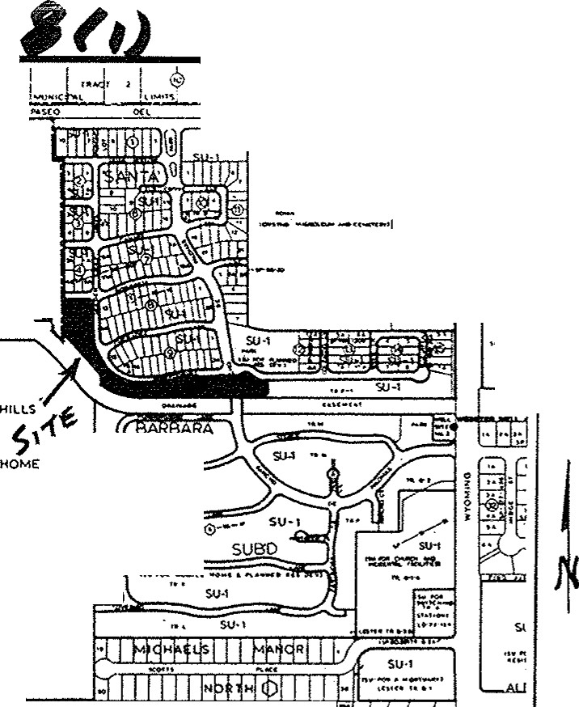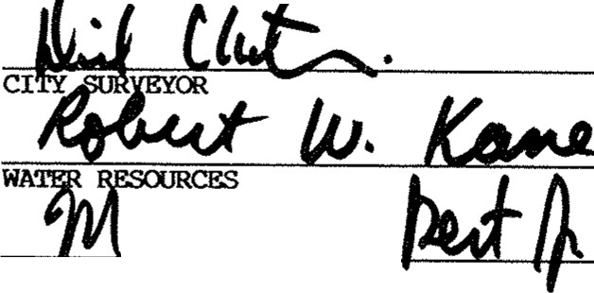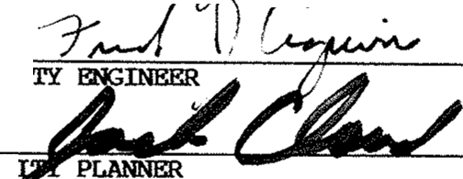

***9 -,r,)***

- - .--., knowledge

*d :?a.,f ,r'1,,sC}*

*:s*,;,:_,,

*/*

Douglas H. Smith, N.M.P.S. No. 7002 .•.,..,.,

**EAS!lMENT l!Cl'ES:**

I

l} 12' Existing utility esmt. as per plat filed 1/21/86,

-.- Vol. C29, folio 85.

***1***

2) 15' Existing utility esmt. as per plat filed 1/21/86, Vol. C29, folio 85.

3} 10' Existing utility esmt. as per plat filed 1/21/136, Vol. C29, folio 05.

**4}** 20' Existing utility **esmt.** as per plat filed 1/21/86,

Vol. C29, folio 85.

5) Portion of Rancho De PalOIIBB to be vacated by this plat (V-93-50}.

6} Existing drainage esmt. as per plat filed 1/21/86,

Vol. C29, folio 85 to be vacated by this plat (V-93-58).

7} Existing 20' utility esmt. as per plat filed 1/21/86, Vol. C29, folio 85 to be vacated by this plat (V-93--58).

0} ao' Water line esmt. to ·be gronted to the City of Albuquerque by this plot. (Public)

9) 12' Utility eamt. to be granted by this plat.

10} 16' drainage eamt. to be granted by this plat.( PRIVATE)

1. Existing 2q'droinoge esmt. as per plot filed 9/22/92
2. Existing 20 water line esmt. ( City *oj* AlbuQ )as per plot filed 1/21/86

ACS STA. 1-C19, 1969

*PLAT OF* **94003225**

LOTS 1 THRU 24 (INCLUSIVE), BLOCK 17 SANTA BARBARA SUBDIVISION

**i**

*WITHIN PROJECTED SEC.19, T.11 N.,R.4 E.,N.M.P.M.*

***i***

*BEING A REPLAT OF TRACT E-1* & *LOTS 1* & *2, BLOCK 16 TOGETHER WITH THE VACATED PORTION* ;Q:f◊ i' , r /go}ss

**l**

***RANCHO DE PALOMAS N. E.*** *(* ***V*** - ***9 3- 5 8)*** Tlus instrument was filed tor record on

***ALBUQUERQUE, NEW MEXICO ;,o-':'*** -· 71nn4 G

*JU****LY, 199 3*** Ai!:'. o croc m Recorcec '" *v2 '-\-*

or rt:coros of saia County Foi1o

*4*

*y*_j *h* n

---\ *Ooci. . Clerk* & *Recorder*

*C!erk*

CURVE TABLE

*1,-*

N.A.D. 1927 **X=404941.91 Y=1518845.74** *GROUND-TO-GRID* **0.99965598**

N.M.' CENTRAL ZONE DELTA ALPHA

,.-00·11·00"

1 BLOCK **4**

w

:z

oii,: 'l' I

l

WD.

]> GO**P')**

BLOCK 7, SANTA BARBARA *SUBDIVISION*

FILED: JANUARY *21,* 1986 VOL. C-29, FOLIO 85

GRAPHIC



!E

t

SCALE

**RADIUS**

**25.0Q**

***TANGENT***

­

*?? .s*

Lw....._,

J- D. :z

w

a

.....- , £. ?f' **a\e)**

--------- - "\'-It, I .

"" 0

**215** ""

100 **200**

I

I

,.;, *iJ, I* t.V v. f I I• , I I .;J ,.,;;, C,.

**1 S *7* -to** .,.., r ,.

**'IP.-.r**- 'l 1-, **aT T.E""** ,... -••

*Vo.--.*

BOBWHITE LANE N.E.(Pnvote)I (30' **P/W***J*

S 89"51'37" E **102.94'** -

8-

_J

0

4nd

1306 1; • \,yj)

,, ,,

)(

( IN **1'DT** )

1 inch = 60 ft.

L·t ' n te 9. II ir .

0 (\j **Q)** • (.) o I o

fl!

.!)0 • ..., O 0 0,-: :,: 0

Q)Q O o 0

(\j I

LI'-.N• t:o•

(() (,,"\,j.0)

* P') :i; C\j

.,C\j

..., (/J " ***-i***

I()

f--0) *-i*

Q) .

I

(I) ,-.J

0) 00

_J •

oi of-c- s1 f*:*-*t*-*o*0*o*)

0 _J ci;:: _J 0 •

- I I

ffi

.

w

**t**

1-1- 20.0' ••• **note *4***

I I

Lt

OC\l

.!) 0

I.."

(**P**\**'**j**)** .

* + **P')**

.

0(() ,,,..

0.

0

Jl

**see** note 2

LOT 21

0.1305 ac.

127.94'

BLOCK 8, SANTA BARBARA *SUBDIVISION*

FILED: JANUARY *21,* 1986 VOL. C-29, FOLIO 85

JI ..

)(

Q)0

..., vi

Q) .

f/) ,.J

,



N 89"51'37" ***W***

LOT 20 \

15_99• 0.1265 ac.

' 121.67' \\

*'5"?'\_* N 89"51'37" ***W***

##### /\.,I'- ;

\. (\

-

-

. ..,o ***e'***

--

l / "' \,,1/--s Hr. ***l.t.***

12.0

see note *1*

*·o* LOT 19

1., - "'- 0.1100 ac.

*??:,. 105.11* •

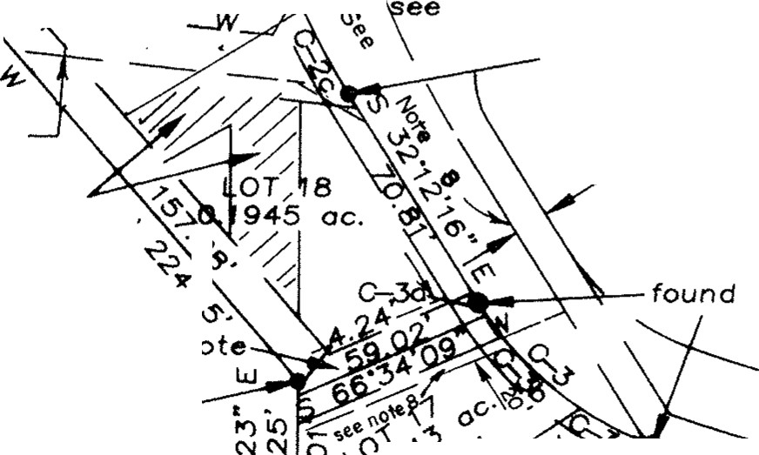0*o*-*.*,*.,*-*....*8.3:33'.Ja" ..

./ l'-0 • /

...c,,0.,-'cv--' '-'!Jo ./

n

0 -;

*r'* 0 ­

. ...

UQI \"'' \ "

-u ..,

,. '

.,, )>

. . \(002},1\ ,f

-- ..>"

\

***;t;*** .

NGS STA. "HEAVEN",

N.A.D. 1927 X=407051.31 Y=1518737.03 *GROUND-TO-GRID*

0.99965263

1969

*I*

* 1. o• see note 10

see notes T,

found "x"

10. 0' see note 3

BLOCK 9, SANTA BARBARA *SUBDIVISION*

FILED: JANUARY 21, 1986 VOL. C-29, FOLIO 85

* + 1. 0

--../

\

#### ti

)

-z.

I'\

set rebar

***N.M.*** CENTRAL ZONE DELTA ALPHA

-00·10•45"

*1*

. (()

*<o:*

*1/'*

*6* & 7

*o*-

*'?.*

*'\'*/ 4I5

ft ..

--

)(

"LS.7002"

_/

----

found rebar /

"L.S. 7002"

1/) ,-._

,-._ ,-._

set rebar

"LS. 7002"

. i-·"01

.. - _ WHIPPOOR LL_ LANE N.E.(Privote)'· ; U:J =i= ::;:e-a::f::V:O Uril'.'.:Q::\_ Lr::.u.<--r 20 */),* ::; , ***s***

cao'p1wr:-- -

**SANTA** BARB'ARA RO. found rebar

*_J.* s.

_ , ( **Private)** /"L. 7002"

' ,."89"40'37" E86.2

o , (30 ***P,W)*** see / . //\ 120_) **ee** - . -,u,- .v • IC>

O· - ***':, E,*** *cl;,-,* found **x** G-5 C/J Vl Vl C/J C/J C/J e ,1 / / · *note*

_.

o o" "o 1o ·· . (/J (/J O o O o o o o *9* o o 9 *.,.:* / /

***7*** :3 W

***9*** : ,, "'a. I. . **-i-** 0:::

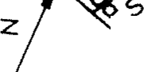o - ....,01'?3 **E,·** ·'='" o" · , *(j* .:tc-sa . o O *o9 g9* <0 or Oro Or Oro :...r Ol % • : P'). g Ol 10 '-.Q

C' O *l::"1-8·* - § ij §i ! g ///re;O,; te 5 LOT *2*:.; : o 'l':"" o j *p ! ;* !§; ;i /. : \ :i ! ,' ! g

*I* • **'It** O - (() 0) v- 1-- "" ,,,. (() f--1'-. (Jl (() • 0) C0 • 0) 0 • • 0 • *i* O • ; Q ; ;; t / / 0 5059 QC *g* Q Q (\j Q

set rebar - **t>.**'O *"j* ...., (? *t° to* 0*1*0*-..f\ f* ·"" 0 i,, "- Oo · Ola .O a 'g 'f> • f> f> f> rr, f> · !X> **r-,---**'20.0'•ee oote rt • :: a" IO ci 0l P') a

"Ls 7002" C' 0 ° *(y*

***"I-*** -.J0• 0 _Jci 'f> f> rr,. rr, rr, rr, rr, (,4 1/0/. . . : *2* .a:o:: ..,. r f-.ZJ.u_j

· · 0 o· rri 01 / / *-..J* <:'.!" "- o <.Jo



TALOS LOG#

Oe **4.48** *Cl)* 55.00' (/J 45.00' 18.01' 38.01' 38.01' 38.01' 38.01' 38.01' 38.01' 51.02' ·/ *1/j* 201.60' 40.00' 0 SC/JG:>

N 89"54'17" W 683.19'

93081816140451

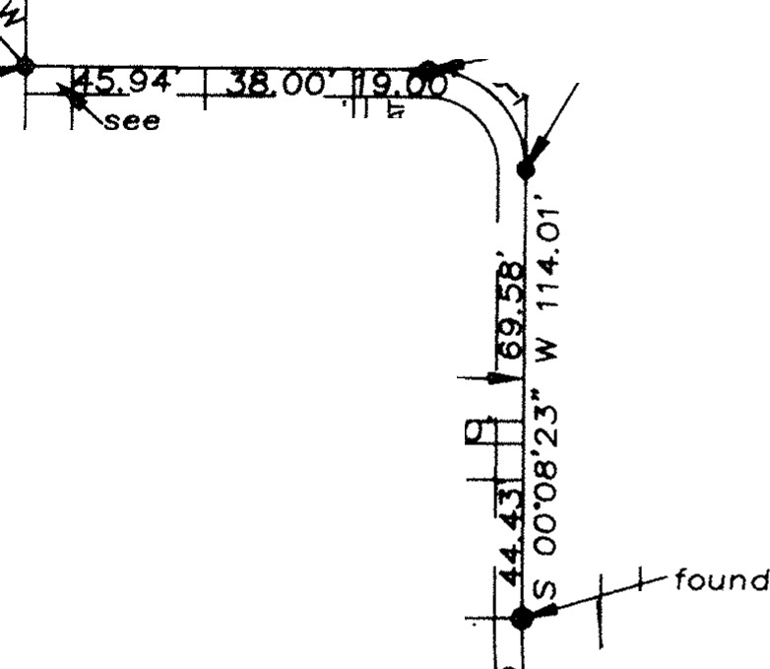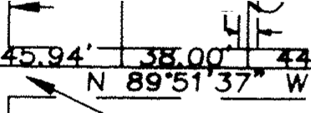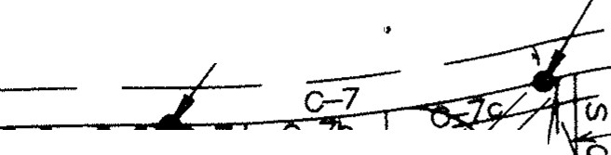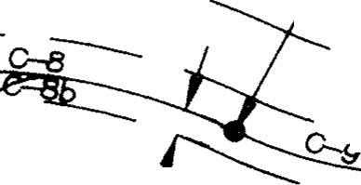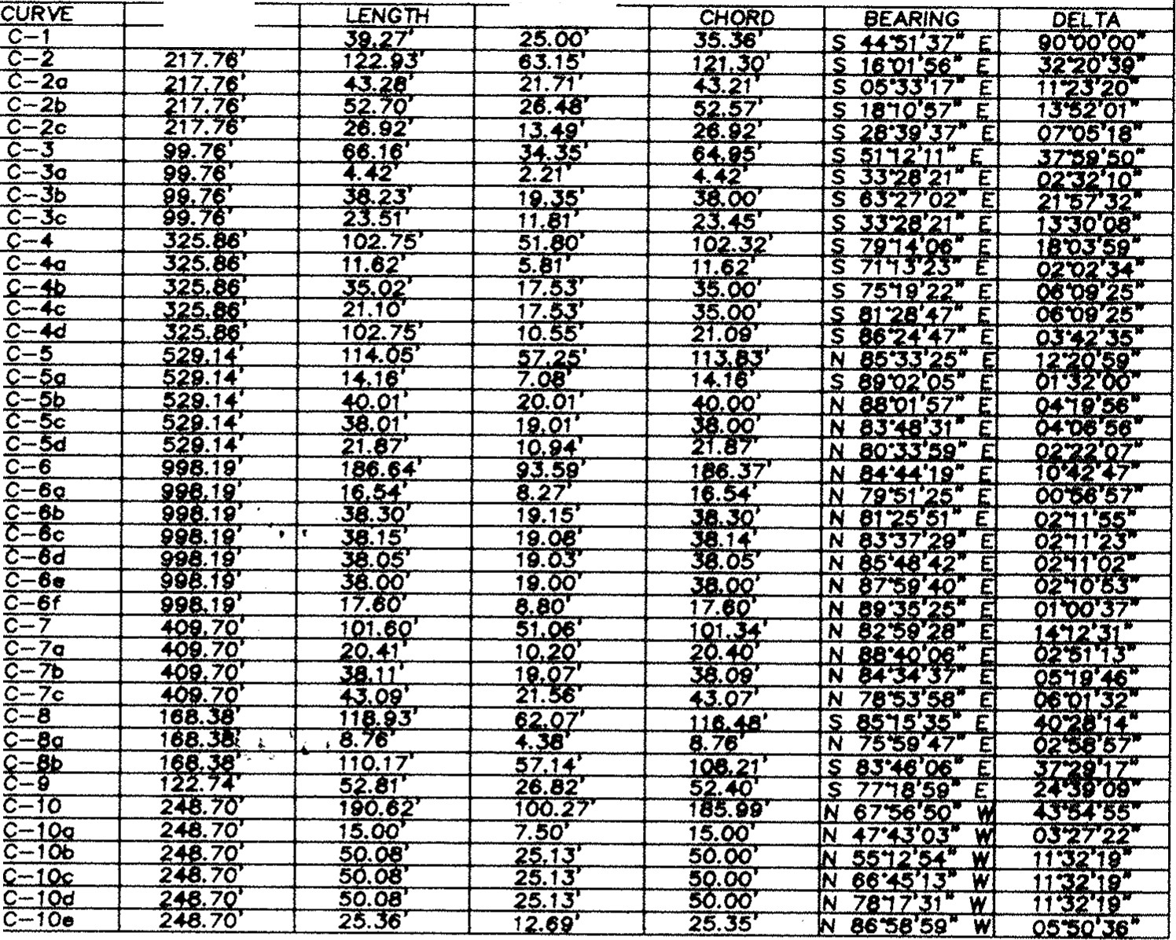

***--,{"I,)***

set rebar

"L.s.7002"

DOMINGO BACA *ARROYO (70' R/W)*

found rebar.

"L.S. 7002"

***911<-lb)***