Aib querque

**DEVELOPMENT REVIEW BOARD APPLICATION**

Effective 8/12/2021

|  |  |  |
| --- | --- | --- |
| ***Please check the appropriate box(es) and refer to supplemental forms for submittal requirements. All* fees *must be paid at the time of application.*** | | |
| **SUBDIVISIONS** | □ Final Sign off of EPC Site Plan(s) *(Form P2A)* | □ Extension of IIA: Temp. Def. of SNV *(Form V2)* |
| □ Major - Preliminary Plat *(Form S1)* | □ Amendment to Site Plan (Form P2) | □ Vacation of Public Right-of-way *(Form V)* |
| □ Major- Bulk Land Plat *(Form S1)* | **MISCELLANEOUS APPLICATIONS** | □ Vacation of Public Easement(s) ORB *(Form V)* |
| □ Extension of Preliminary Plat *(Form S1)* | □ Extension of Infrastructure List or IIA *(Form S1)* | □ Vacation of Private Easement(s) *(Form V)* |
| □ Minor Amendment - Preliminary Plat *(Form S2)* | □ Minor Amendment to Infrastructure List *(Form* S2) | **PRE-APPLICATIONS** |
| □ Minor - Final Plat *(Form S2)* | □ Temporary Deferral of *SNJ (Form V2)* | Sketch Plat Review and Comment *(Form S2)* |
| □ Minor - Preliminary/Final Plat *(Form S2)* | □ Sidewalk Waiver *(Form V2)* |  |
| **SITE PLANS** | □ Waiver to 100 *(Form V2)* | **APPEAL** |
| □ ORB Site Plan *(Form P2)* | □ Waiver to DPM *(Form V2)* | □ Decision of ORB *(Form A)* |
| **BRIEF DESCRIPTION OF REQUEST** | | |
| NMDOT IS DIVIDING ABOUT 0.68 ACRES OUT OF THE EXISTING CAMPUS AT 7500 PAN AMERICAN FWY. TO BE TRANSFERRED TO THE | | |
| GENERAL SERVICES DEPARTMENT FOR CONTINUED USE AND PROPOSED EXPANSIONS BY THE RADIO COMMUNICATIONS BUREAU. | | |

|  |  |  |  |
| --- | --- | --- | --- |
| **APPLICATION INFORMATION** | | | |
| Applicant: NEW MEXICO DEPARTMENT OF TRANSPORTATION (NMDOT) | | | Phone: 505-470-3789 |
| Address: 7500 PAN AMERICAN FREEWAY NE | | | Email: [billy.barr@state.nm.us](mailto:billy.barr@state.nm.us) |
| City: ALBUQUERQUE | | State: **NM** | Zip: 87109 |
| Professional/Agent (if any): | | | Phone: |
| Address: | | | Email: |
| City: | | State: | Zip: |
| Proprietary Interest in Site: | | List 211 owners: NMDOT | |
| **SITE INFORMATION (Accuraclt'. of the existing legal descriation is crucial! Attach a separate sheet if necessary.)** | | | |
| Lot or Tract No.: **NEW** MEXICO STATE HIGHWAY DEPARTMENT TRACT | | Block: **N/A** | Unit: NIA |
| Subdivision/Addition: VOLUME C27, FOLIO 158 | | MRGCD Map No.: | UPC Code: 101806306514530301 |
| Zone Atlas Page(s): D-18-Z | Existing Zoning: NR-LM | | Proposed Zoning: NR-LM |
| # of Existing Lots: 1 | # of Proposed Lots: 2 | | Total Area of Site (Acres): 0.679 |
| **LOCATION OF PROPERTY BY STREETS** | | | |
| Site Address/Street: 7500 PAN AMERICAN FWY NE | Between: DEL REY AVENUE NE I and: SAN FRANCISCO ROAD NE | | |
| **CASE HISTORY (List any current or prior project and case number(s) that may be relevant to your request.)** | | | |
|  | | | |

I certify that the information I have included here and sent in the required notice was complete, true, and accurate to the extent of my knowledge.

|  |  |  |  |  |  |  |
| --- | --- | --- | --- | --- | --- | --- |
| **Signature:** | | | | **Date:** 12/9/21 | | |
| **Printed Name: BILLY W. BARR JR.** | | | | Kl Applicant or □ Agent | | |
| FOR OFFICIAL USE ONLY | | | | | | |
| Case Numbers | Action | Fees | Case Numbers | | Action | Fees |
|  |  |  |  | |  |  |
|  |  |  |  | |  |  |
|  |  |  |  | |  |  |
|  |  |  |  | |  |  |
| Meeting Date: | | | | Fee Total: | | |
| Staff Signature: | | | Date: | **Project#** | | |

**FORM S2: SUBDIVISION** OF **LAND** - **MINOR ACTIONS**

***Please refer to the DRB minor* case *schedule for meeting dates and deadlines. Bring original Mylar or paper copy of plat with property owner's and City Surveyor's signatures on it to the meeting. Your attendance is required.***

# 0 X SKETCH PLAT REVIEW AND COMMENT

Interpreter Needed for Hearing? _NO_if yes, indicate language:

_X_ A *Single* PDF file of the complete application including all documents being submitted must be emailed to [**PLNDRS@cabg.gov**](mailto:PLNDRS@cabg.gov) prior to making a submittal. Zipped files or those over 9 MB cannot be delivered via email, in which case the PDF must be provided on a CD. PDF *shall be organized with the Development Review Application and this Form S2 at the front followed by the remaining documents in the order provided on this form.*

x_ Zone Atlas map with the entire site clearly outlined and labeled

_X_Letter describing, explaining, and justifying the request

_X_ Scale drawing of the proposed subdivision plat

_X_ Site sketch with measurements showing structures, parking, building setbacks, adjacent rights-of-way, and street improvements, if there is any existing land use

# □ MAJOR SUBDIVISION FINAL PLAT APPROVAL

Interpreter Needed for Hearing? if yes, indicate language:

_ A *Single* PDF file of the complete application including all documents being submitted must be emailed to [**PLNDRS@cabq.gov**](mailto:PLNDRS@cabq.gov) prior to making a submittal. Zipped files or those over 9 MB cannot be delivered via email, in which case the PDF must be provided on a CD. PDF *shall* be *organized with the Development Review Application and this Form S2 at the front followed by the remaining documents in the order provided on this* form.

_ Zone Atlas map with the entire site clearly outlined and labeled Proposed Final Plat

_ Design elevations & cross sections of perimeter walls

_ Copy of recorded IIA

_ Landfill disclosure and EHD signature line on the plat if property is within a landfill buffer

_ DXF file and hard copy of final plat data for AGIS submitted and approved

# □ SUBDIVISION OF LAND-MINOR (PRELIMINARY/FINAL PLAT APPROVAL)

Interpreter Needed for Hearing? if yes, indicate language:

_ A *Single* PDF file of the complete application including all documents being submitted must be emailed to [**PLNDRS@cabg.gov**](mailto:PLNDRS@cabg.gov) prior to making a submittal. Zipped files or those over 9 MB cannot be delivered via email, in which case the PDF must be provided on a CD. PDF *shall be organized with the Development Review Application and this Form* S2 *at the front followed by the remaining documents in the order provided on this form.*

_ Zone Atlas map with the entire site clearly outlined and labeled

_ Letter describing, explaining, and justifying the request per the criteria in 100 Section 14-16-6-6(1<)

_ Sites 5 acres or greater: Archaeological Certificate in accordance with 100 Section 14-16-6-5(A)

_ Proposed Preliminary/ Final Plat with property owner's and City Surveyor's signatures on the plat prior to submittal.

_ Site sketch with measurements showing structures, parking, building setbacks, adjacent rights-of-way, and street improvements (to include sidewalk, curb & gutter with distance to property line noted) if there is any existing land use Sidewalk Exhibit and/or cross sections of proposed streets

=

Signed Form DRWS Drainage Report Grading and Drainage Plan, and Water & Sewer Availability submittal information

_ Proposed Infrastructure List, if applicable

_ Required notice with content per 100 Section 14-16-6-4(K)

_Office ofNeighborhood Coordination inquiry response and proof of emailed notice to applicable

Neighborhood Association representatives, copy of notification letter, completed notification form(s), and proof of additional information provided in accordance with 100 Section 6-4(K)(1){b)

_ Sensitive Lands Site Analysis for new subdivisions of land in accordance with 100 Section 5-2(C)

_ Landfill disclosure and Environmental Health Department signature line on the plat if property is within a landfill buffer DXF file and hard copy of final plat data for AGIS submitted and approved

*Note: Any application that requires major public infrastructure must be processed as a Subdivision of Land- Major.* See *Form S1.*

□ **MINOR AMENDMENT TO PRELIMINARY PLAT/ INFRASTRUCTURE LIST**

Interpreter Needed for Hearing? if yes, indicate language:

_ A *Single* PDF file of the complete application including all documents being submitted must be emailed to [**PLNDRS@cabg.gov**](mailto:PLNDRS@cabg.gov) prior to making a submittal. Zipped files or those over 9 MB cannot be delivered via email, in which case the PDF must be provided on a CD. PDF *shall be organized with the Development Review Application and this Form S2 at the front followed by the remaining documents in the order provided on this form.*

_ Zone Atlas map with the entire site clearly outlined and labeled

_ Letter describing, explaining, and justifying the request per the criteria in 100 Section 14-16-6-4(X)(2)

_ Proposed Amended Preliminary Plat, Infrastructure List, and/or Grading Plan

_ Original Preliminary Plat, Infrastructure List, and/or Grading Plan Infrastructure List, if applicable

***Note: Any application that does not qualify as* a *Minor Amendment in /DO Section 14-16-6-4()() must be processed* as a *Major Amendment.* See *Form S1.***

FOR OFFICIAL USE **ONLY**

**X** □ Applicant or □ Agent I



Updated 8/12/21



Project Number:

Case Numbers

Staff Signature:

Date:

|  |  |  |  |  |  |  |
| --- | --- | --- | --- | --- | --- | --- |
| *I, the applicant or agent, acknowledge that if any required information is not submitted with this application, the application will not be scheduled for* a *public meeting or hearing, if required, or otherwise processed until it is complete.* | | | | | | |
| **Signature:** | **41..** ; *I* "- • /'  **fv .JVV*<s*** ",' | *II.:I:?>* | . | *)-* | **w** | **Date: 12/9/21** |
| **Printed Name: Billy W. Barr Jr.** | | | | | |  |

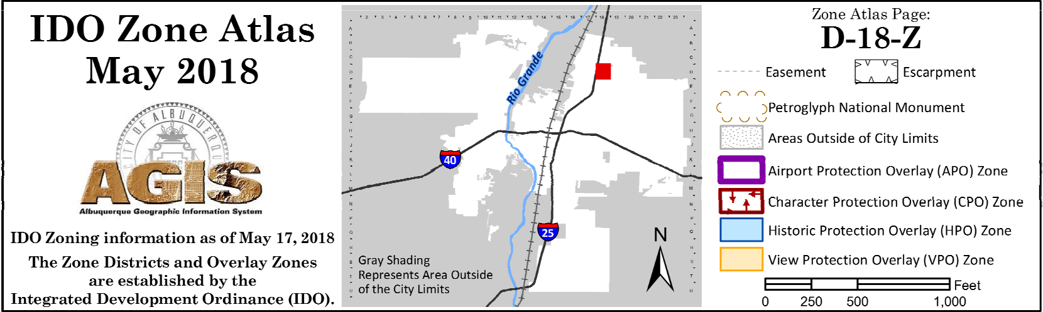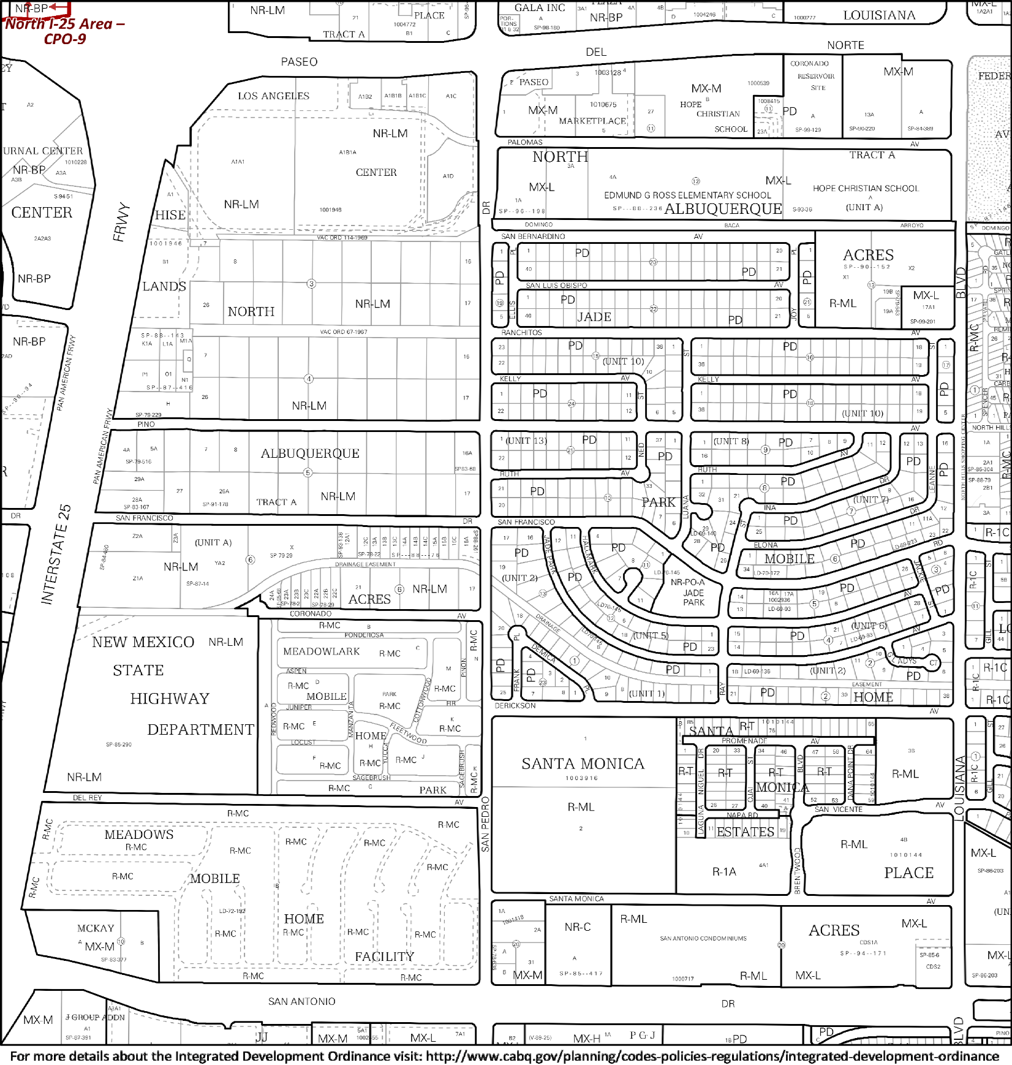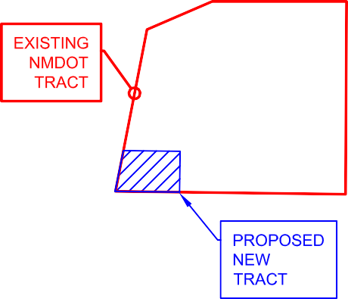



**An Equal Opportunity Employer**

SUBJECT: Proposed **Subdivision of NMDOT District 3 Campus** DATE: December 9, 2021 7500 Pan American Freeway NE

Albuquerque, NM

TO: City of Albuquerque Design Review Board FROM: Billy Barr

Geospatial Staff Manager, NMDOT 1120 Cerrillos Road

Santa Fe, NM 87505

The New Mexico Department of Transportation is proposing to subdivide an approximate 0.68 acre tract out of the Southwest corner of the NMDOT District 3 campus at 7500 Pan American Freeway NE in Albuquerque, NM. This subdivision is being pursued so ownership in the 0.68 acre tract can be transferred to the State of New Mexico’s General Services Department. The tract is currently occupied and used by the State’s Radio Communications Bureau. The Radio Communications Bureau plans to continue using the tract for its present purposes while possibly expanding and or upgrading the existing facilities in the future.

Sincerely,

Billy W. Barr Jr.

|  |  |  |  |  |  |  |
| --- | --- | --- | --- | --- | --- | --- |
|  | .f t } I 11 1 l'l **l2I**  ,, , ,I I P 1 I·  ·:I'":I I I I lUE I I f""I  *:_*"*q*/ .• II  ca "' *I* ,:;;::"'" " I 1 '' , l NRILf,I I I I I oe ,I :Iu c c,Jo' I I ' ' ' ***'(J_***  ,o  I'-" ' (UNIT /,I I C I I I I I I ***rT.'I***  N.T.S  *1£* r  */:'*  *?:*  --NEW MEXICO N'HM  t!EADO'NLARK f".•v1c  STATE  l-tAC E  HlGHWAY I. ,, _' ,;:\11C  DEPARTMENT , r I""'',{M.1C _  **1½4-SITE** I w,sc I \,';.'./!,"'"' SAl\JTA MOJ\!CA  II il-MG C, PARK / *d'.*  R-/ L  -MC  .1:-r:·-_C!E t/:S:::::·:•;··::r •: ; /,'7-;;:; ),:c);'. M:/  *j* ':,. 0 :'." --;:•M EfL\ /< [: ,, ,;--  '-1-ITAl.\:Ym;;.  ,: '°"'"'::,:ll: HOME :: -\l[:: -,: M[:: z.,.I NR-C R-ML  l!-M : NC': ::R ::R  , ,' ,, ,, •: :: Ft.¢ILIT'i' ::  : --:.:.'_':::.:;_;..: ·-------- *=-* --*.::,* ; : : :: - .... ---..:. *_-_-_-:*_-_ --  )(-  **VICINITY MAP**  **ZONE ATLAS MAP NO. D-18-Z**  SUBDIVISION DATA:  ZONE ATLAS INDEX NO: D-18-Z NO. OF LOTS CREATED: 1  MILES OF FULL-WIDTH STREETS CREATED: 0  NOTES:   1. PLAT SHOWS ALL KNOWN EASEMENTS OF RECORD. THIS PLAT WAS PREPARED WITHOUT THE BENEFIT OF A TITLE REPORT. NOT ALL EASEMENTS OR OTHER TITLE MATTERS MAY BE REFLECTED HEREON. 2. EASEMENT BEARINGS AND DISTANCES SHOWN HEREON ARE PER RECORD AND HAVE BEEN ROTATED TO MATCH BASIS OF BEARINGS AND BOUNDARY UNLESS OTHERWISE INDICATED. 3. BEAR!NGS SHOWN ARE NEW MEXICO STATE PLANE GRID BEARINGS (CENTRAL ZONE NAO 83) BASED UPON A LINE FROM ACS "!-25-14" TO ACS "18_018". SAID BEARING BEING N 67"05'57" E. 4. ALL SHOWN DISTANCES ARE GROUND DISTANCES BASED ON A GRID TO GROUND CONVERSION FACTOR OF 1.00033347. 5. RECORD PLAT BEARINGS AND DISTANCES, WHERE THEY DIFFER FROM THOSE ESTABLISHED BY THIS SURVEY, ARE SHOWN IN PARENTHESES (). 6. THE FOLLOWING DOCUMENT(S) WERE USED IN THE PREPARATION OF THIS PL.AT:    1. PLAT OF SURVEY, DATED 6/3/85, VOL. C27, FOLIO 158.    2. WARRANTY DEED, DATED 3/14/07, BOOK A133, PAGE 9495.    3. WARRANTY DEED, DATED 10/15197, BOOK 97-28, PAGES 7187-7188.    4. CONSTRUCT!ON & OCCUPATION EASEMENT, DATED 12/9/69, BOOK M!SC.158, PAGES 113-115.    5. ELECTRIC LINE EASEMENT, DATED 6/15/12, DOC. #2012060342    6. EASEMENT, DATED 1015/67, MISC. BOOK 82, PAGE 347.    7. PERMANENT EASEMENT, DATED 8/6196, BOOK 96-21, PAGES 5542-5545.    8. PARTIAL RELEASE & TERM!NAT!ON OF EASEMENT, DATED 2118/99, BOOK 99-03, PAGES 1984-1985. 7. NO PROPERTY WITHIN THE AREA OF REQUESTED FINAL ACTION SHALL AT ANY T!ME BE SUBJECT TO A DEED RESTR!CT!ON, COVENANT, OR BINDING AGREEMENT PROHIBITING SOLAR COLLECTORS FROM BEING INSTALLED ON BUILDINGS OR ERECTED ON THE LOTS OR PARCELS WITHIN THE AREA OF PROPOSED PLAT, THE FOREGOING REQUIREMENT SHALL BE A CONDITION TO APPROVAL OF TIS OR S!TE DEVELOPMENT PLAT FOR SUBDIVISION.   PURPOSE OF PLAT:  THE PURPOSE OF THIS PLAT !S TO CREATE NEW PARCEL "A-1" TO BE SUBDIVIDED OUT OF THE NEW MEXICO STATE HIGHWAY DEPARTMENT TRACT RECORDED IN VOLUME C27, FOLIO 158 OF THE PLAT RECORDS OF BERNALILLO COUNTY, NEW MEXICO. | | **A PLAT OF** | | **PRELIMINARY**  THIS PRELIMINARY EXHIBIT IS RELEASED FOR THE PURPOSES OF INTERIM REVIEW ONLY AND SHALL NOT BE VIEWED OR USED OR RELIED UPON AS A FINAL SURVEY DOCUMENT.  **PROJECT NUMBER:** ---------------  **APPLICAT1ON NUMBER:** --------------  **PLAT APPROVAL**  UTILITY **APPROVALS:**    PNM ELECTRIC SERVICES DATE    NEW MEXICO GAS COMPANY DATE    CENTURY LINK DATE    COMCAST DATE  **CITY APPROVALS:**    CITY SURVEYOR DATE    "REAL PROPERTY DIVISION (CONDITIONAL) DATE  "*ENVIRONMENTAL HEALTH DEPARTMENT (CONDITIONAL) DATE    TRAFFIC ENGINEERING, TRANSPORTATION DIVISION DATE    ABCWUA DATE  PARKS AND RECREATION DEPARTMENT DATE    AMAFCA DATE  CITY ENGINEER/HYDROLOGY DATE    CODE ENFORCEMENT DATE    DRB CHAIRPERSON, PLANNING DEPARTMENT DATE | |
| **STATE OF NEW MEXICO** | |
| **GENERAL SERVICES DIVISION RADIO COMMUNICATIONS TRACT** | |
| **IN THE ELENA GALLEGOS GRANT,** | |
| **SECTION 24, TOWNSHIP 11 NORTH, RANGE 3 EAST, N.M.P.M.** | |
| **AND BEING HEREBY DIVIDED OUT OF THE EXISTING** | |
| **NEW MEXICO STATE HIGHWAY DEPARTMENT TRACT** | |
| **AS SHOWN AND DESIGNATED ON THE PLAT RECORDED IN** | |
| **BOOK C27, FOLIO 158** | |
| **OF THE RECORDS OF BERNALILLO COUNTY, NEW MEXICO** | |
| LEGAL DESCRIPTION: | |
| A PARCEL OF LAND HEREBY DESIGNATED AS "GENERAL SERVICES | |
| DIVISION RAD!O COMMUNICATIONS TRACT" LYING AND SITUATED !N | |
| THE ELENA GALLEGOS GRANT, SECTION 24, TOWNSHIP 11 NORTH, | |
| RANGE 3 EAST N.M.P.M., BERNALILLO COUNTY, NEW MEXICO AND | |
| BEING HEREBY DIVIDED OUT OF THE REMAINDER OF THE NEW | |
| MEXICO STATE HIGHWAY DEPARTMENT TRACT AS SHOWN AND | |
| DESIGNATED ON THE PLAT RECORDED IN BOOK C27, FOLIO 158 OF | |
| THE RECORDS OF BERNALILLO COUNTY, NEW MEXICO. | |
| SAID "GENERAL SERVICES DIVISION RADIOS COMMUNICATIONS | |
| FREE CONSENT: TRACT" BEING MORE PARTICULARLY DESCRIBED BY NEW MEXICO | |
| THE SUBDIV!S!ON SHOWN HEREON !SPLATTED W!TH THE FREE STATE PLANE COORDINATE SYSTEM GRID BEARINGS (NAO 83, | |
| CONSENT AND IN ACCORDANCE WITH THE DESIRES OF THE CENTRAL ZONE) AND GROUND DISTANCES (U.S. SURVEY FEET) AS | |
| UNDERSIGNED OWNER(S). EX!ST!NG PUBLIC UTILITY EASEMENTS FOLLOWS: | |
| SHOWN HEREON ARE FOR THE COMMON AND JOINT USE OF GAS, | |
| ELECTRICAL POWER AND COMMUN!CAT!ON SERVICES FOR BURIED BEG!NN!NG AT AN EX!ST!NG BRASS D!SK IN CONCRETE STAMPED | |
| AND/OR OVERHEAD DISTRIBUTION LINES, CONDUITS, AND PIPES FOR "STATE OF NEW MEXICO HIGHWAY COMMISSION S.W. CORNER L.S. | |
| UNDERGROUND UTILITIES WHERE SHOWN OR INDICATED, AND 8911", SA!D BRASS DISK MARKING THE SOUTHWEST CORNER OF THE | |
| INCLUDING THE RIGHT OF INGRESS AND EGRESS FOR REMAINDER OF SAID NEW MEXICO STATE HIGHWAY DEPARTMENT | |
| CONSTRUCTION AND MAINTENANCE, AND THE RIGHT TO TRIM TRACT AS SHOWN IN PLAT BOOK C27, FOLIO 158; | |
| INTERFERING TREES AND SHRUBS. SAID OWNER DOES HEREBY | |
| CERTIFY THAT THIS SUBDIVISION !S THEIR FREE ACT AND DEED. THENCE NORTH 10"44'10" EAST A DISTANCE OF 152.37 FEET WITH THE | |
| SAID OWNERS WARRANT THAT THEY HOLD AMONG THEM COMPLETE WEST LINE OF SAID REMAINDER OF NEW MEXICO STATE HIGHWAY | |
| AND INDEFEASIBLE TITLE IN FEE SIMPLE TO THE LAND SUBDIVIDED. DEPARTMENT TRACT, SAME BEING THE EAST RIGHT-OF-WAY LINE OF | |
| INTERSTATE HIGHWAY 25, TO A MONUMENT SET WHENCE A BRASS | |
| SAID OWNER DOES HEREBY GRANT ALL EASEMENTS AS SHOWN DISK IN CONCRETE STAMPED "STATE OF NEW MEXICO HIGHWAY | |
| HEREON WITH LISTED BENEFICIARIES AND STIPULATIONS. COMM!SS!ON !-25-14" BEARS NORTH 09"47'44" EAST A DISTANCE OF | |
| 45.93 FEET AND AN ALUMINUM DISK ON AN !RON ROD STAMPED "N.M. | |
| STATE HIGHWAY DEPT. PS 11255" MARKING THE PRESENT | |
| PRINTED NAME:. _ DATE NORTHWEST CORNER OF THE REMAINDER OF SAID NEW MEXICO | |
| OTRIGTALNE-!:Z_A_T !O_N_: STATE HIGHWAY DEPARTMENT TRACT BEARS NORTH 10"44'10" EAST | |
| A DISTANCE OF 779.97 FEET | |
| THENCE SOUTH 79"25'44" EAST A DISTANCE OF 204.97 FEET TURNING | |
| ACROSS SAID REMAINDER OF NEW MEXICO STATE HIGHWAY | |
| DEPARTMENT TRACT TO A MONUMENT SET: | |
| ACKNOWLEDGEMENT: | |
| STATE OF NEW MEXICO) THENCE SOUTH 33"53'22" EAST A DISTANCE OF 17.83 FEET TO A | |
| COUNTY OF SANTA FE) MONUMENT SET; | |
| THIS INSTRUMENT WAS ACKNOWLEDGED BEFORE ME THIS DAY THENCE SOUTH01"53'57" WEST A DISTANCE OF 98.96 FEET TO A | |
| OF ,, 2021 BY _ MONUMENT SET IN THE SOUTH LINE OF SAID REMAINDER OF NEW | |
| MEXICO STATE HIGHWAY DEPARTMENT TRACT, SAME BEING THE | |
| NORTH RIGHT-OF-WAY LINE OF DEL REY AVENUE WHENCE A BRASS | |
| BY DISK IN CONCRETE STAMPED "STATE OF NEW MEXICO HIGHWAY | |
| -N O T A R Y P U B L ,c ----- DEPT." MARKING THE SOUTHEAST CORNER OF THE REMAINDER OF | |
| SAID NEW MEXICO STATE HIGHWAY DEPARTMENT TRACT BEARS | |
| MY COMMISSION EXPIRES _ SOUTH 89"36'46" EAST A DISTANCE OF 948.03 FEET; | |
| THENCE NORTH 00"59'38" EAST A DISTANCE OF 238.31 FEET WITH THE | |
| COMMON SOUTH LINE OF SAID REMAINDER OF NEW MEXICO STATE | |
| HIGHWAY DEPARTMENT TRACT AND NORTH RIGHT-OF-WAY LINE OF | |
| DEL REY AVENUE TO THE POINT OF BEG!NN!NG AND CONTAINING | |
| 0.679 ACRES. | |
|  | THIS IS TO CERTIFY THAT TAXES ARE CURRENT AND PAID ON UNIFORM PROPERTY CODE #1-018-063-065-145-30301 |  | | | | |
|  | PROPERTY OWNER OF RECORD: NEW MEXICO STATE HIGHWAY DEPT  BERNALILLO COUNTY TREASURER'S OFFICE DATE | SURVEYOR'S CERTIFICATE:  !, BILLY W. BARR JR., NEW MEXICO PROFESSIONAL SURVEYOR NO. | | | | **NEW MEXICO DEPARTMENT OF TRANSPORTATION** |
| 25114, HEREBY CERTIFY THAT THIS SUBD!VISION SURVEY PLAT WAS  PREPARED FROM AN ACTUAL GROUND SURVEY PERFORMED BY ME | | | | | |
|  |  | | OR UNDER MY SUPERVISION, THAT I AM RESPONSIBLE FOR THIS SURVEY, THAT THIS SURVEY IS TRUE AND CORRECT TO THE BEST OF MY KNOWLEDGE AND BELIEF, AND THAT THIS SUBDIVISION SURVEY PLAT AND THE FIELD SURVEY UPON WHICH IT IS BASED MEET THE MINIMUM STANDARDS FOR SURVEYING IN NEW MEXICO. | | **1120 CERRILLO$ ROAD SANTA FE, NM 87505 PH #(505) 827-5100** | |
|  | OWNER(S): NEW MEXICO STATE HIGHWAY DEPARTMENT | |  |  |  |  |
| SECTION 24, TOWNSHIP 11 NORTH, RANGE 3 EAST, N.M.P.M.  SUBDIVISION: NEW MEXICO STATE HIGHWAY DEPT | | BILLY W. BARR JR.  NEW MEXICO DEPARTMENT OF TRANSPORTATION | DATE |  |
|  | | ADDRESS: 1120 CERR!LLOS ROAD, SANTA FE, **NM** 87505 |  |  |
|  | | PHONE: 505-795-1401 |  |  |
|  | |  |  | SCALE 1"=XXXX' SHEET 1 OF 2 |



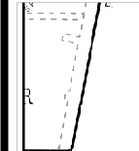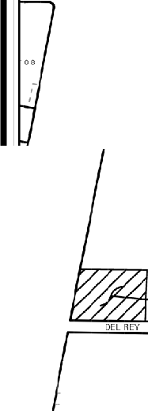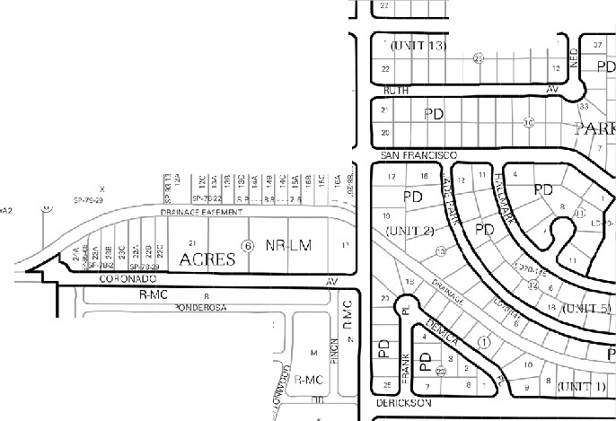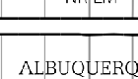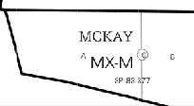

|  |  |
| --- | --- |
| **PRELIMINARY A PLAT OF**  FOUND ALUMINUM DISK THIS PRELIMINARY EXHIBIT IS RELEASED FOR **STATE OF NEW MEXICO**  STAMPED "N.M. STATE THE PURPOSES OF INTERIM REVIEW ONLY **GENERAL SERVICES DIVISION RADIO COMMUNICATIONS TRACT**  HIGHWAY DEPT. PS 11255"--. .._  AND SHALL NOT BE VIEWED OR USED OR  RELIED UPON AS A FINAL SURVEY DOCUMENT.  *,o\V'o,,,..----* EW MEXICO STATE PLANE **IN THE ELENA GALLEGOS GRANT,**  N10°44'10"E 779.97' ENTRAL ZONE, NAO 1983  (S10"43'49.3"W) "" .<;/"*k* o<,,".?.>,",c.,..rr- _,,.. ' RID COORDINATES: **SECTION 24, TOWNSHIP 11 NORTH, RANGE 3 EAST, N.M.P.M.**  ljlr,,.-,,.- ",:C -;:;1:,,1:,()'o =1,542,481.6'  •  ,,..,,.. --::,i1°()':i"' =1,515,940.8' **AND BEING HEREBY DIVIDED OUT OF THE EXISTING**  NEW MEXICO STATE PLAN _,,,.,..,.,.,. \ *I* RND TO GRID=N/A  CENTRALZONE.NAD198 **NEW MEXICO STATE HIGHWAY DEPARTMENT TRACT**  ELTA ALPHA(MAPPING ANGLE)= N/,  X=1,540,074.23 *I* RTHO HEIGHT: 5245.507 NAVD88 **AS SHOWN AND DESIGNATED ON THE PLAT RECORDED IN**  GRID COORDINATES  Y=1,514,923.41 **BOOK C27, FOLIO 158**  GRND TO GRID=0.99966670 REMAINDER OF **OF THE RECORDS OF BERNALILLO COUNTY, NEW MEXICO**  ELTA ALPHA(MAPPING ANGLE)= (-)00"11'36.07' NEW MEXICO STATE HIGHWAY DEPARTMENT TRACT  ORTHO HEIGHT: N/,  PLAT BOOK C27, FOLIO 158  N09°47'44"E 45.93' (TIE) RECORDS OF BERNALILLO COUNTY, NEW MEXICO  *_r i'* .. . ' ' .,. 'I"'"  J I PN I I II I I"I I I I I I I I I  **GRAPHIC SCALE** ' ' · ' I I , I I UQ;,bER UE ..:: I;''",;T. lI fffi  l ETRACTABLE GATES  ;. ***ASPHAL*** *r* ***DRIVE*** 0 20' 40' rnAd ""I'"' ,. I :i I rl1111;  iSPHALT */!J*  AREA1 f:-' , f i r (UtJJTA) N.T.S  SCALE: 1" = 20' *i'! i* NR-fl_M (1,  (0  MONUMENT TO ( IN FEET) *cc*  */!'*  BE SET *25+1_/ :,;*  g *I I* _,.NEW MEXICO NR-LM  *J* / *1* t" " l Sl9°25'44"E *204_97,* HIGHWAY  STATE  --- ONUMENTTO DEPARTMENT R-1-.1:-:'  BESET  **1½4--SITE** i'-:,,1,C 11 R-MC fH4C. SANTA !vlO:.'-  RMC iwIBOEf, PAF.K a';11 .. ,, ..  i'-.. *I* 25' BY 30' RETRACTABLE -- c;_:, R-'VIL  -*f*"*ij*" *I* GATE EASEMENT ONUMENTTO ,*j* -----------------------_-_-_-_-----_-_- -_-- -_-_-.- -_-_-_-.- - -.-.-.-.- -. · - . R-MCJ  *ct,:* .l\'!Ell...UO\'\'S *,:* ,; ;_, *•:* ;, -::. z  **1./)** *?:'* t,J ·20· GENERAL SERVICES DIVISION l S33°53'22"E 17.83' *,.::',': .---_-_-_-_-_-_- ----_-_-_-_-_-/* RMC :: *t* ,;;' ,:' / • ;•'  HEREBY CREATED BESET ; R-fiC /1 ', FU C ,, ,', R--MC,, 1 *::-,* .• c:;:;  **(\J** *(?* 0 RADIO COMMUNICATIONS TRACT *k* u ,',' R-,\IC ,;1'1omLE :: : *:;* " ,',' ·,,-,,  .>- ,0,,.-..... - 29,574.2 SQUARE FEET/0.679 ACRES *i jf* '::_-,_-_-_-_-_-_-_-_-_-_-_-_-_-_<, ,, \: : , !: •,; *.•,:•* **(.-.-.-,-**,**1** ,-,,._,r, MO V,  *1* . *!J* 1 XISTING 20' SEWER EASEMENT RASSYAREAl )> :,:: ::::R'-"M"'c:::: :, HOME ::::Rl•/C:•, '":;R,1c:::; :::' l_:_:,..',"_1 I  a Ooo'-t PLAT BOOK C27, FOLIO 158 ***(f)*** ,:R-1-,:C', \JR-C  *::r:* 6 *Cf)* < I**lJ** _ I \_ -:._'_: _-:. - *-:.;_,* c*i*c*-*:\ !- :;·--_•_ --*_}* er_...! I X-M  *52 er bY I* )> **VICINITY MAP**  M  *::r:* ,_ *er* **r ZONE ATLAS MAP NO. D-18-Z**  ,***L***_***LJ*** <***-.J***:( _***:***,***5***. ,-...... **-I**  **0**  *l I I* S01°53'57"W 98.96'---111 **;:o**  *eCrf) Cf) er I* **m**< □ LEGEND  <t  -*I!!* EDGE OF BRASS CAP IN CONCRETE  ***z*** ---------------ASPHALT MOBILE STORAGE CONCRETE CURB ALUMINUM CAP  *61.92•* TRAILER & GUTTER"-._  *I I* ---0 CHAIN LINK FENCE  EASEMENT  *I* PARKING LOT1 P.O.B. POINT OF BEGINNING  \_ASPHALT  *I* 29.17' :,  *I* EASEMENT *II* OMMUNICATIONS h  ELECTRIC LINE  DOC. #2012060342 1n TOWER  N  *I* oi t;; ONSTRUCTION &  ' "'  *I* LJ ;;; OCCUPATION EASEMENT  MISC. 158, PAGES 113-115  TRANSFORMER PA□-----o MONUMENT TO  rHAINLINK FENCE BE SET\  N89°36'46"W 236.55'  (S89'36'40.5"E)  LOB. S89'36'46"E 948.03'  FOUND BRASS CAP IN CONCRETE (S89°36'40.5"E) lOUND BRASS CAP IN CONCRETE  STAMPED "STATE OF NEW MEXICO HIGHWAY COMMISSION S.W. CORNER L.S. 8911"  **DEL REY AVENUE ASPHALT ROAD** | |
| **60' R/W** | **NEW MEXICO DEPARTMENT OF TRANSPORTATION** |
| **1120 CERRILLO$ ROAD SANTA FE, NM 87505 PH #(505) 827-5100** | |
|  | SCALE 1"=20' SHEET 2 OF 2 |

