9200 Wilshire Site Visit 11/21/23

Shakeel Rizvi, Adil Rizvi and Bonnie Strange met on the site on 11/21/23 to discuss existing site conditions. Adil shared documentation that the property to the west of the subject property was approved to be graded so that water flowed from south to north, to Wilshire and that the property to the west should have built a retaining wall when that subdivision was constructed. This has been included in a Drainage Report (physical copy) dated October 2004 “The upland flows will be directed to the north along the eastern wall”. Adil stated that they are bringing 6000 cubic yards onto the site for filling & re-grading.

Adil, Shakeel & Bonnie then went to a property Adil had developed that showed the common condition of terracing in yards in this part of the City.

Photos from the visit below:

Looking north from southwest corner:

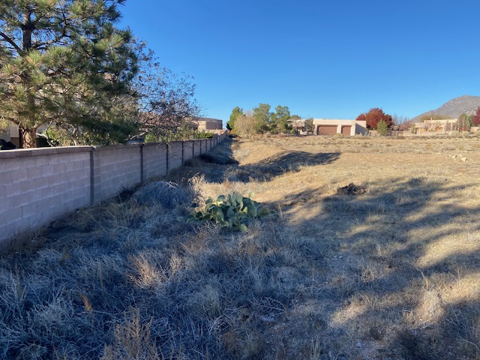

Looking south at “hole” in southwest corner:

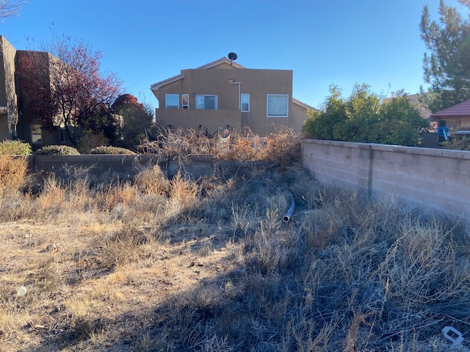

Looking south on Vintner:

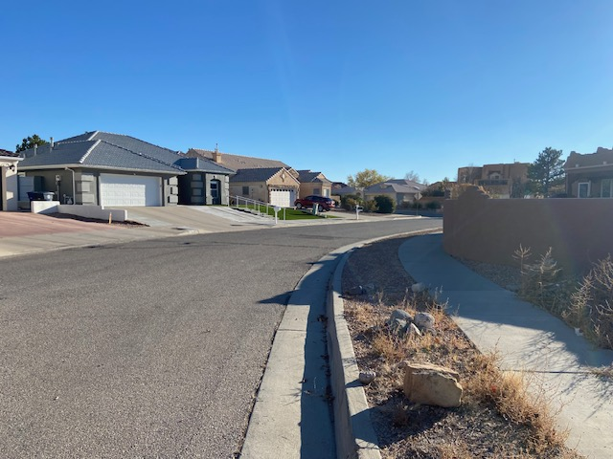

Looking west from Vintner:

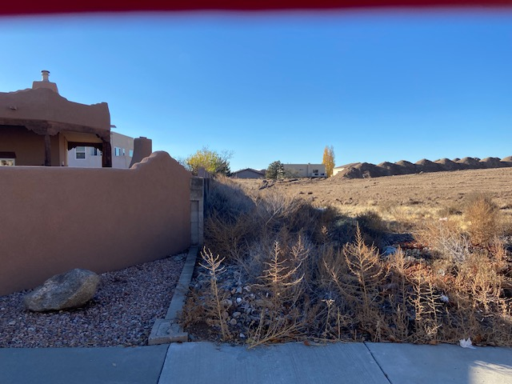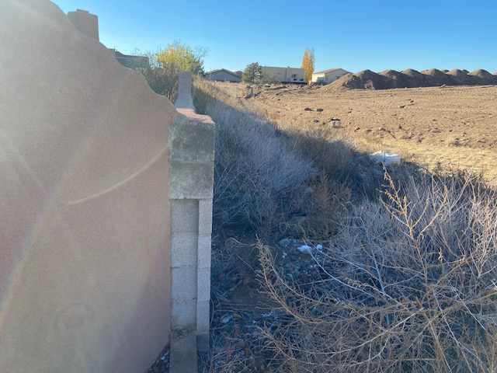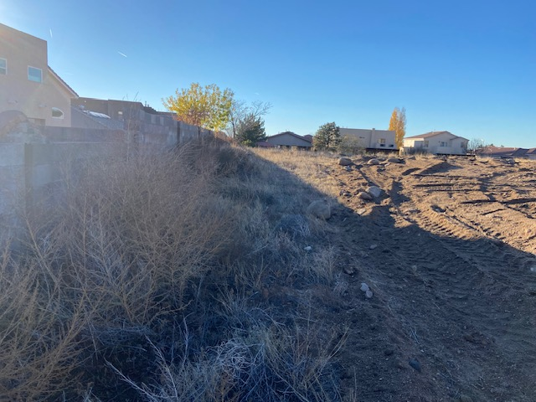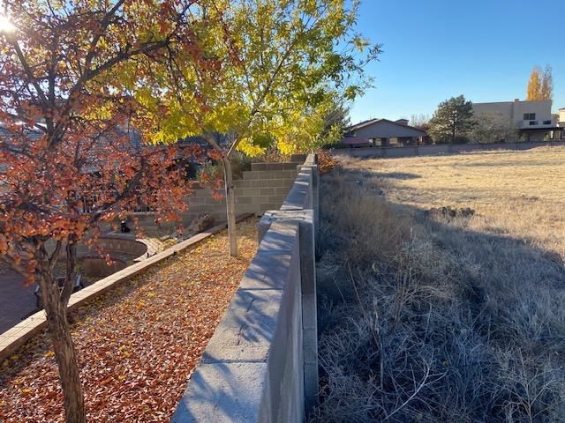

Looking north from Vintner:

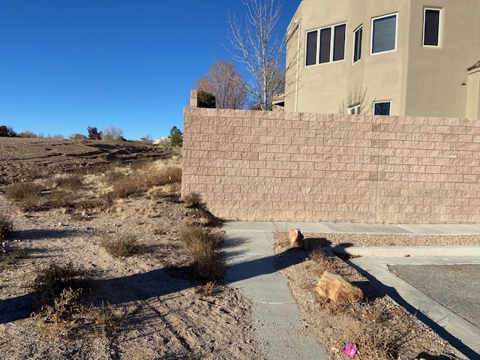

Looking from site to Vintner:

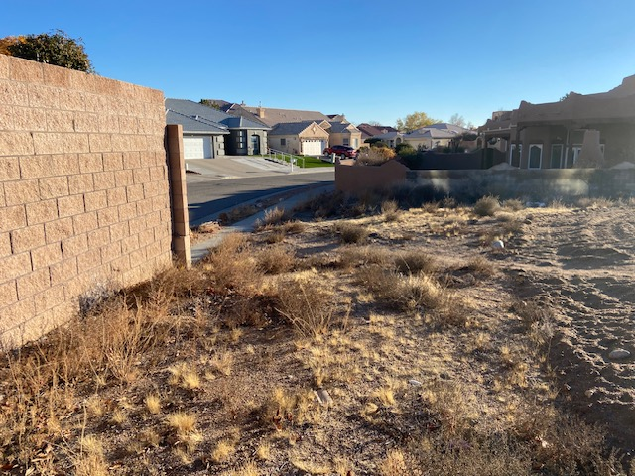

Looking into site from Vintner:

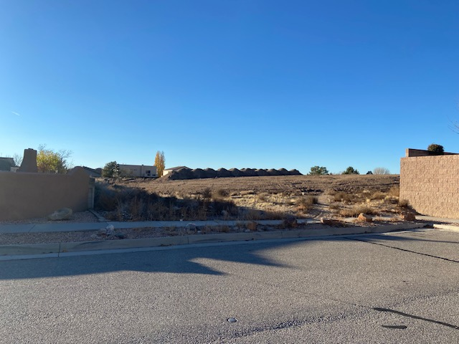

Looking southeast towards Vintner:

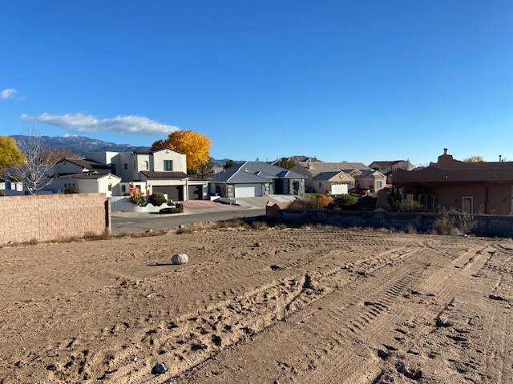

Looking south along east wall towards Vintner:

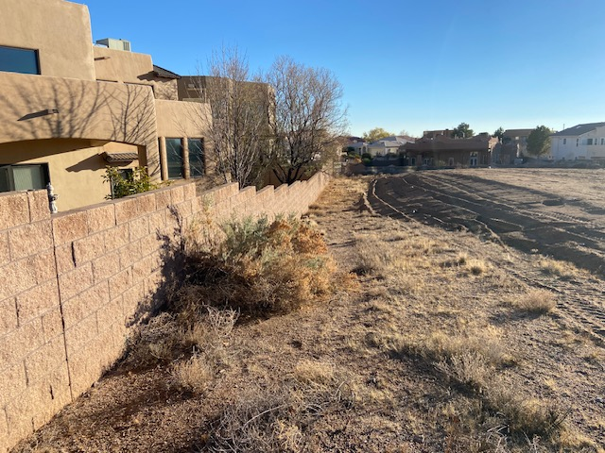

Looking east from southwest corner:

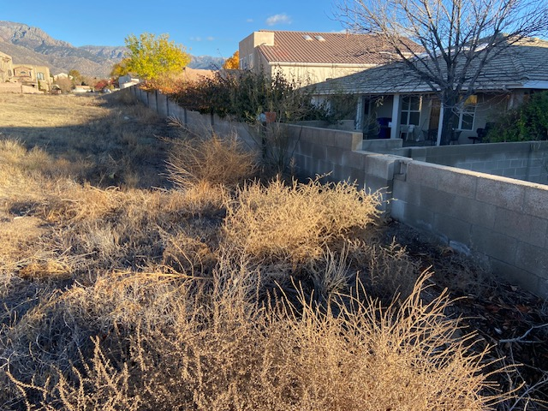

Looking south towards “hole” at southwest corner:

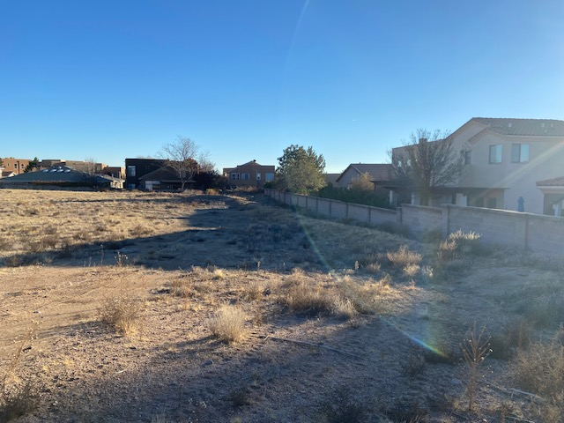

Example of a terrace in neighborhood nearby:

