Dear CABQ DRB,

My name is Steve Carney and a longtime resident of ABQ. My wife Yolanda and I have been working diligently over many decades preparation for our retirement right here Albuquerque.  Our plans include the purchase of land to construction of our forever home.  To enable this we've been researching land for sale around the city and finally found our dream lot in North ABQ Acres.  Prior to purchasing the lot we vetted the property contacting the city engineers, utility companies and variety of realtors & builders.  In researching the only down side we learned of surrounded the fact the city would not be supplying sewer or water to our undeveloped lot.  
  
After purchasing the property and locking in our builder we were informed through his engineering consultant about a new ordinance called the Integrated Development Ordinance (IDO). Soon after we learned the IDO would most likely impact our ability to construct the house do the additional infrastructure costs e.g. street, curb, storm drain, water, sewer, etc...

Our initial reaction to this news was to apply for an IDO waiver which we were originally granted in early February, 2022; however weeks later it was later retracted due an approval related miscue by CABQ. During the retraction, the CABQ Planning Department recommended we schedule a Sketch Plat DRB meeting to better understand the specifics related to gaining approval for our project.

So with this we are requesting support from the CABQ DRB in helping us to understand the following:

* How our plan and lot will be subjected to via the IDO.
* What we need to do from here to obtain a construction permit.
* If needed, how we go about officially requesting a waiver from IDO requirements.

Our rationale for this request surrounds the facts there is no existing infrastructure in this neighborhood to include established pedestrian connectivity, sidewalks, curbs, nor is there any evidence of recent street upkeep or maintenance. There is also no water or sewer services available to us and we would be the only acre lot home with this infrastructure in our area. Our concerns here surrounds added costs that will exceed our budget. Additionally, we are concerned about the need to install significant infrastructure that will be dead ended i.e. sidewalk & curb on a hill, a large storm drain, along with water & sewer piping all connected to nothing.  
  
In closing please know we would greatly appreciate any support you can provide in helping us with navigating very stressful and long in ongoing and frustrating   
  
Regards,  
Steve & Yolanda Carney

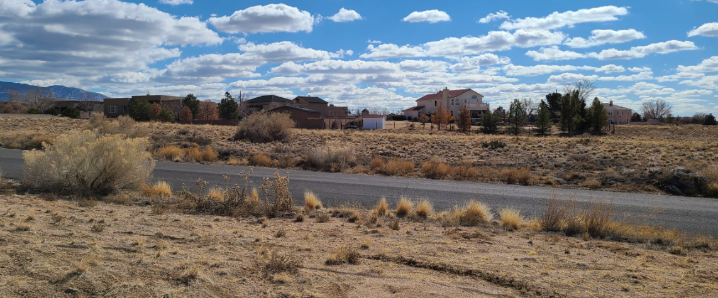

Wider angle view from across the street

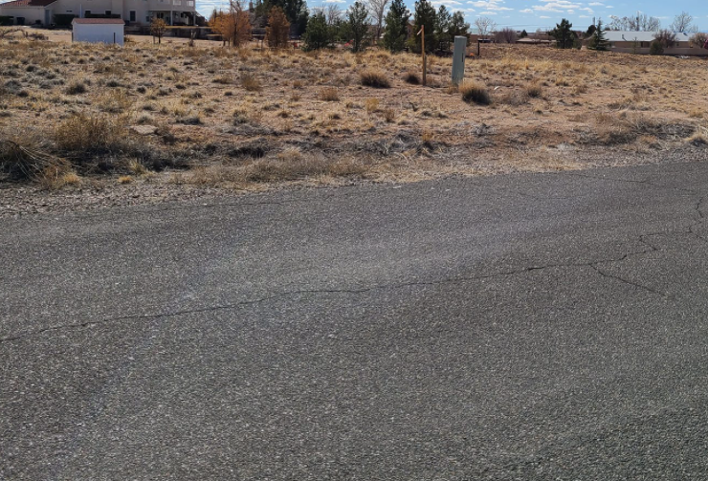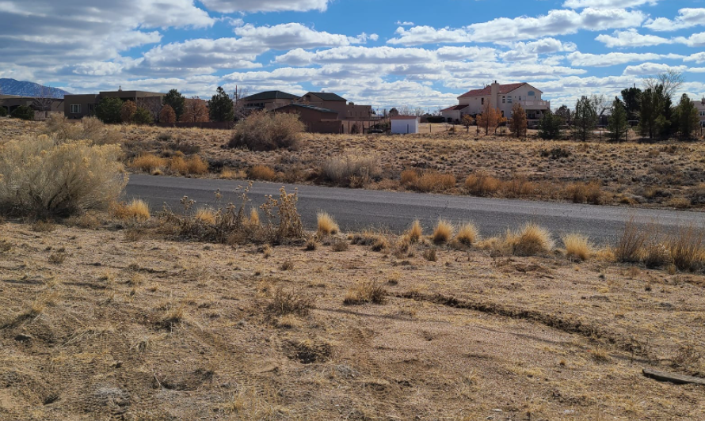

Road directly in front of property View from across the street

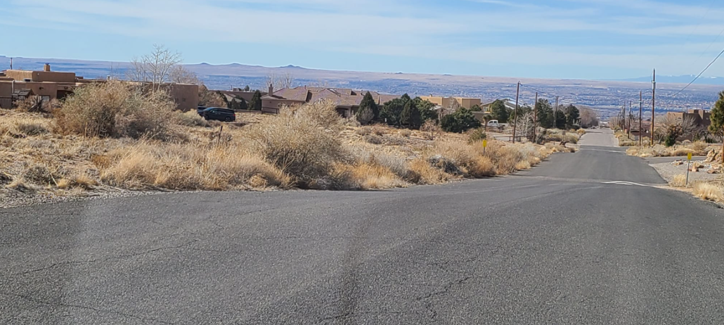

Property is on left side of street ending at the speed bump