Good morning,

Thank you for your submittal.

* We can confirm that a [Pre-submittal Tribal Meeting](https://www.cabq.gov/planning/codes-policies-regulations/integrated-development-ordinance-1/pre-submittal-tribal-meeting-request) is not required for the subject property pursuant to IDO §14-16-6-4(B). The IDO link is below:

<https://documents.cabq.gov/planning/IDO/2023_IDO_AnnualUpdate/IDO_2023_AnnualUpdate_Effective.pdf> (14-16-6-4(B))

A PDF of the email from Planning staff confirming that a Pre-submittal Tribal Meeting was not required, please log in to ABQ-plan and upload this information in “other documents”.

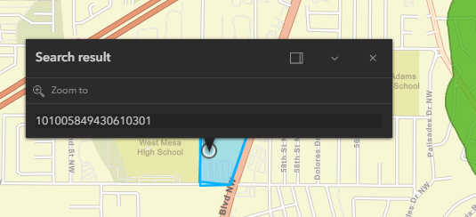

Should you require further assistance, please don’t hesitate to contact me, and/or Annette Ortiz at 505.924-3623.

Thank you,



**RENEE ZAMORA**

Senior Administrative/Navigator  
**o**  505-924-3358

**e**  [rczamora@cabq.gov](mailto:rczamora@cabq.gov)

[**cabq.gov/planning**](https://www.cabq.gov/planning)