Black Watershed Park Management Plan Technical Addendum August 2013
I, Patrick L. Stovall, Registered Professional Engineer No. 13830, hereby certify that these documents were prepared by me, or directly under my supervision, and are true and correct to the best of my knowledge and belief.


Patrick L. Stovall, P.E.
New Mexico P.E. No. 13830
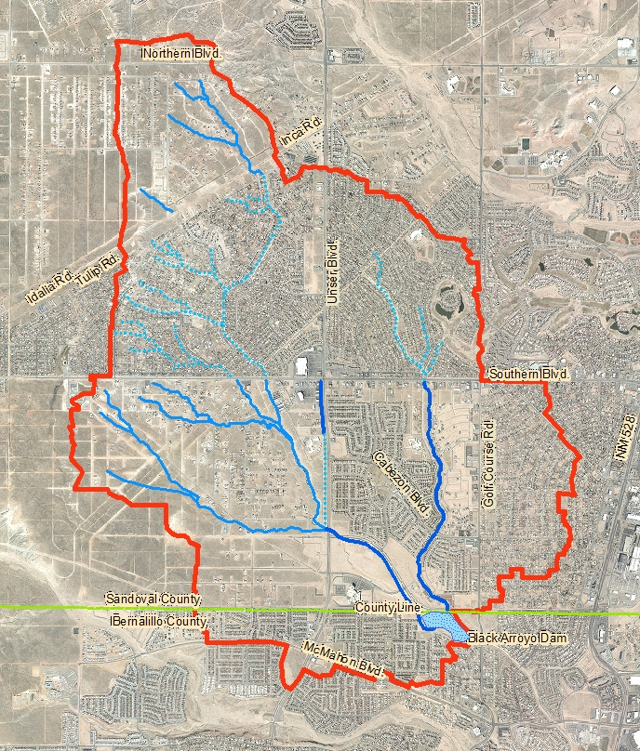


Southern Sandoval County
Arroyo Flood Control Authority

BOARD OF DIRECTORS
John Chaney
Mark Conkling
Steve House
Donald Rudy
James F. Fahey Jr.

Charles Thomas, P.E.
Executive Engineer

Black Watershed Park
Management Plan
Technical Addendum
August 2013

The SSCAFCA Black Watershed Park Management Plan Technical Addendum updates the Black Arroyo Watershed Management Plan dated August 2002. This is a technical and structural update and incorporates development changes since the original August 2002 Plan and converted the original AHYMO_97 models to HEC-HMS (version 3.5) models.
Accepted

By: Date:
Charles Thomas, P.E. Executive Engineer

CONCURRENCE:

Date:
City of Rio Rancho Title

This is a planning document. Nothing herein constitutes any commitment by SSCAFCA to construct any project, study any area, acquire any right of way or enter into any contract. This watershed park management plan does not obligate SSCAFCA in any way. Drainage facility locations and rights-of-way are conceptual only, and may be altered or revised based upon future project analysis, changed circumstances or otherwise.

Land uses included in this document were assumed for the basis of hydrologic modeling only. This document does not grant “free discharge” from any proposed development. Naturalistic channel treatments and piped storm drains are to be used for conveyance stabilization, unless otherwise authorized by SSCAFCA.

