June 13, 2024

David McEachern

RBA Architects, PC

1104 Park Ave SW

Albuquerque, NM 87102

[david@rba81.com](mailto:david@rba81.com)

**Re**: **Eagle Ranch Retail**

**9641 Eagle Ranch NW**

**Traffic Circulation Layout**

**Engineer’s/Architect’s Stamp 3-5-24 (B13D002C)**

Dear Mr. McEachem,

Based upon the information provided in your submittal received 6-12-24, the above referenced plan cannot be approved for Building Permit until the following comments are addressed:

1. Mark the project location on the vicinity map, and add the missing symbols to Legend. 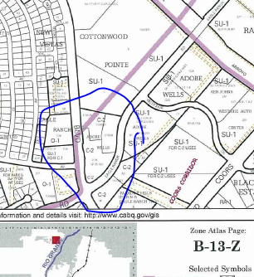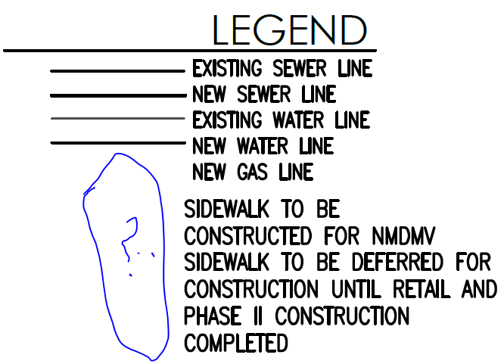
2. List the number of parking spaces required by the IDO as well as the proposed number of parking spaces including bicycle and motorcycle parking correctly. 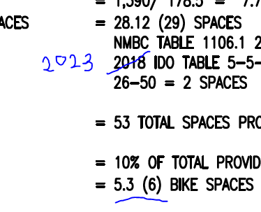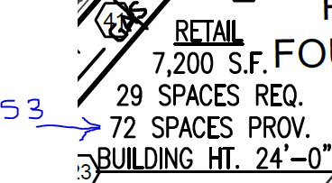
3. Please, draw a line for boundary of Phase 2. Your parking calculation is only for this phase (Building A).Hatch all the parking spaces that are not part of this phase 2.
4. ADA curb ramps must be updated to current standards and have truncated domes installed.
5. Minimum drive through stacking spaces is 12. Modify your drive through design to accommodate for 12 cars. Keyed note 39 is not acceptable.
6. Submit documentations on keyed note 28 and on the following note at the bottom of the sheet 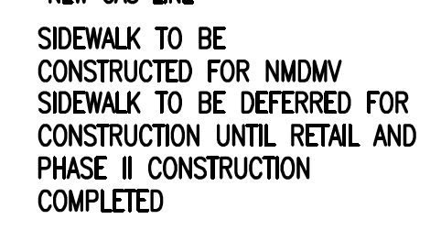

Once corrections are complete resubmit

1. The Traffic Circulation Layout
2. A Drainage Transportation Information Sheet (DTIS)
3. Send an electronic copy of your submittal to [PLNDRS@cabq.gov](mailto:PLNDRS@cabq.gov) .
4. The $75 re-submittal fee.

for log in and evaluation by Transportation.

If you have any questions, please contact me at (505) 924-3909.

Sincerely,

Sertil A. Kanbar

Sertil Kanbar, PhD,PE,CFM

Sr. Engineer, Planning Dept.

Development Review Services

\xxx via: email

C: CO Clerk, File