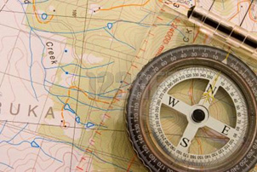

July 31, 2014

City Hydrology

Development & Building Services Div.

600 2nd Street NW, Ste. 201

Albuquerque, NM 87102

RE: SUMCO Parking Slab (B-17/D002)

Dear Mr. Olson,

The previously submitted plan (approved April 30), is being re-submitted with minor revisions. The proposed slab has been shortened to 58’ and has shifted slightly to the west. Parking bumpers are proposed to close off the existing 8 parking spaces immediately west of the proposed slab. Notes have been added regarding the removal of the existing storm drain under the proposed slab. No other changes have been made to the approved plan.

Please contact me if you have additional questions. Thank you.

____________________

Scott M McGee

**From Project Inception to Construction Completion**

**9700 Tanoan Dr NE • ABQ, NM 87111 • 505.263.2905 • scottmmcgee@gmail.com**

**Scott M McGee PE, LLC**

**Civil Engineer**