January 30, 2020

Gama Development, LLC. – Brian McCarthy [Brian@Abrazohomes.com](mailto:Brian@Abrazohomes.com)

Site: Ascension Subdivision – 8814 Horizon - B17E006

**Re: Drainage Ordinance (14-5-2-1) Violations for Erosion and Sediment Control**

Dear Mr. McCarthy

The following violations were observed at the inspection today.

1. Sediment in offsite road is being washed by rains into inlets at the southeast corner of the site.
2. 20' of Silt fence is down and sediment is offsite at north corner of the site (same as previous inspection/violation notice)
3. North construction entrance BMP is missing and track-out in offsite road.

These photos were taken today:

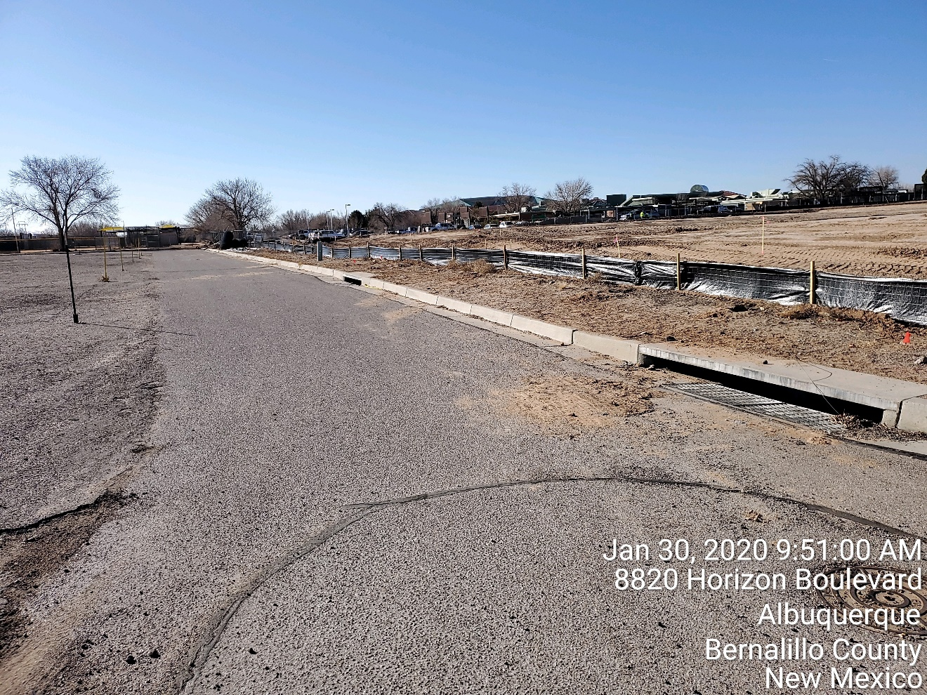

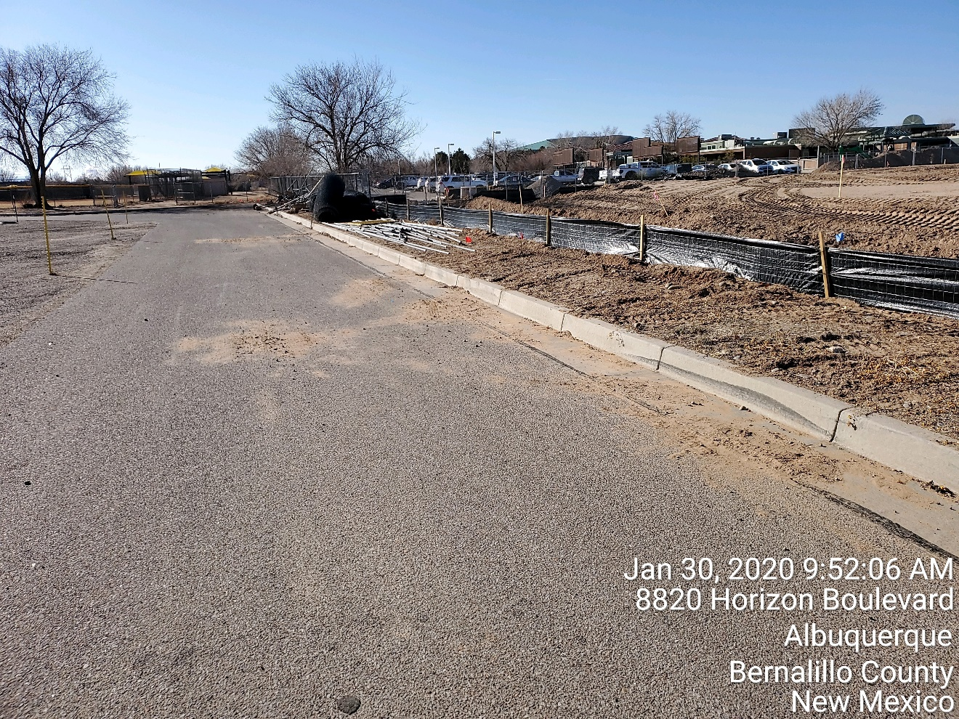

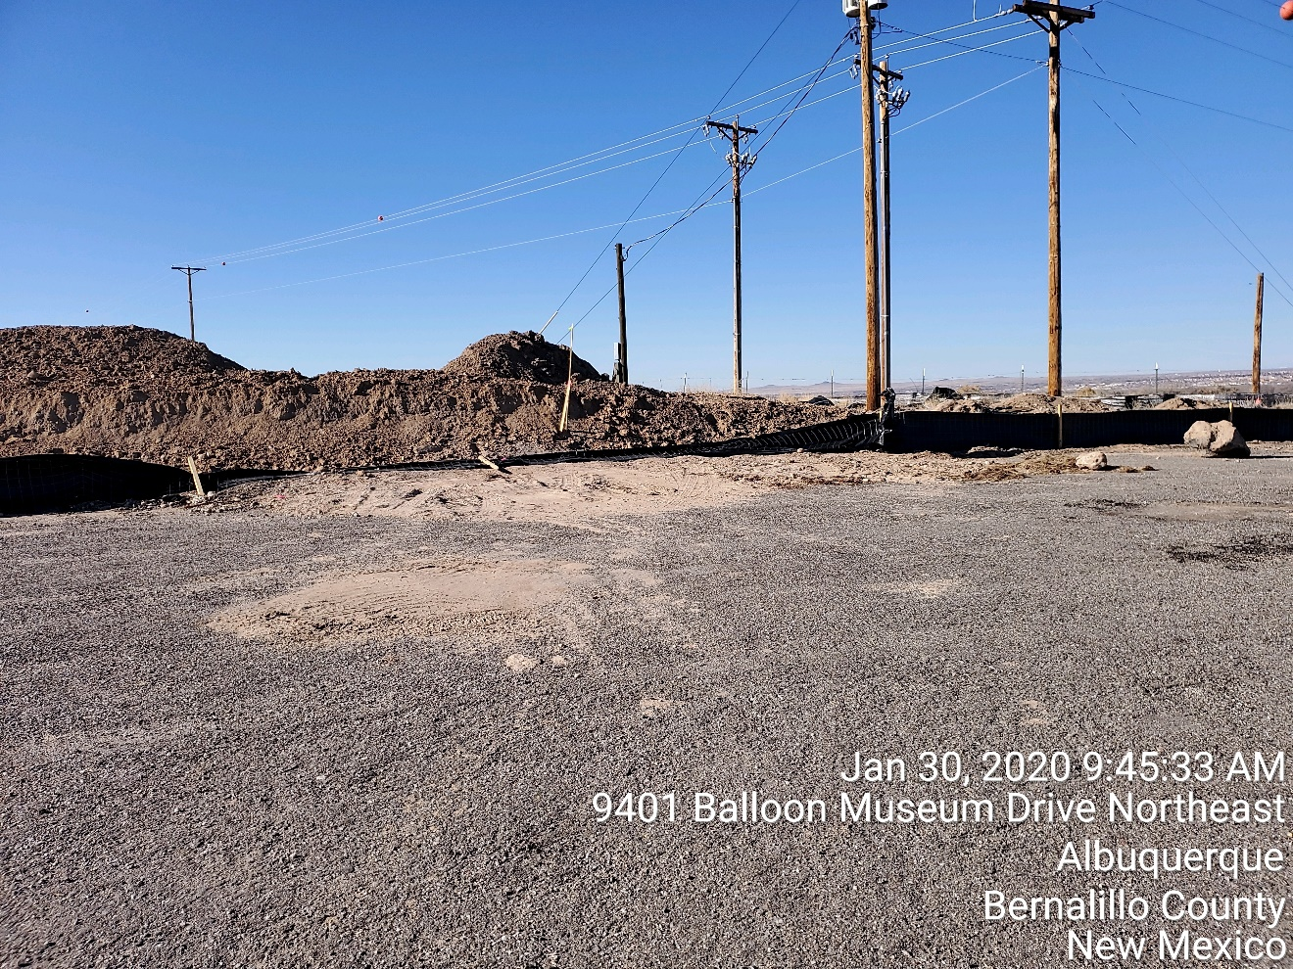

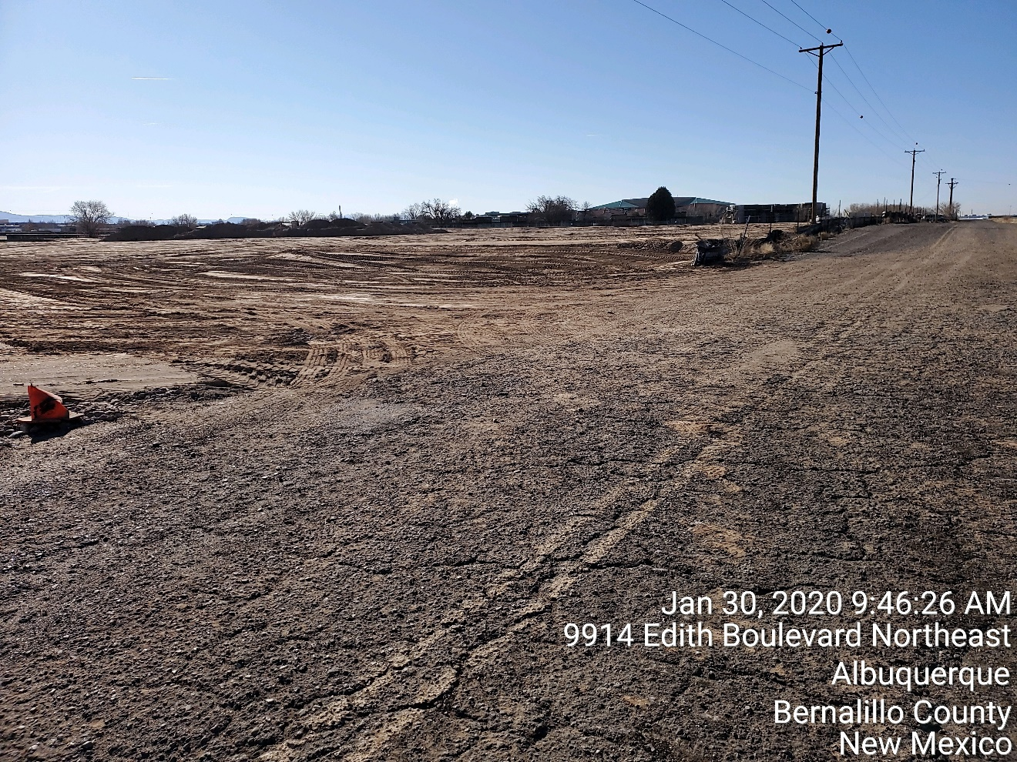

**Required Mitigation:**

1. Maintain stormwater controls including silt fence and construction entrance.
2. Where sediment has been tracked-out onto paved areas outside your site remove and dispose of sediment by the end of the same business day.

Per the previous Violation letter, the City is assessing a fine of $4,000. This fine is for 8 days (Jan 23-30).

Additional days may be added if the violation is not mitigated within 7 days. This non-compliance will be reported to the New Mexico Environment Department, Surface Water Quality Bureau to aid in the determination if this issue is to be forwarded to the EPA.

If you would like to schedule a follow-up inspection at a day and time of your convenience, prior to 7 days from the date of this letter please let me know.

If you have any questions, you can contact me at 924-3420 or [jhughes@cabq.gov](mailto:jhughes@cabq.gov) .

Sincerely,

James D. Hughes, P.E.

Principal Engineer, Hydrology/Stormwater Quality

Planning Dept.