Glendale Road East of San Pedro

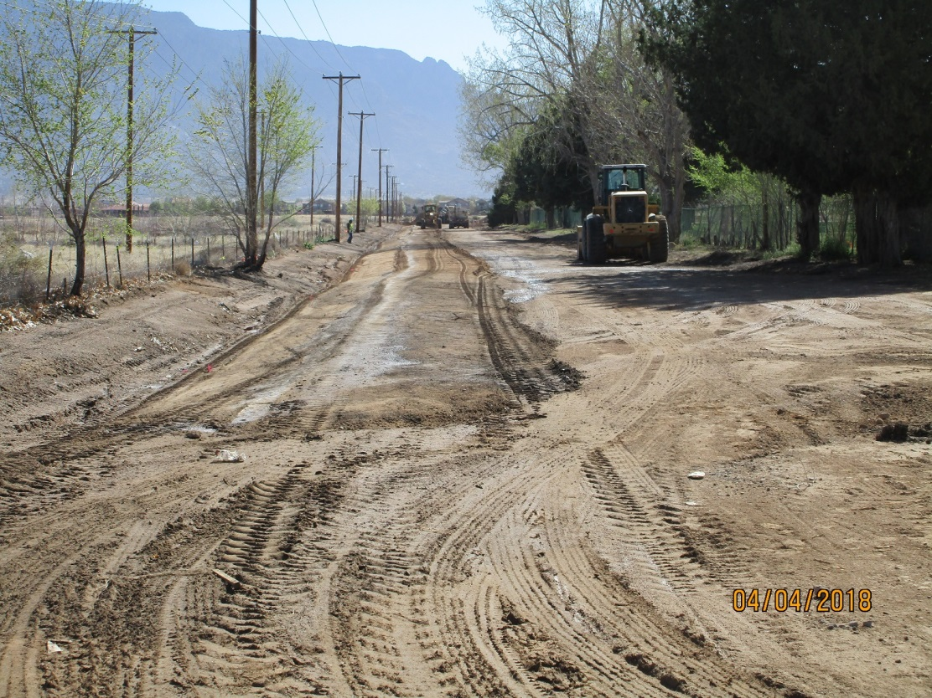

Glendale Rd photo taken 4-4-18. No more gravel.

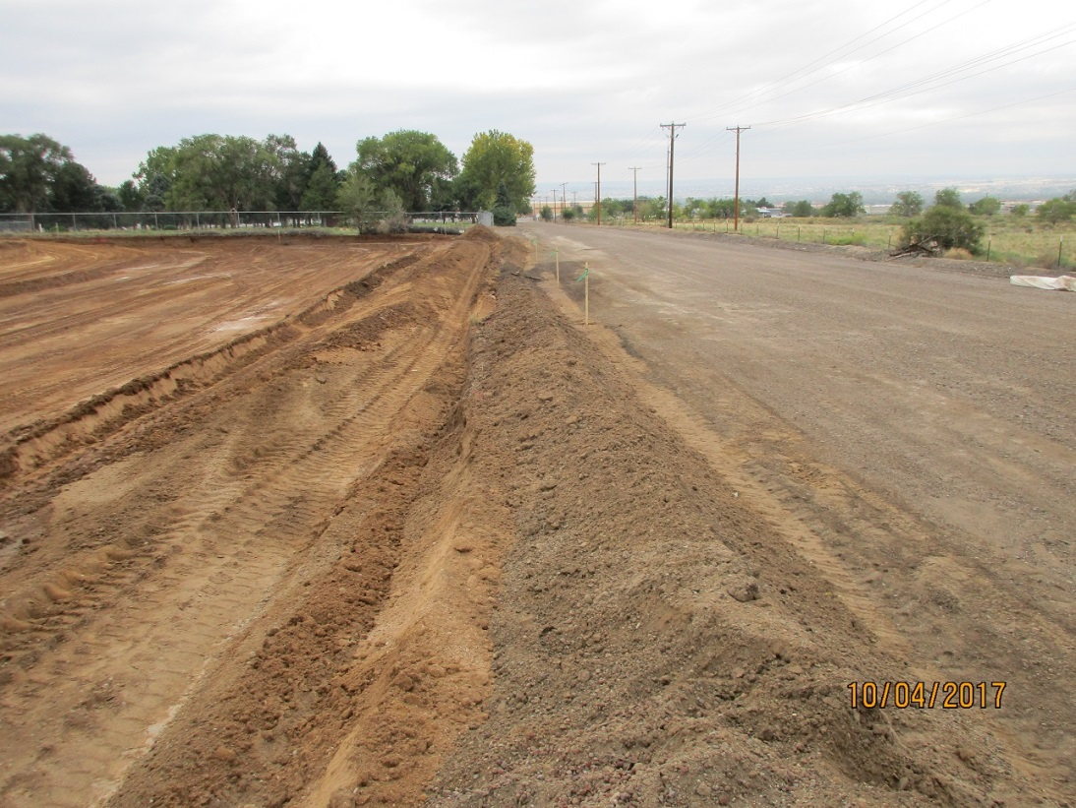

Photo of Glendale Rd. Pre work order shows gravel road surface.

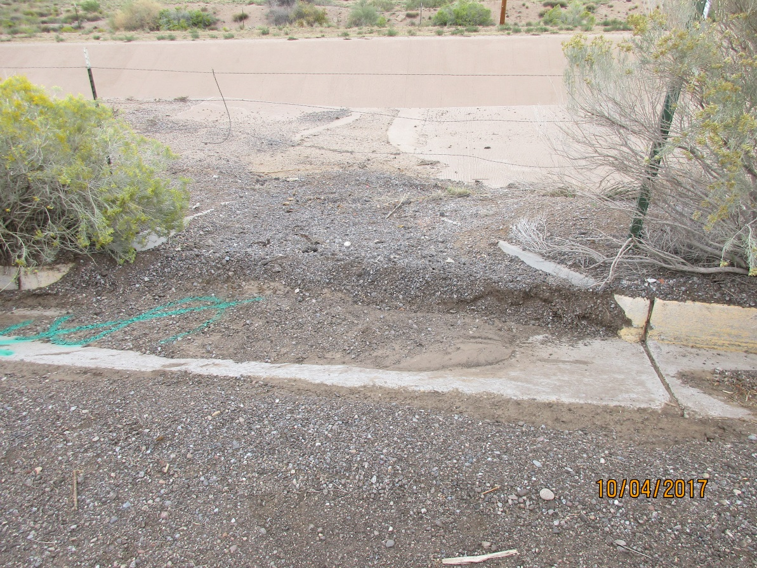

Close-up of road surface.