August 26, 2025

DANOFF MARGO KAWIN TRUSTEE DANOFF RVT
9115 MOON DUST LN NE,
ALBUQUERQUE NM 87122-3688

GLENDALE HOA
ASHTON HOMES LLC
C/O SCHMILLE
11209 SPYGLASS HILL LANE NE
ALBUQUERQUE NM 87111

NATHAN PABILONA
ASSOCIA CANYON GATE MANAGEMENT, AAMC
8500 JEFFERSON ST NE, STE B
ALBUQUERQUE NM 87113

RE: Notice of Violation
9115 MOON DUST LN NE (Lot 4, The Estates at Glendale Unit 3)

To whom it may concern,

This notice of violation is being sent in response to drainage and flooding complaints received by the City Planning Department by the neighboring property at 7911 Modesto Ave NE (Lot 25 NAA Tr 1 Unit 3) in August of 2025.

The plats for The Estates at Glendale Unit 2 and Unit 3 show a 5’x5’ private drainage easement at the SW corner of 9115 Moon Dust Ln NE (Lot 4 of Estates at Glendale Unit 3) that is maintained by the Glendale Unit 2 Homeowner’s Association for the benefit of Lots 25, 26 Tract 1 Unit 3 of North Albuquerque Acres. The Grading & Drainage plans (Hydrotrans # B19D027) that were approved for 9115 Moon Dust Lane NE show that is lot is to accept offsite flows from 7911 Modesto NE and allow for those flows to continue west through the private drainage easement.

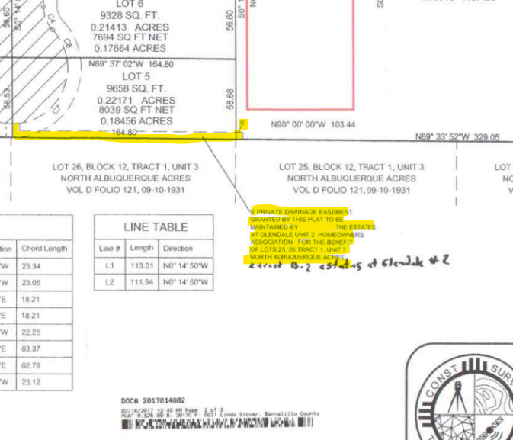

A site visit was conducted on August 22, 2025 and it was observed from the south side of the subdivision perimeter wall that the flow path has been obstructed and signs of wall failure are starting to show along with erosion issues due to the blockage.
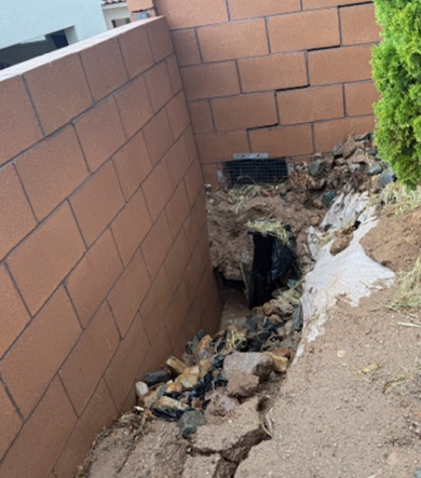

Per 14-5-2-11(D)(2)(d) of the Flood Hazard and Drainage Control Ordinance: Demand for construction or repair - The city may send written notice ("notice") to the owner requiring maintenance, construction, or repair to the drainage facility within 30 days ("deadline") of receipt of the notice, and the owner, at their expense, must comply with the requirements of the notice by the deadline provided.

This Notice of Violation also serves as a formal Demand for Construction or Repair of the site’s grading and drainage to allow for the offsite flows to continue through the historical path in the private drainage easement with a construction deadline of September 26, 2025.

Per 14-5-2-12(B)(2) of the Flood Hazard and Control Ordinance: Construction, grading or paving on any lot within the jurisdiction of the city shall not increase the damage potential to upstream, downstream or adjacent properties or public facilities. Damages shall be defined as those caused by flooding from the 100-year design storm and all smaller storms and from erosion and sedimentation resulting from the 10-year design storm and all smaller storms.

Given that the blockage of the drainage flow path resulted in a change to the historic grading and drainage pattern that allows stormwater flows across the property line, potentially causing damage to the neighboring lot to the south and east, the 9115 Moon Dust Lane NE property is in violation of the Flood Hazard and Control Ordinance.

Per 14-5-2-99 Penalty: A person who violates any provisions of §§ 14-5-2-1 et seq. shall be subject to the penalty provisions set forth in § 1-1-99 of this code of ordinances. Each day of violation is considered a separate offense.

Per 1-1-99 General Penalty: Any person who violates any provision of this code for which another penalty is not specifically provided shall, upon conviction, be subject to a fine not exceeding $500 or by imprisonment not exceeding 90 days or both unless a different specific penalty is provided. Each separate violation shall constitute a separate offense and, upon conviction, each day of violation shall constitute a separate offense.

Failure to comply with the requested Demand for Construction or Repair by the stated deadline of September 26, 2025, will result in the filing of a criminal complaint against the property owner(s).

If you have any questions, please contact me at 505-924-3314 or amontoya@cabq.gov.

Sincerely,

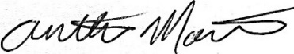

Anthony Montoya, Jr., P.E., C.F.M.
Senior Engineer, Hydrology
Planning Department, Development Review Services

