Photos taken on 12-16-13 for Permanent CO approval.

Curtis Cherne, 12-16-13

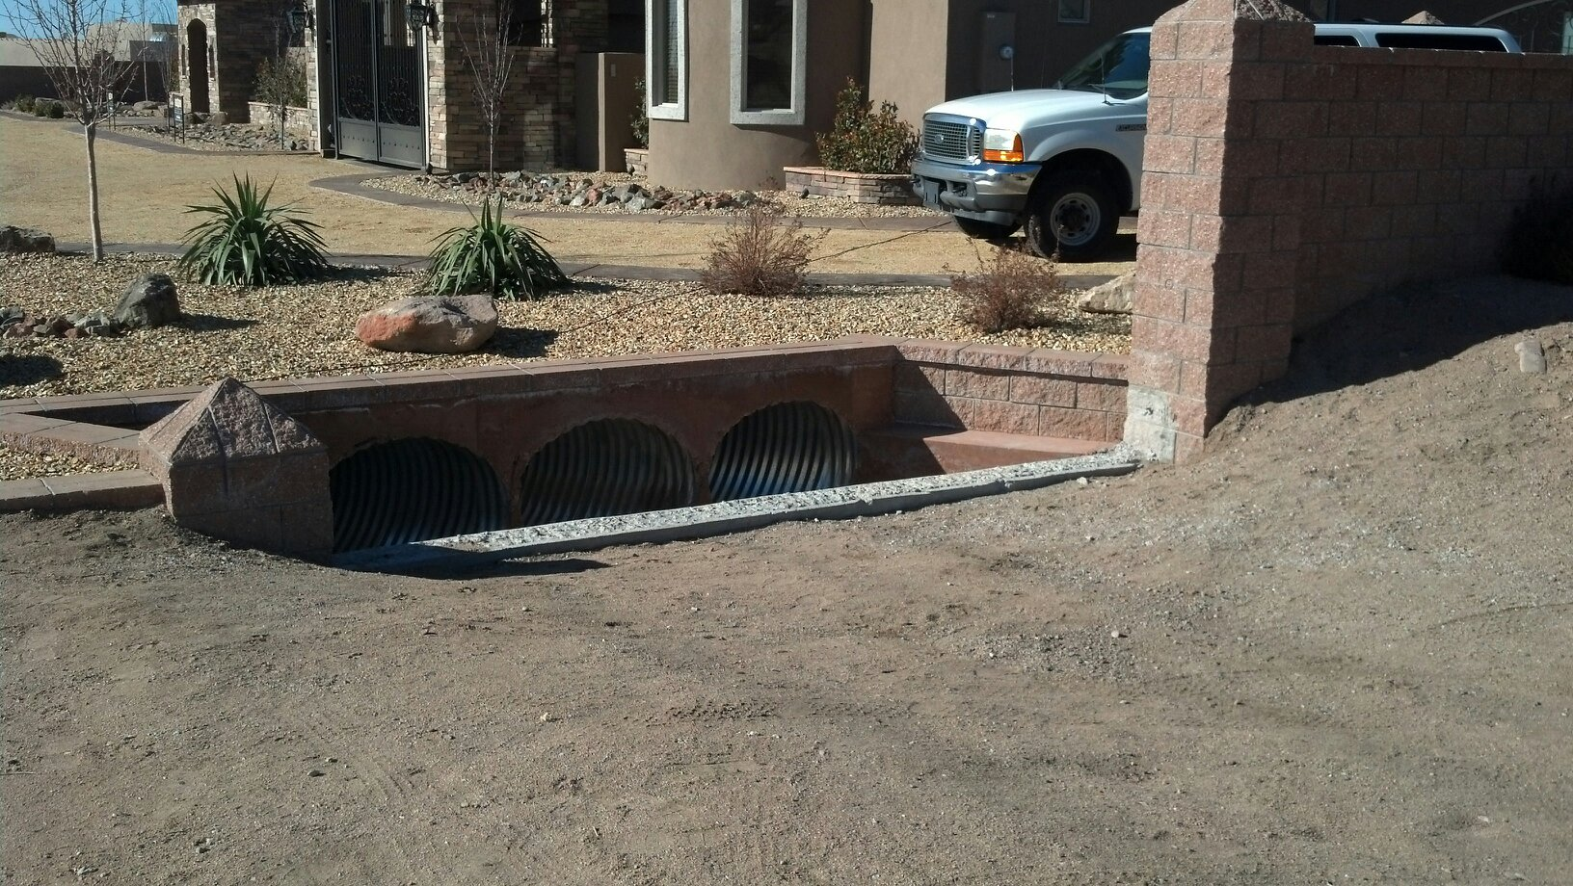

Upstream end of storm drains.

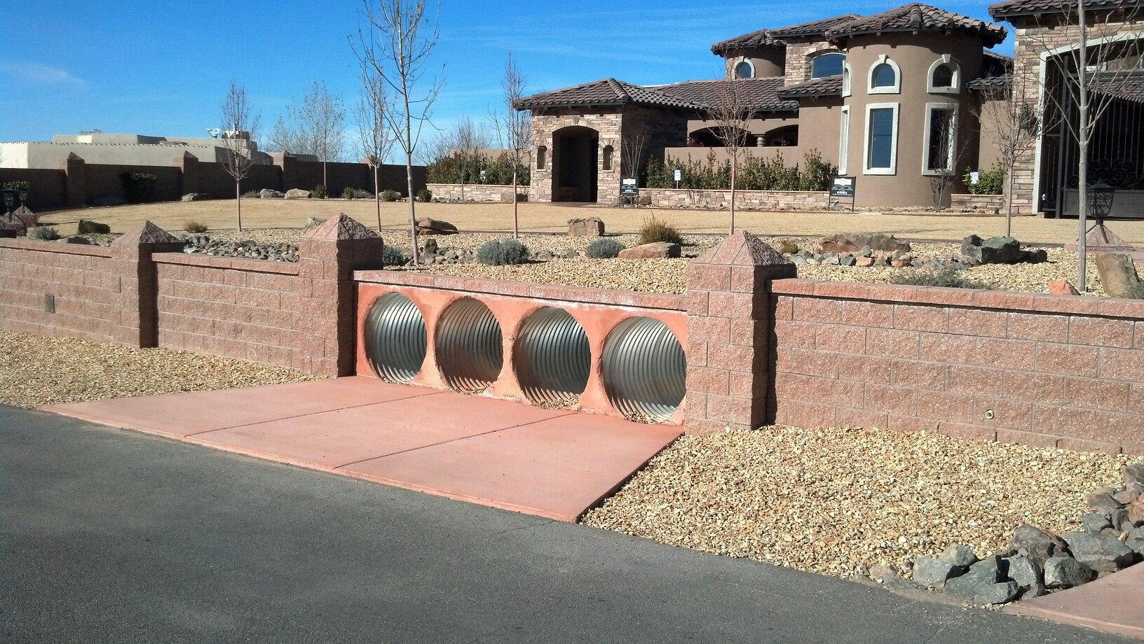

Downstream end of storm drains.

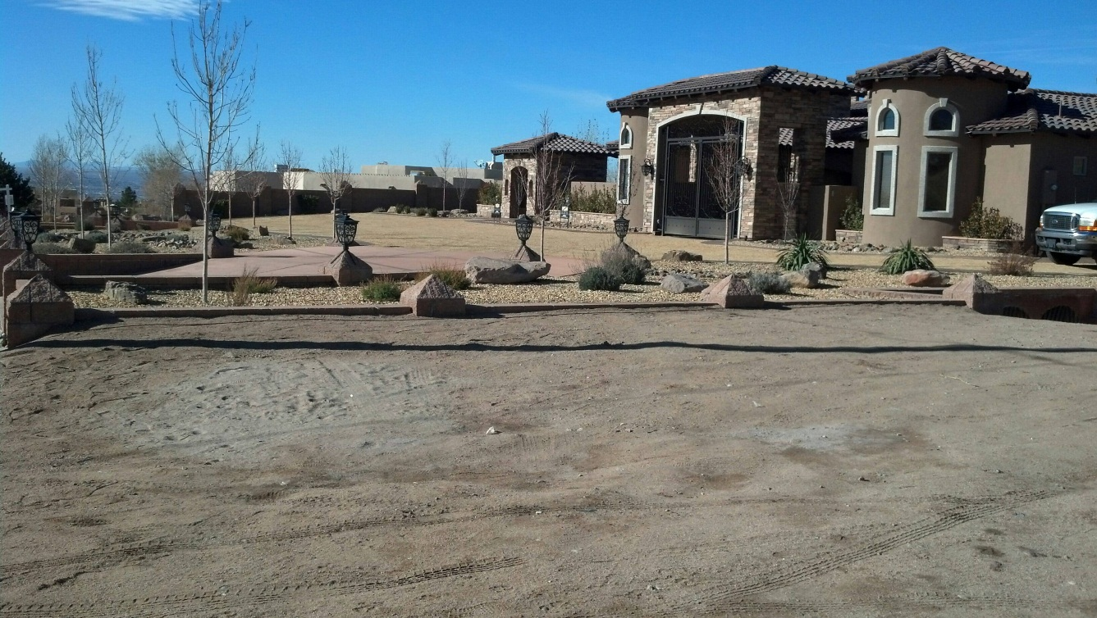

East property line where wall was removed.

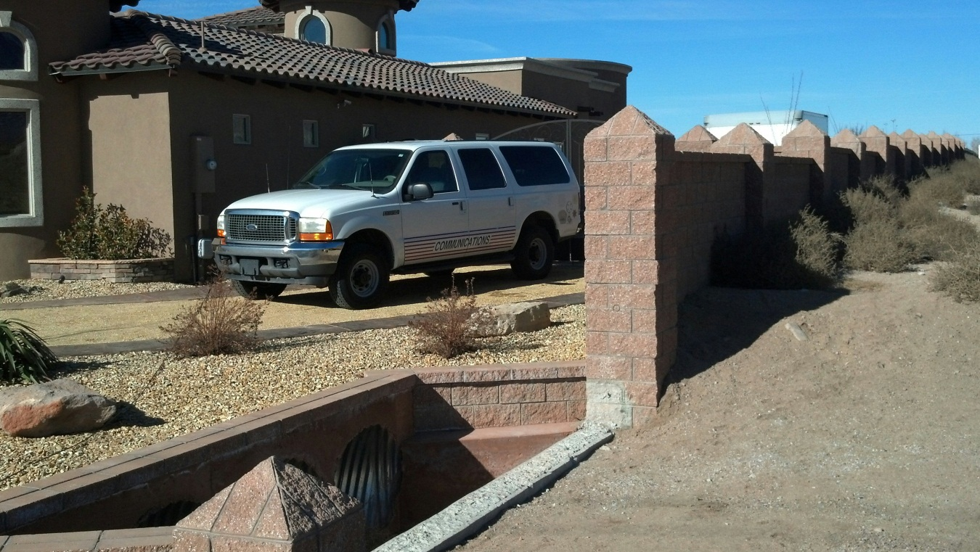

Upstream end showing height of intake wall compared to pilaster.

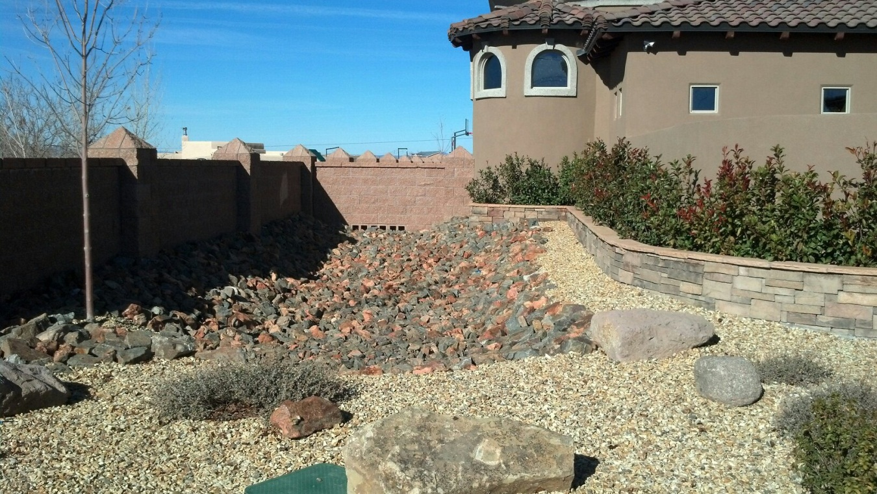

Pond on west side of property to mitigate the increase in impervious area.

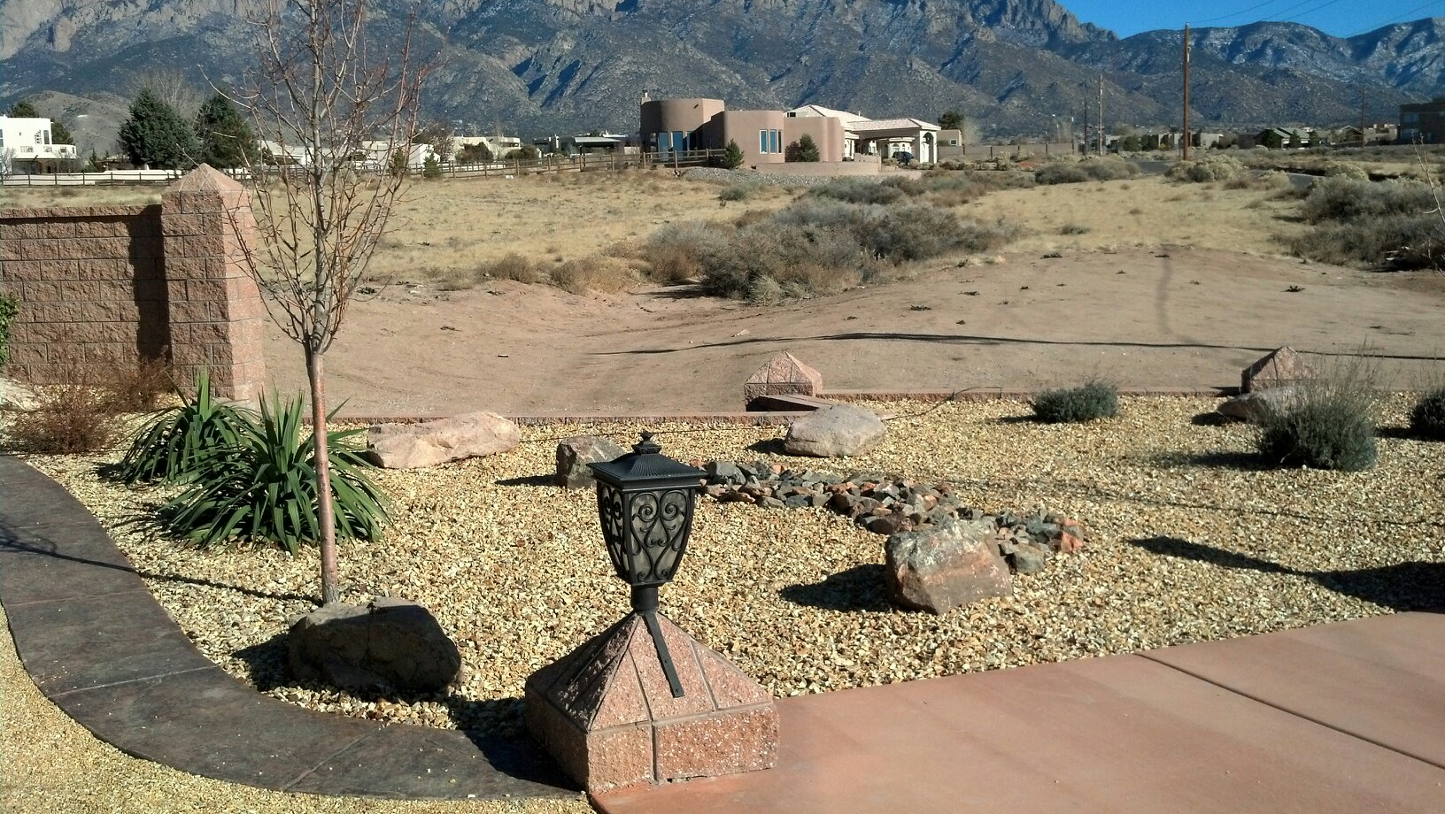

View from driveway looking east at the arroyo.

Additional photos are electronically stored in \B20D021\Final_CO