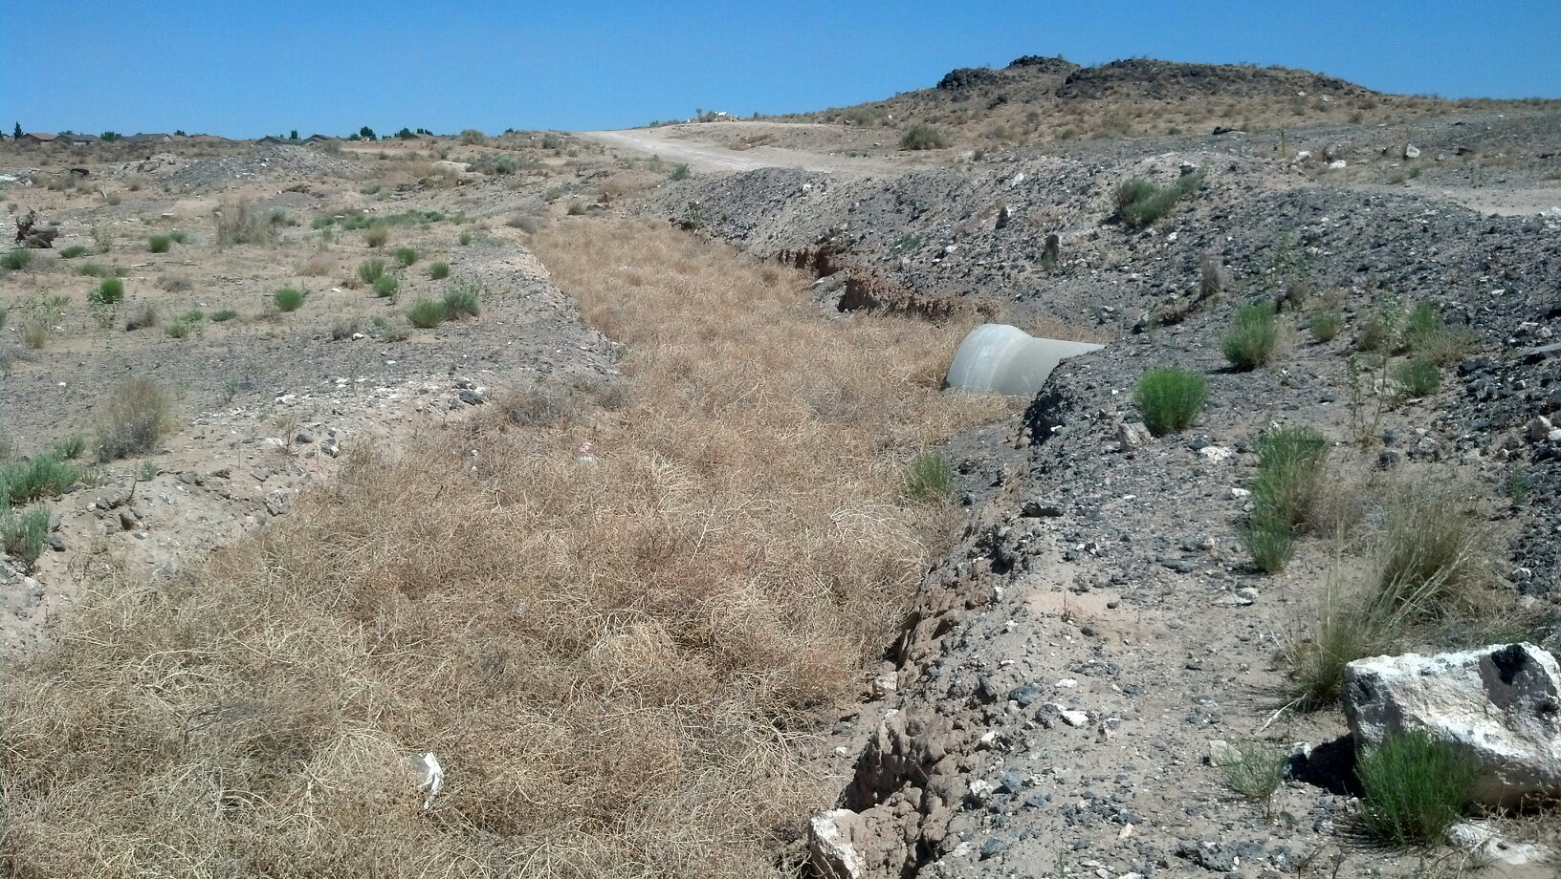

Tumbleweed pond northwest of the end of Treeline Road.

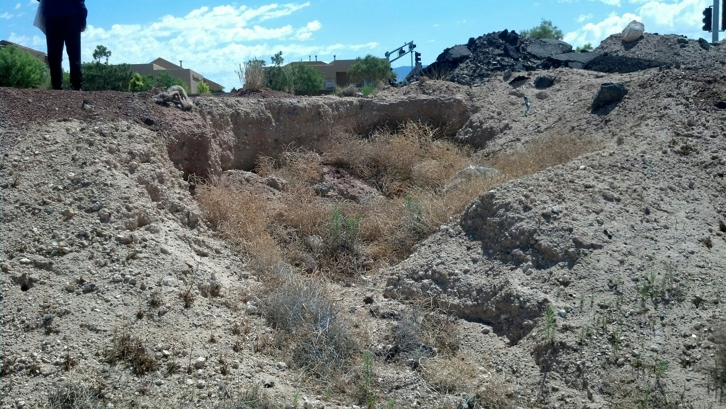

Southeast corner of Pond E where offsite flows have eroded the side of the pond.