May 2, 2019

Brent Jennings, Albuquerque Medical Offices, LLC, bajennings@allergypartners.com

Copy: Tim Ott, Truemindllc@gmail.com, Shakeel Rizvi, shaky1424@yahoo.com

Site: Allergy Clinic, 7001 Signal Ave

**Re: Drainage Ordinance (14-5-2-1) Violation for Erosion and Sediment Control**

Dear Mr. Jennings,

The following violation was observed at yesterday’s inspection.

1. Too much sediment in the street.

2. No sediment BMP downhill from street utility cut.

Photos are shown below:

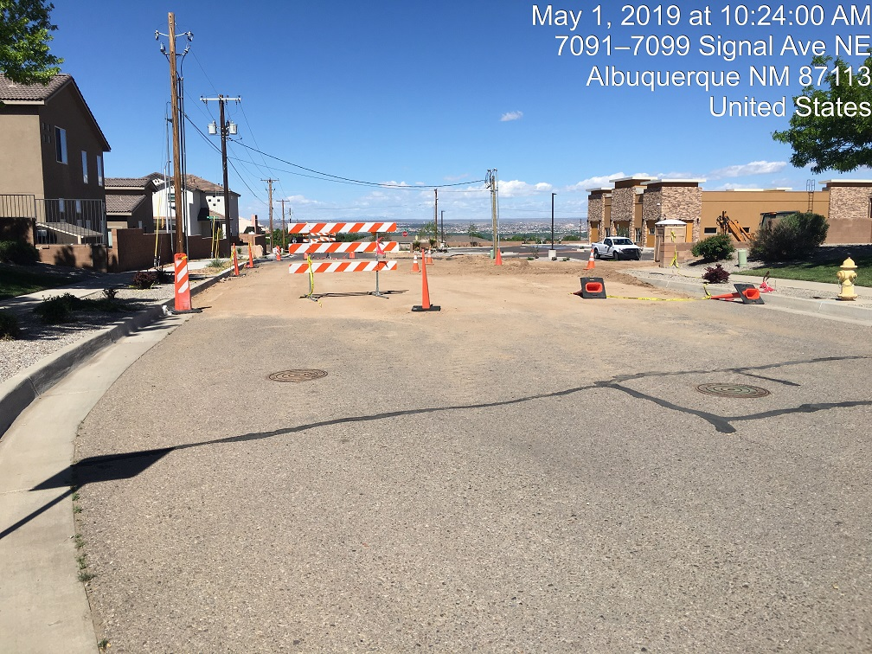

Sediment in Signal Ave 5-1-19.

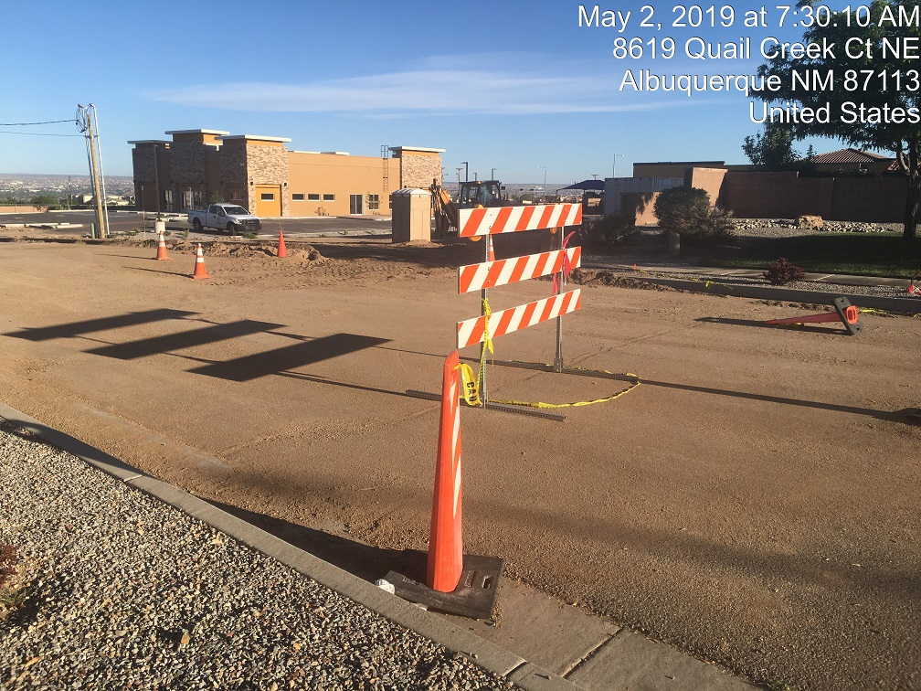

Sediment in Signal Ave 5-2-19. Dirt piles in the street/gutter.

**Required Mitigation:**

1. Remove sediment from Signal Ave.

2. Do not leave sediment in Signal Ave in the future. If sediment is present in the street it is to be removed daily.

3. Provide a sediment BMP for the utility cut in the street or repave it so dirt is not exposed.

If violations are not mitigated within 7 days, the property owner is subject to a fine of $500/day per the City’s Drainage Ordinance.

If you would like to schedule a follow-up inspection at a day and time of your convenience, prior to 7 days from the date of this letter please let me know.

If you have any questions, you can contact me at 924-3420.

Sincerely,

Curtis Cherne, P.E.

Principal Engineer, Stormwater Quality

Planning Dept.