July 1, 2016

Donnie Duneman, P.E.

Wilson and Company, Inc.

4900 Lang Ave NE

Albuquerque, NM 87109

**Re: La Cuentista Unit II**

**Erosion and Sediment Control Plan**

**Engineer’s Stamp Date 6-20-16 (D10E002B)**

Dear Mr. Duneman,

Based upon the information provided in your submittal received 6-21-16 the above referenced plan cannot be approved until the following comments are addressed:

To apply for an ESC Permit for Grading:

1. Silt fence or other sediment BMP should be proposed on the north side of lots 31 through 36 since they are higher than Rosa Parks Rd.

2. The outlet structure in the existing pond should be protected.

To be included in the Work Order Construction Plans:

1. The plan was submitted not seeking ESC Permit-Building Permit, however, in residential subdivisions, the plan should provide BMPs to allow the owner of the lots to obtain an ESC Permit for Building Permit so that the homebuilder can use this plan to apply for his/her ESC Permit. Comments will align with this method.

2. Provide inlet protection for all inlets shown on the plan. Inlet protection should be modified as the subdivision develops. When the inlets are first constructed a more restrictive form of protection should be used then as the roads get completed, houses

start getting built and there is less exposed dirt and the peak flows increase due to more impervious area the inlet protection should be revised to a BMP that is less restrictive such as a gravel mulch sock or similar. See photo below.

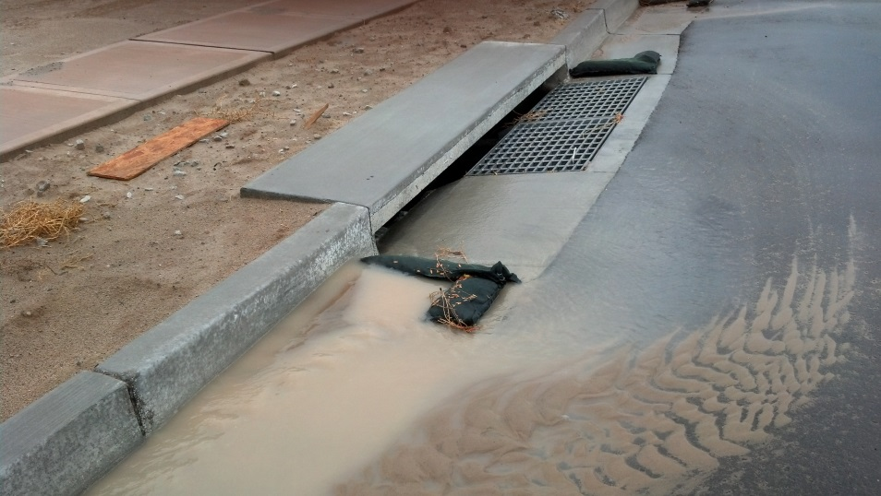

3. Provide longitudinal street slopes. On streets where the longitudinal slope is steeper than 2.5%, wattles or j-hook silt fence should be placed in the front yard swale.

4. Include the interim erosion measure shown on the grading plan on the ESC plan; Interim Erosion Control System Detail and its location on Basil Place and the Coir Roll Detail from Sheet 10 of 32 and the interim measure on Red Clover St.

5. It is not clear where the Detail A5 “Inlet Sediment Barrier Detail is to be used. It is too large to be placed in a constructed street and appears to only apply to a Type “D” inlet.

6. Provide an electronic copy (e-mail) with the next submittal.

If you have any questions, you can contact me at 924-3420.

Sincerely,

Curtis Cherne, P.E.

Principal Engineer, Stormwater Quality

Planning Dept.

C: kisusco@wilsonco.com