February 24, 2026

Yolanda Padilla Moyer, P.E.
Bohannan Huston, Inc.
7500 Jefferson St NE
Albuquerque, NM 87109

RE: La Cuentista Subdivision Phase 4 – Lots 202-220 and 228
Pad Certification – Accepted
Engineer’s Certification Date: 02/11/2026
Engineer’s Stamp Date: 12/10/2021
Hydrology File: D10D002D
Case # HYDR-2026-00054

Dear Ms. Padilla Moyer:

Based on the Pad Certification received 02/19/2026 and the site visit on 02/20/2026, this letter serves an approval of the Pad Certification for La Cuentista Subdivision Phase 4 – Lots 202-220 and 228. Please attach a copy of this approval letter and approved Grading and Drainage Plan with each lot’s Building Permit submittal.

If you have any questions, please contact me at 505-924-3995 or baileythompson@cabq.gov.

Sincerely,
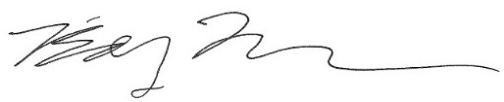
Bailey Thompson, E.I.
Engineering Associate, Hydrology
Planning Department, Development Review Services

