November 26, 2019

Las Lomitas Industrial, LLC - Joshua Pineda [Joshua.pineda@comcast.net](mailto:Joshua.pineda@comcast.net)

[josh@yardmanlandscaping.com](mailto:josh@yardmanlandscaping.com)

Site: 7901 Las Lomitas Dr. NE – D16E002I

**Re: Drainage Ordinance (14-5-2-1) Violations for Erosion and Sediment Control**

Dear Mr. Thukar,

The following violations were observed at the inspection today.

* Stormwater controls (BMPs) are missing (Silt Fence).
* Your ESC Permit is not posted for public inspection.

Photos are shown below.

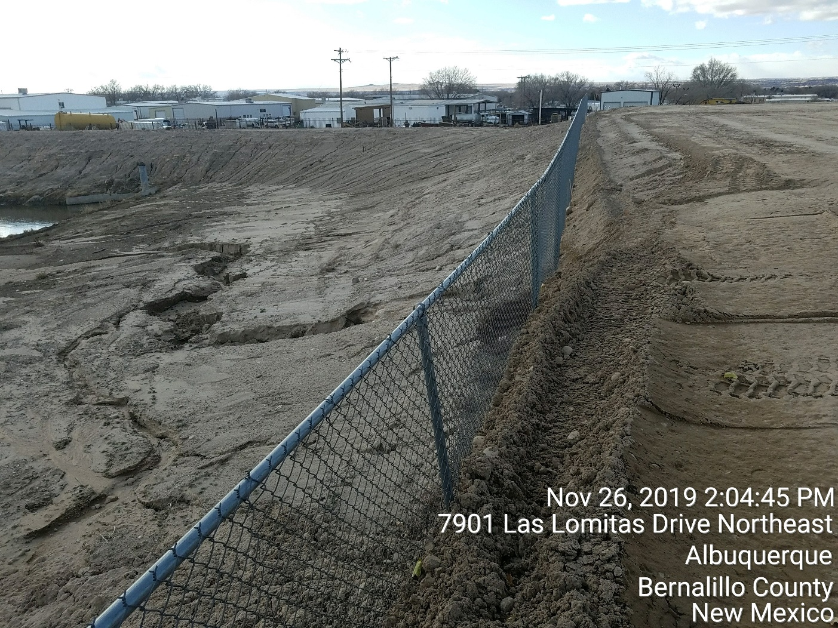

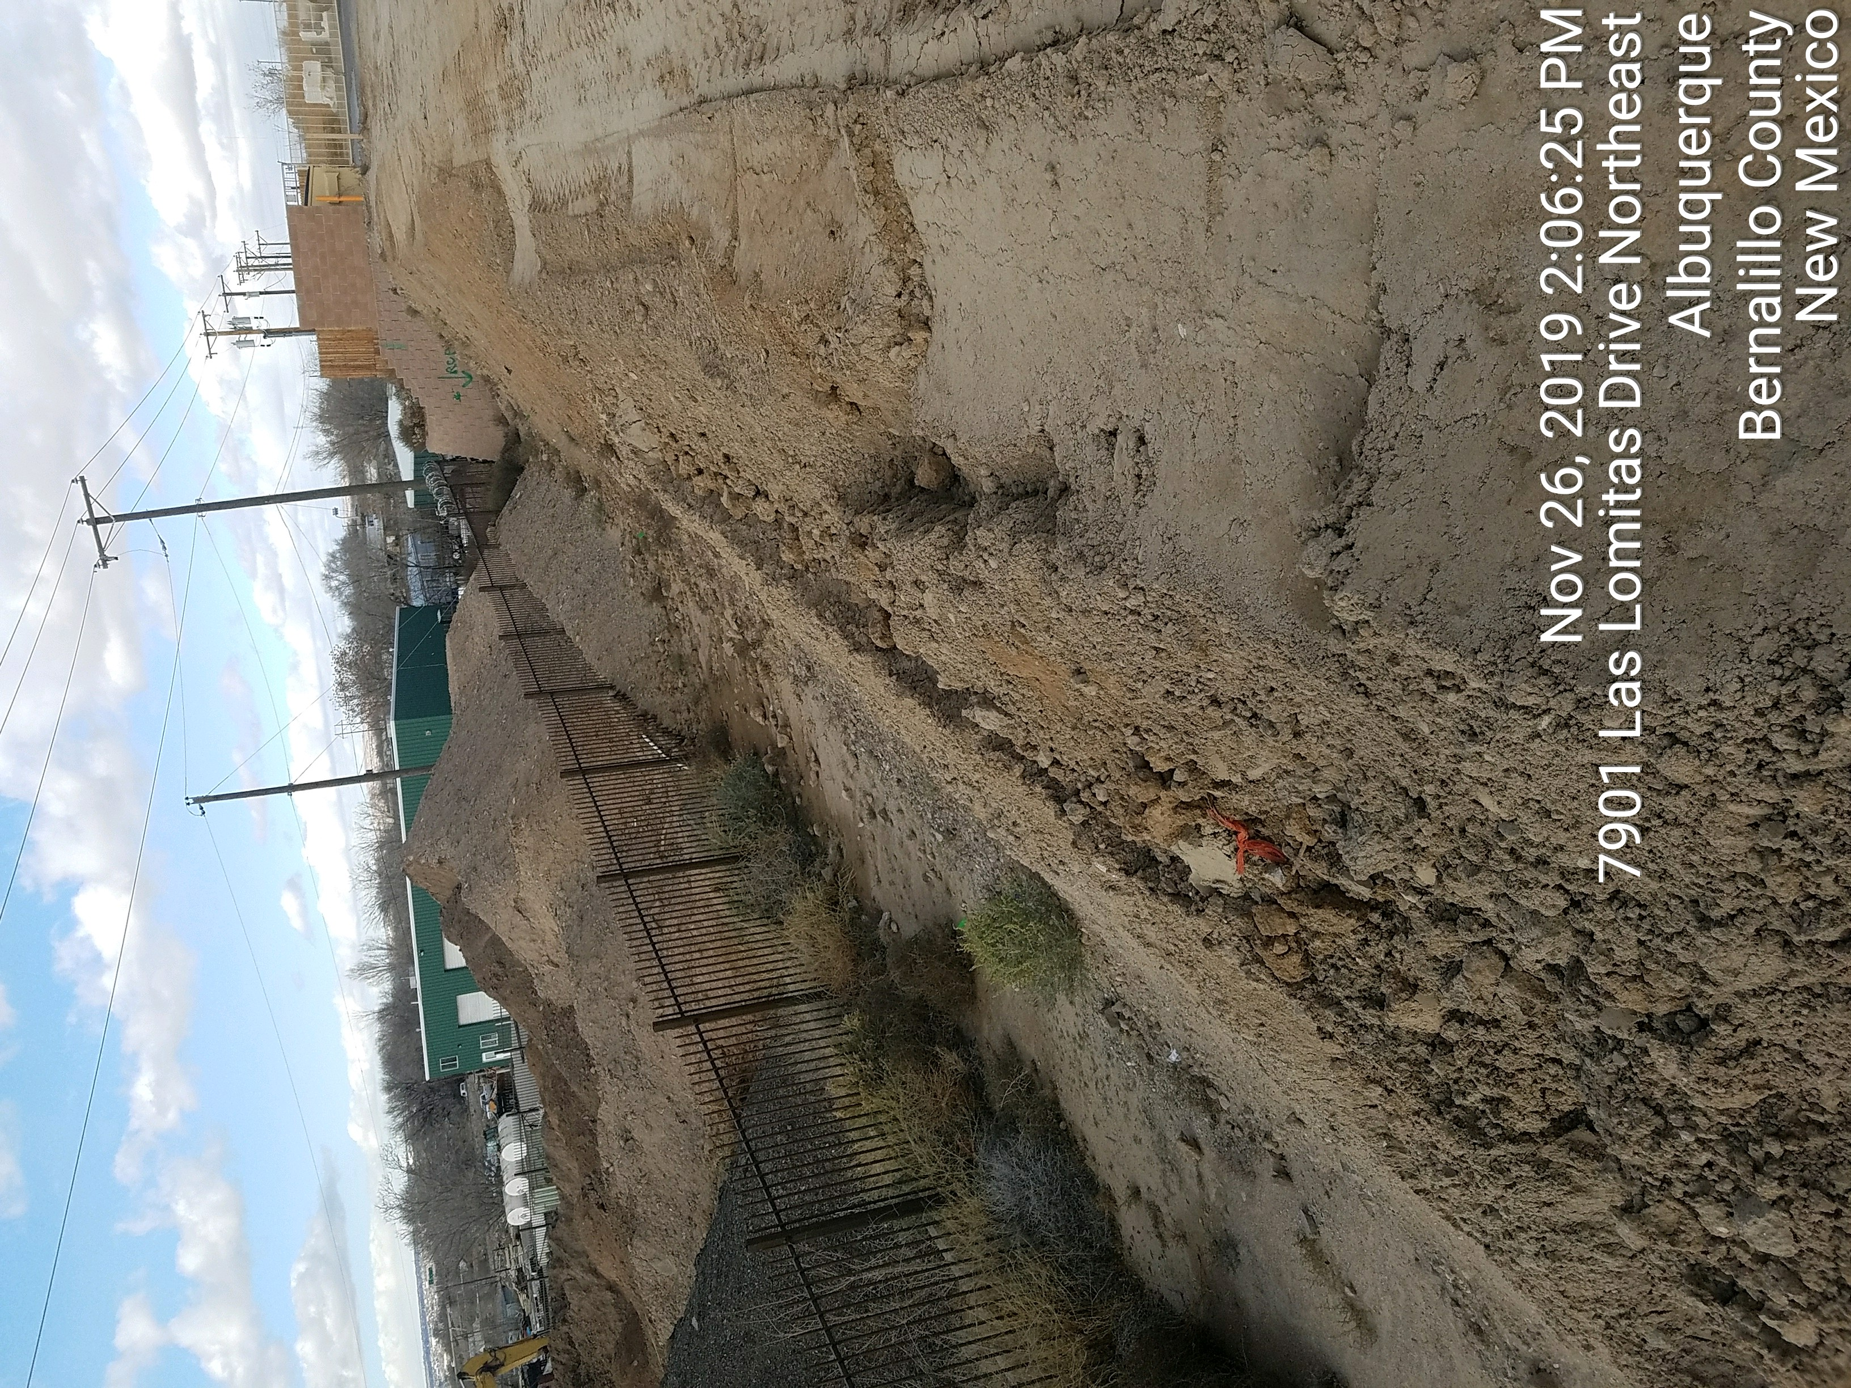

**Required Mitigation:**

* Post your permit.
* Install and maintain stormwater controls (BMPs) per the approved plan.

If the violations are not mitigated within 7 days, the property owner is subject to a fine of $500/day per the City’s Drainage Control Ordinance.

If you have any questions, you can contact me at 924-3420 or [jhughes@cabq.gov](mailto:jhughes@cabq.gov) .

Sincerely,

James D. Hughes, P.E.

Principal Engineer, Hydrology/Stormwater Quality

Planning Dept.