May 7, 2024

Joe Casares

JCII Group, LLC

8105 Sand Springs Ct NW

Albuquerque, NM 87114

**Re: Hope Christian High School**

**Neighborhood Impact Analysis, HT#D18D009**

**Report dated April 29, 2024**

Engineer’s Stamp ---

Via email JCIIGroup@gmail.com

Dear Mr. Casares,

The subject Neighborhood Impact Analysis received May 2, 2024, has been reviewed by the City of Albuquerque Planning Development Transportation Section. The City has the following comments to be addressed. Please resubmit the NIA for review by the City.

1. Revise the striping of the northbound Two-way Left-turn lane on San Pedro Dr. approaching the proposed Hope Christina School south driveway to a left-turn lane. Adjust the southbound left-turn lane striping at the access to the FAA facility on the east side of San Padro D., across from the proposed Hope Christian school access.
2. Convert the two-existing crosswalk on Palomas Ave. to Raised Crosswalks/Speed tables. Refer to *https://nacto.org/publication/urban-street-design-guide/street-design-elements/vertical-speed-control-elements/speed-table/*
3. Refer to Part 7, Traffic Control for School Areas, of the of the MUTCD and consult with the City of Albuquerque DMD Traffic Operations to establish and properly sign and mark the School Zones on Palomas Dr.
4. On Palomas Ave. in locations where there are raised medians and curb extensions on-street parking is prohibited. Consider using pavement marking words (No Parking) or crosshatching in the no parking zone in addition to the painted curbs and parking restriction signs. In areas where there is illegal on-street parking, parking enforcement should be enhanced to reduce the parking violations. Below is an image, in front of the elementary school, from Google Earth showing what appears to be parking in the no-parking zone with painted curbs.

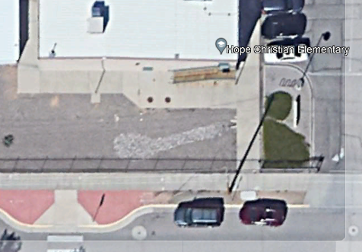

If you have any questions, feel free to contact me at (505) 924-3362.

Sincerely,



Matt Grush, P.E.

City of Albuquerque

Senior Engineer, Planning Dept.

Development Review Services

via: email

C: Applicant, File