May 2, 2019

Nic Whittaker, Overture Senior Living Center, nwhittaker@greystar.com

Copy: Jeff Smith, Pavilion Construction, jsmith@pavilionconstruction.com

Site: Overture Senior Living Center ABQ

**Re: Drainage Ordinance (14-5-2-1) Violation for Erosion and Sediment Control**

Dear Mr. Whittaker,

The following violation was observed at yesterday’s inspection.

1. Too much sediment in the street since 4-24-19.

2. Inadequate sediment BMP downhill from street utility cut that has not been repaved and the curb and gutter has not been replaced.

Photos are shown below:

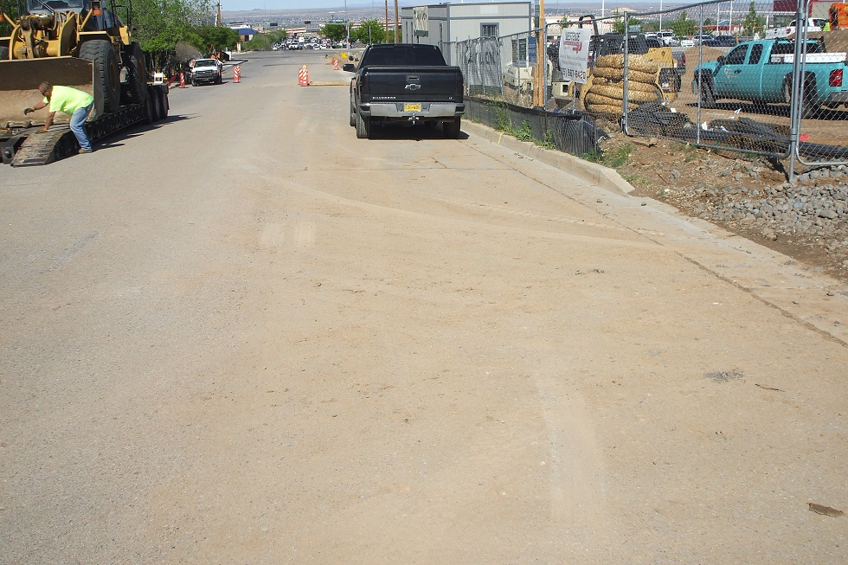Sediment in Palomas Ave 4-24-19.

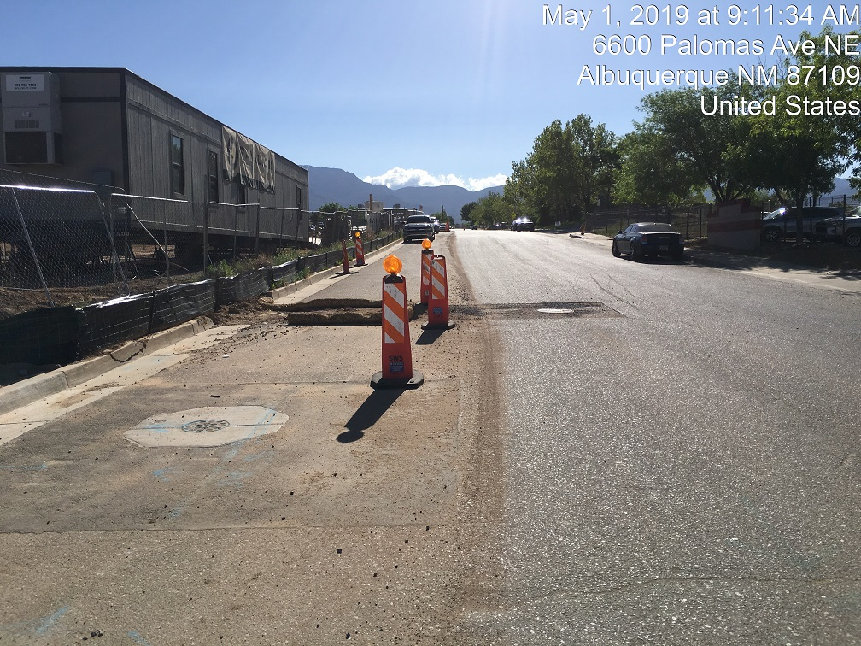

Sediment in Palomas Ave 5-1-19, west frontage of site. Street patch is dirt. No BMP downhill from patch at gutter.

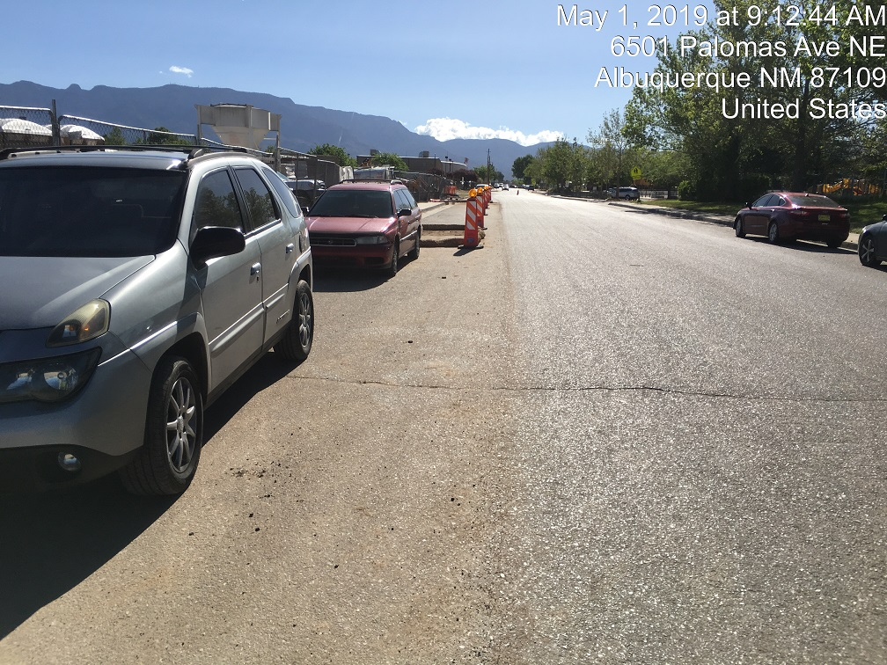

Sediment in Palomas Ave; east frontage of site.

**Required Mitigation:**

1. Remove sediment from Palomas Ave for the entire frontage of the project.

2. Place an adequate sediment BMP downhill from utility cut(s) in the street or replace the curb and gutter and asphalt.

3. Implement improved track-out control. Lengthening the track-out pad or increasing the aggregate size may help.

4. If sediment is observed in Palomas Ave it is to be removed by the end of the same business day. Having a sweeper on site, mechanical or manual, is most likely necessary.

If violations are not mitigated within 7 days, the property owner is subject to a fine of $500/day per the City’s Drainage Control Ordinance.

If you would like to schedule a follow-up inspection at a day and time of your convenience, prior to 10 days from the date of this letter please let me know.

If you have any questions, you can contact me at 924-3420.

Sincerely,

Curtis Cherne, P.E.

Principal Engineer, Stormwater Quality

Planning Dept.