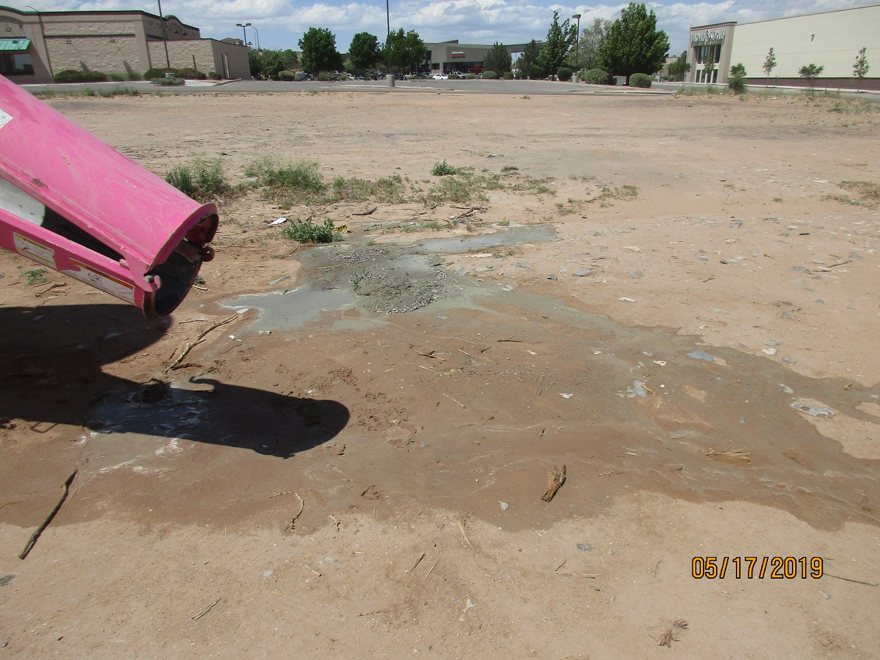

Concrete truck was-out on lot east of the O’Reilly Auto Parts store. This is the day after I met with the owner and the superintendent and we discussed not washing out in the dirt and discussed using an Outpak or similar.