September 13, 2019

Joe E Dennis via e-mail [dee@leumasllc.com](mailto:dee@leumasllc.com)

Site: 3605 Osuna NE

**Re: Drainage Ordinance (14-5-2-1) Violations for Erosion and Sediment Control**

Dear Mr. Dennis,

The following violations were observed at today’s inspection.

* All erosion controls were missing.

Photos are shown below.

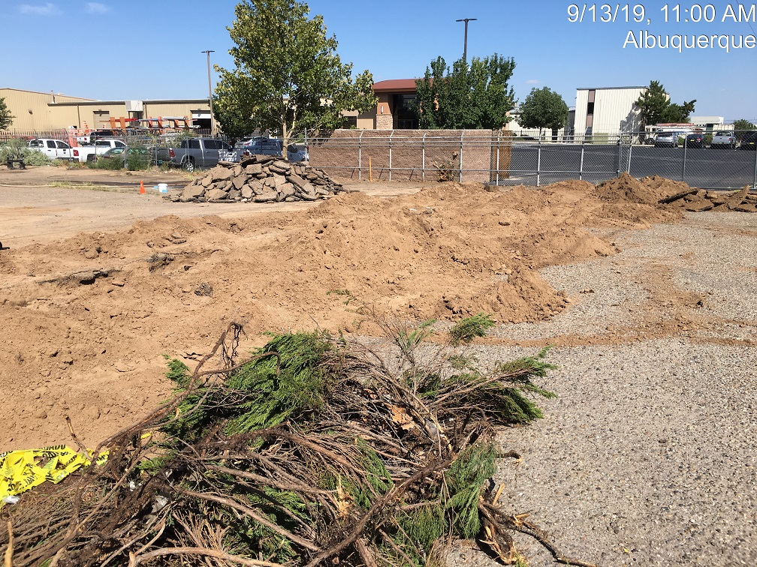East Side

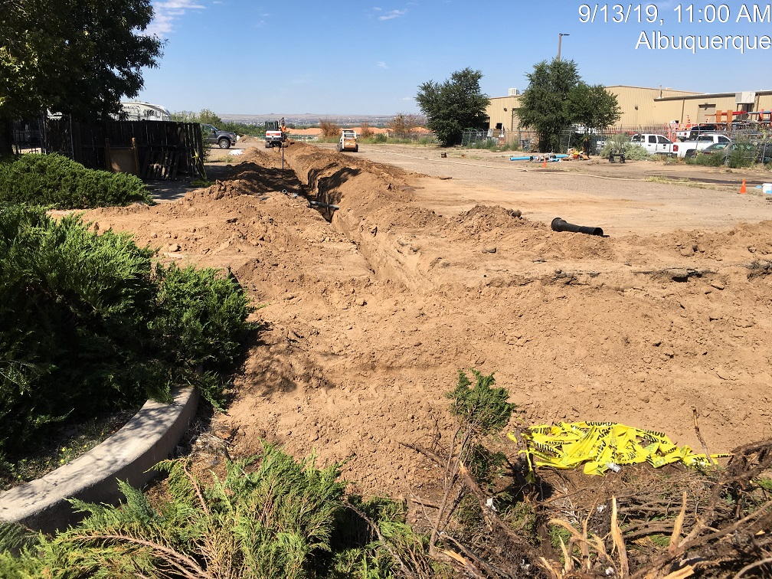

Waterline trench.

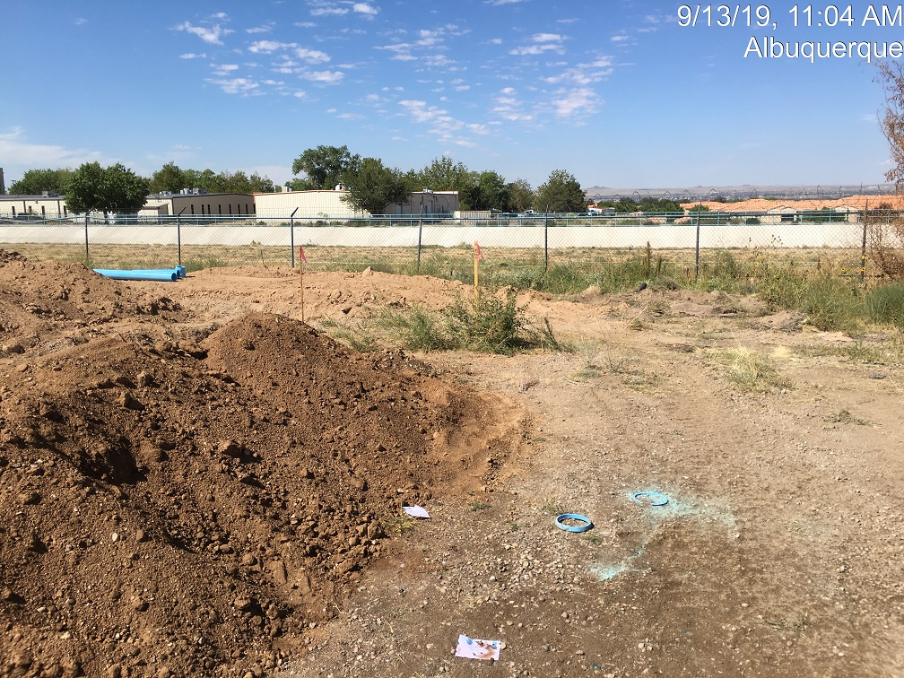

**West side**

**Required Mitigation:**

* Provide Erosion Controls

If the violations are not mitigated within 7 days, the property owner is subject to a fine of $500/day per the City’s Drainage Control Ordinance.

If you have any questions, you can contact me at 924-3420 or jhughes@cabq.gov

Sincerely,

James D. Hughes, P.E.

Principal Engineer, Hydrology/Stormwater Quality

Planning Dept.