February 3, 2016

David Soule, P.E.

Rio Grande Engineering

9171 Glendale Ave NE

Albuquerque, NM 87122

**Re: Papaya Village**

**Erosion Sediment Control Plan**

**Engineer’s Stamp Date 1-21-16 (E19E021A)**

Dear Mr. Soule,

Based upon the information provided in your submittal received 1-27-16 the above referenced plan is not approved to be included in the SWPPP or for ESC Permit or Work Order until the following comments are addressed:

For ESC Permit:

1. This site discharges directly to the Pino Arroyo. A more substantial sediment BMP is required at the discharge location at the north end of Papaya St. A sediment pond or wattle pyramid should be proposed.

2. When the concrete rundowns into the Pino Arroyo are being constructed, the one rundown being removed and the retaining wall is being constructed along the arroyo, a large wattle should be placed on the sill of the channel. See below.

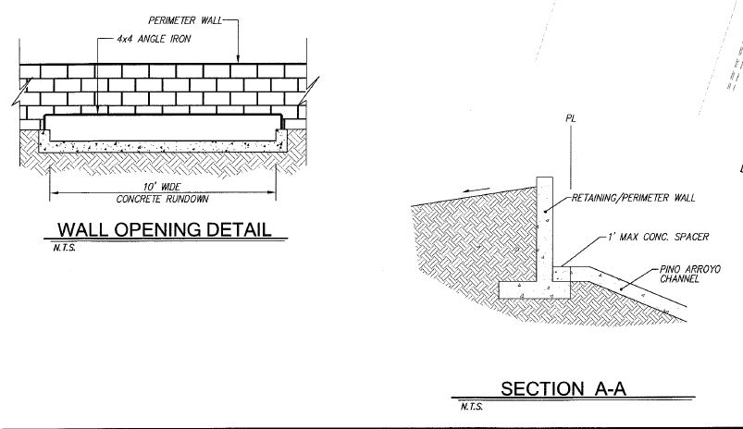

Possibly the silt fence along the channel should be omitted and replaced with the large wattle discussed above.

3. After the 10 foot concrete rundown has been built a wattle or similar should be placed across it. The wattle should be anchored so it doesn’t get washed away.

4. The grading plan shows longitudinal slopes on Tangerine Ct in excess of 2.5% (2.76 and 3.17). A wattle or j-hook silt fence should be placed in the front yard swales of lots 4 and 10.

5. Please add a note or similar that when doing work in the City ROW (sidewalk, sidewalk culverts, drive pads) to avoid dirt from getting into the street.

6. This plan may benefit from more than one sheet; one sheet for mass grading and wall work along the channel and another sheet for Work Order and ESC Permit approval.

If you have any questions, you can contact me at 924-3420.

Sincerely,

Curtis Cherne, P.E.

Principal Engineer, Stormwater Quality

Planning Dept.

C: email, Jeff@inpsectionsplus.com