February 22, 2015

Mark Goodwin, P.E.

Mark Goodwin and Associates

P.O. Box 90606

Albuquerque, NM 87199

**Re: Fruita Del Sol Townhomes**

**Erosion Sediment Control Plan**

**Engineer’s Stamp Date –no stamp- (E19E021A)**

Dear Mr. Goodwin,

Based upon the information provided in your submittal received 2-18-16 the above referenced plan is not approved to be included in the SWPPP or for ESC Permit or Work Order until the following comments are addressed:.

1. When the site is being mass graded, a more substantial BMP (silt fence not strong enough) is required at the discharge location at the north end of Papaya St. A sediment pond or wattle pyramid should be proposed.

2. When the concrete rundowns into the Pino Arroyo are being constructed, the one rundown being removed and the retaining wall is being constructed along the arroyo, a large wattle should be placed on the sill of the channel. See below.

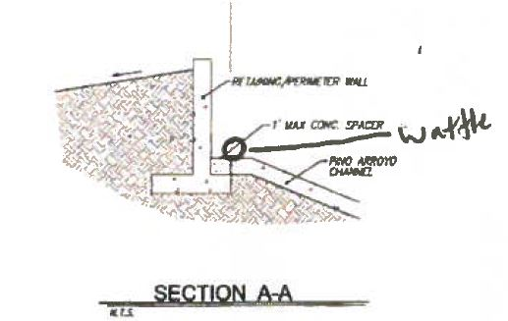

Possibly the silt fence along the channel should be omitted and replaced with the large wattle discussed above.

3. Please add a note or similar that when doing work in the City ROW (sidewalk, sidewalk culverts, drive pads) to avoid dirt from getting into the street.

4. This plan may benefit from more than one sheet; one sheet for mass grading and wall work along the channel and another sheet for Work Order and ESC Permit approval.

5. If a utility cut(s) are required for water and sewer, they should be shown on this plan, with a legend symbol and Keyed note for the dirt pile to be placed on the uphill side of the cut and the street is to be swept when the work is complete.

6. The ESC plan is not stamped.

7. A DTIS sheet is to accompany the plan.

8. The BMPS can be superimposed upon the grading plan or at minimum, street slopes (e.g. 2.8%) are required.

If you have any questions, you can contact me at 924-3420.

Sincerely,

Curtis Cherne, P.E.

Principal Engineer, Stormwater Quality

Planning Dept.

C: email