September 19, 2016

Scott Ashcroft: tscott@lasventanasnm.com

Las Ventanas NM Inc.

8504 Waterford NE

Albuquerque, NM 87122

**Re: Drainage Control Ordinance (14-5-2-1) and NPDES CGP Violations for Erosion and Sediment Control and pollution - La Luz Del Oeste Unit 4**

Dear Mr. Ashcroft,

On August 19th, 2016, the City issued a Violation Letter (Order) that listed the numerous violations that were to be mitigated. They are listed below:

1. A silt fence to be added along Dellyne Ave. to prevent sediment from leaving the site.

2. The construction entrance needed maintenance.

3. Numerous instances of cement pollution.

During the follow-up inspection conducted September 19th, 2106 the following violations were observed:

1. Construction entrance needs maintenance.

2. Multiple instances of cement pollution.

3. Silt fence was installed along Dellyne, Ave., however, it was not installed so that it would function to prevent sediment from leaving the site as it was not buried.

Photos of the violations are shown on pages 2 and 3.

You were notified that “In addition, if the violations are not mitigated within 30 days or are found again after 30 days, the property owner is subject to a fine up to $500/day per the City’s Drainage Control Ordinance.”

Required Mitigation:

1. Install/maintain the silt fence at the site per approved plan.

2. Install a stabilized entrance per the approved plan.

2. Remove cement pollution material per acceptable methods.

Per the previous Violation letter, the City is assessing a fine of $500. This fine is for one day. Additional days may be added if the violations are not mitigated upon a follow-up inspection in seven days or violations are observed in future inspections.

If you have any questions, you can contact me at 924-3420.

Sincerely,

Curtis Cherne, P.E.

Principal Engineer, Stormwater Quality

Planning Dept.

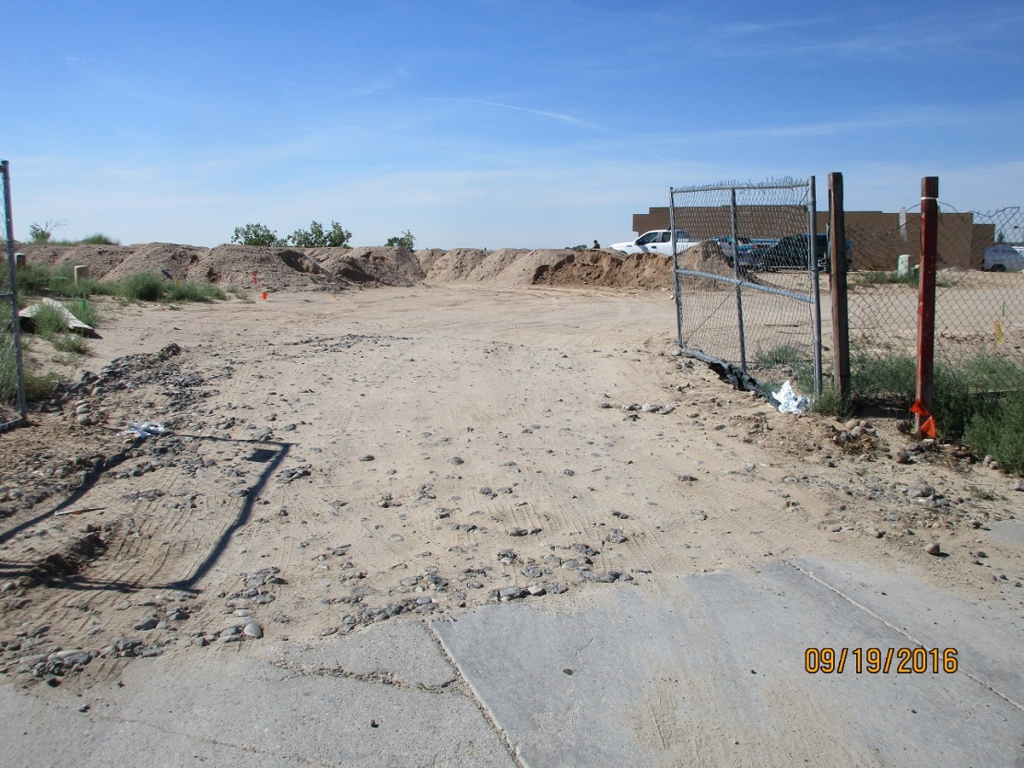

Construction entrance to the site poorly maintained.

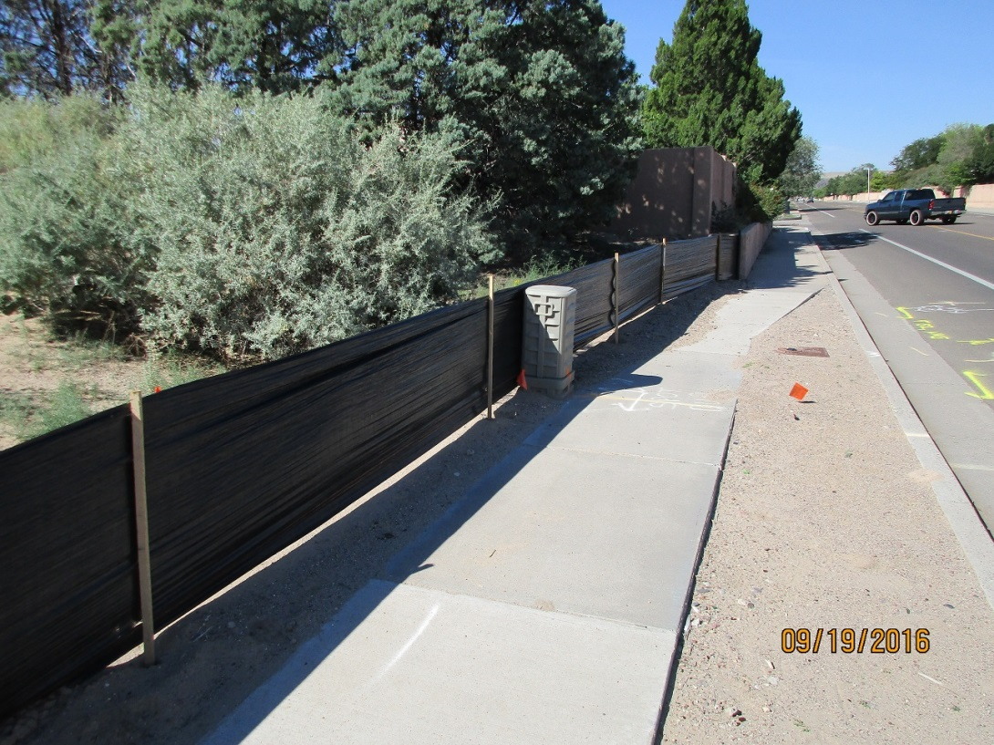

Silt fence along Dellyne Ave. not buried; ineffective.

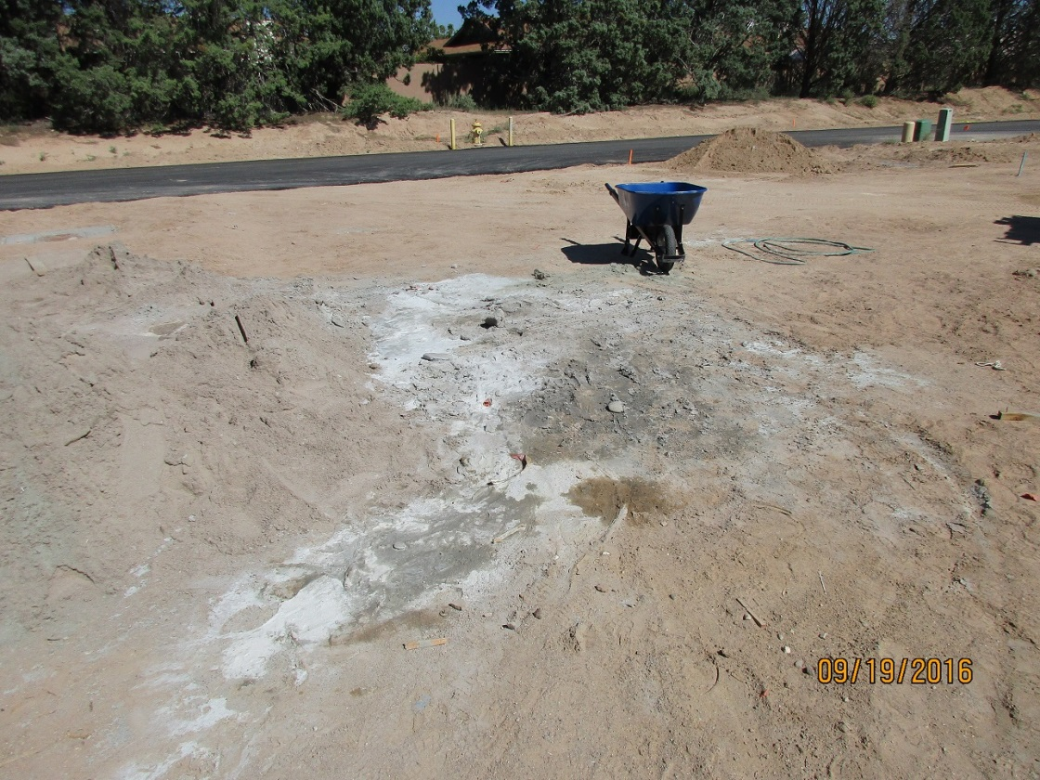

Cement pollution.

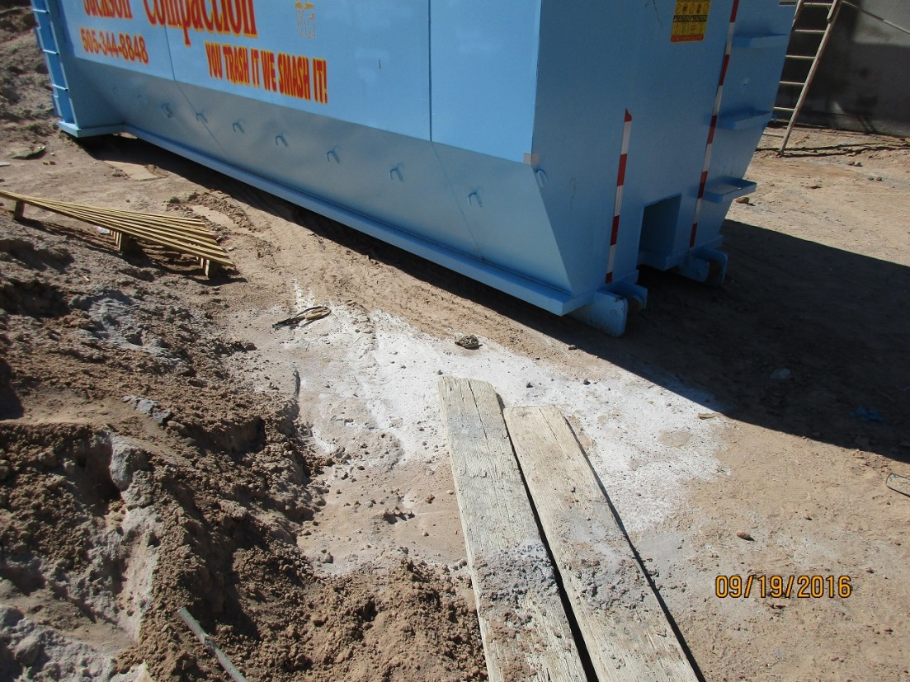

Second photo of cement pollution.

End of photos/letter