October 11, 2019

Montanio I-25 Property, LLC. Manager Steve Abraham

Montanio I-25 Property, LLC Jeff Elliott [Jeff@woodsonia.net](mailto:Jeff@woodsonia.net)

Topgolf USA Albuquerque, LLC [euebelhor@arcomurray.com](mailto:euebelhor@arcomurray.com)

Site: Top Golf - 1600 Desert Surf Cir. NE

UPC 101606124107430118

**Re: Drainage Ordinance (14-5-2-1) Violations for Erosion and Sediment Control**

Dear Mr. Dennis,

The following violations were observed at today’s inspection.

* Sediment Track-out in public street

Photos are shown below.

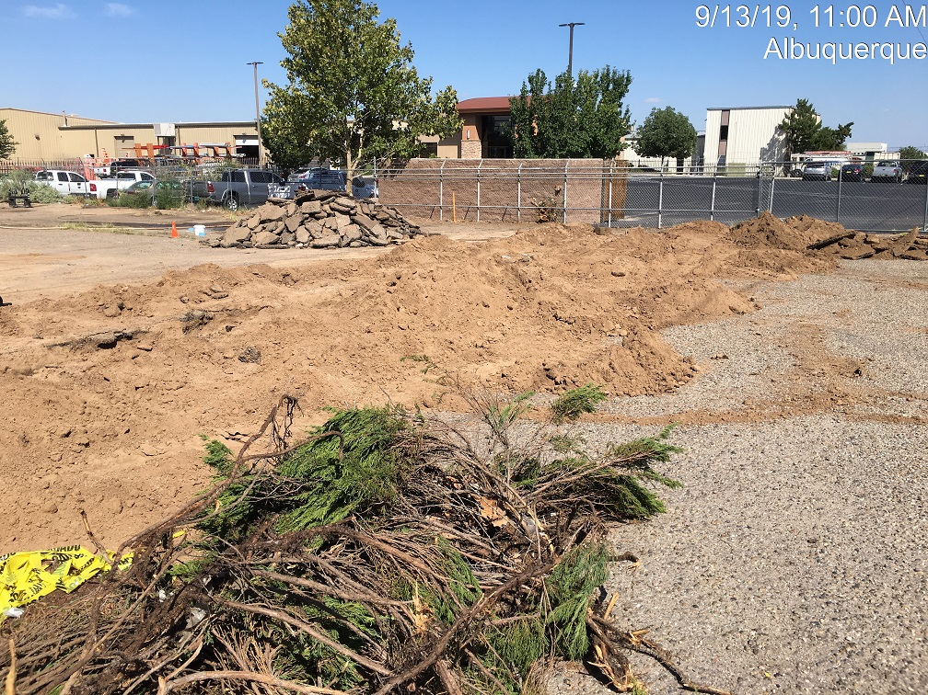East Side

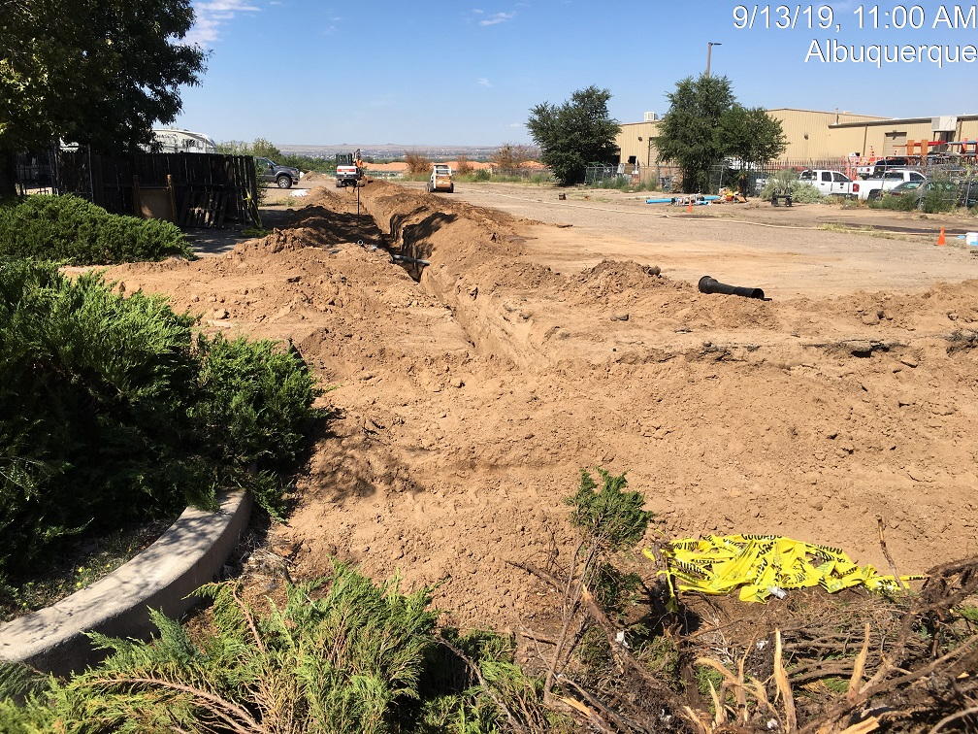

Waterline trench.

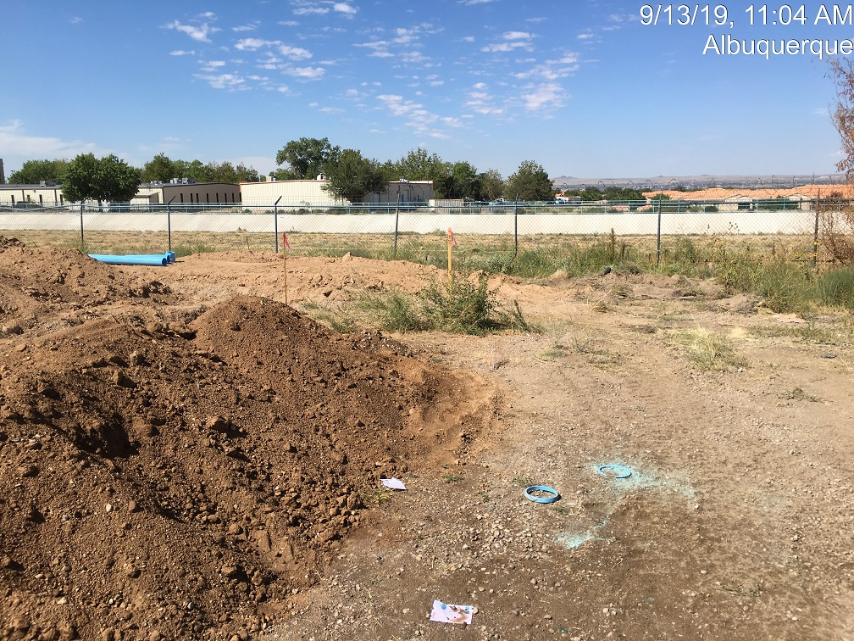

**West side**

**Required Mitigation:**

* Provide Erosion Controls

If the violations are not mitigated within 7 days, the property owner is subject to a fine of $500/day per the City’s Drainage Control Ordinance.

If you have any questions, you can contact me at 924-3420 or jhughes@cabq.gov

Sincerely,

James D. Hughes, P.E.

Principal Engineer, Hydrology/Stormwater Quality

Planning Dept.