October 24, 2019

Hunaman Corporation Sam Patel President [taurus5468@gmail.com](mailto:taurus5468@gmail.com)

Site: True by Hilton,. NE, F17E044C

**Re: Drainage Ordinance (14-5-2-1) Violations for Erosion and Sediment Control**

Dear Mr. Patel,

The following violations were observed at the inspections on 10/17/2019.

* Stormwater controls are in need of repair (Silt Fence).
* Sediment in the street.

Photos are shown below.

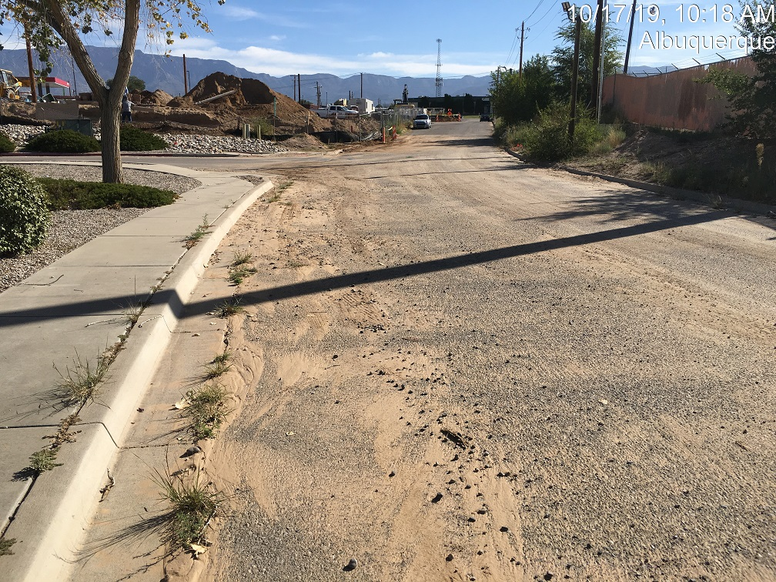

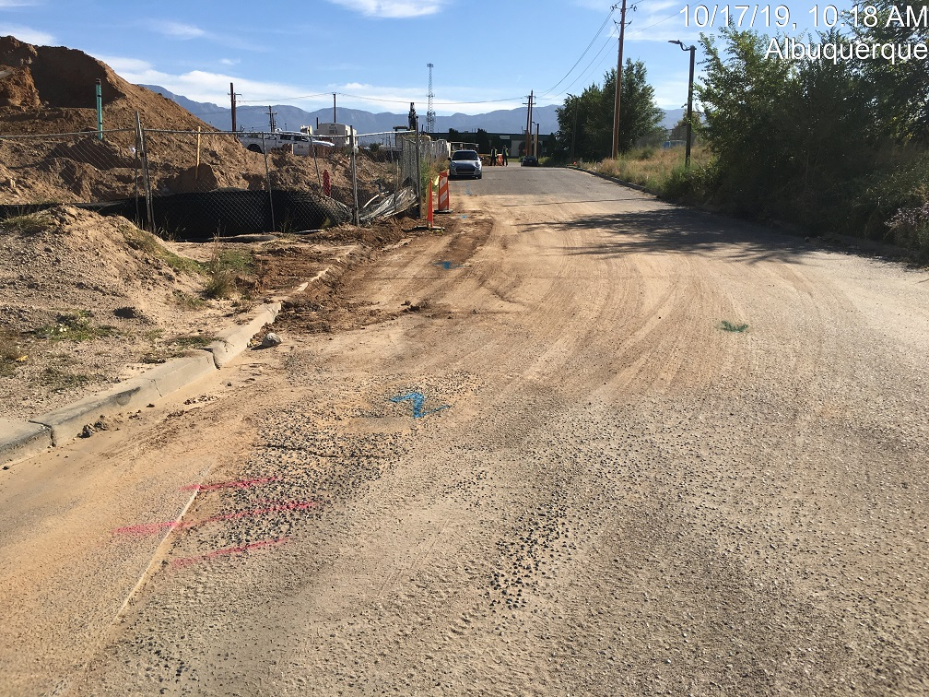

The following violations were observed at the inspections on 10/24/2019.

* Sediment in the street, HC ramp, sidewalk, rundown at south end of street and piled on adjacent private.

Photos are shown below. 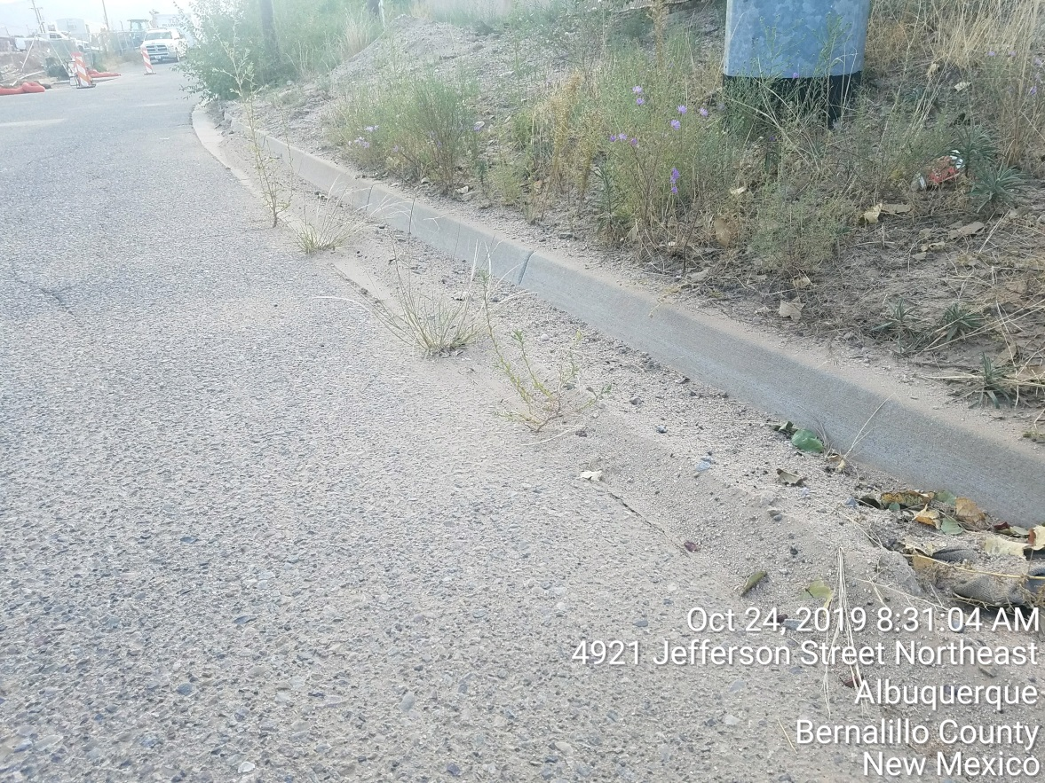

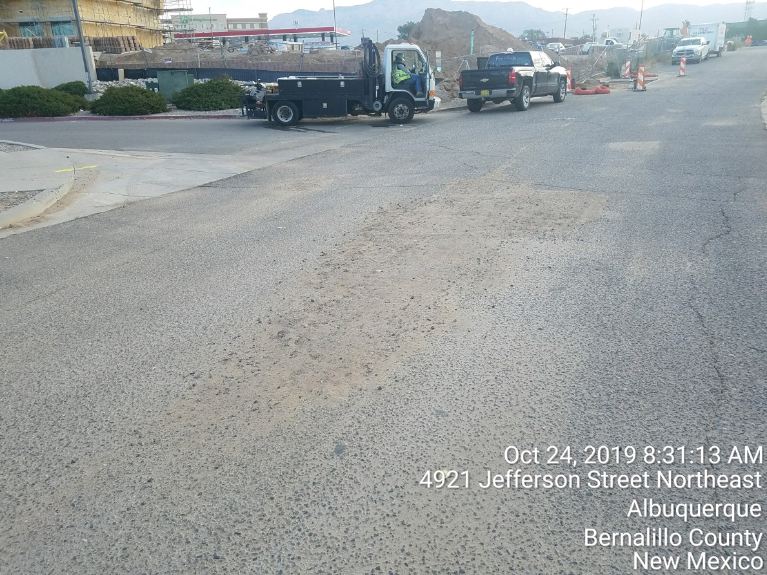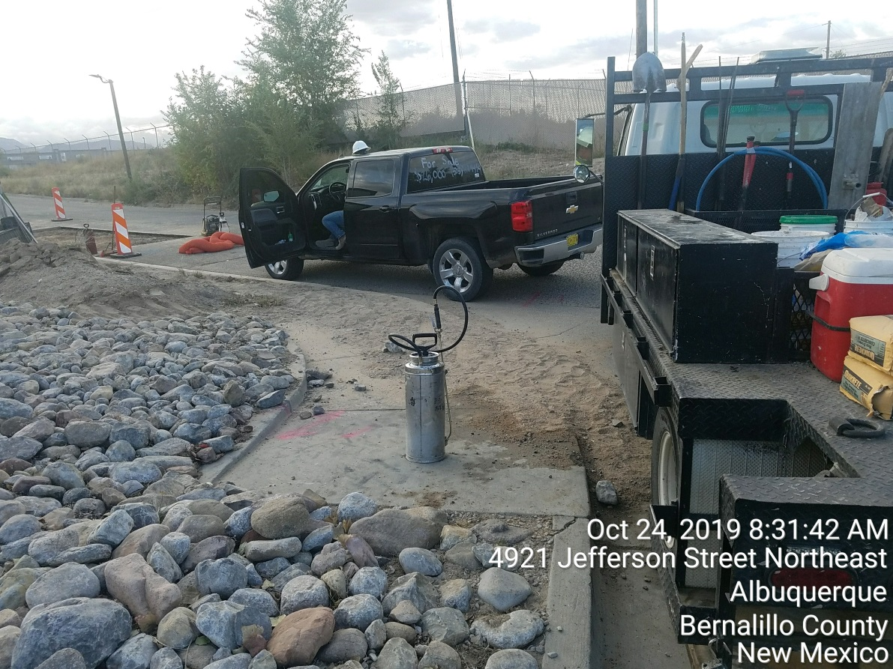

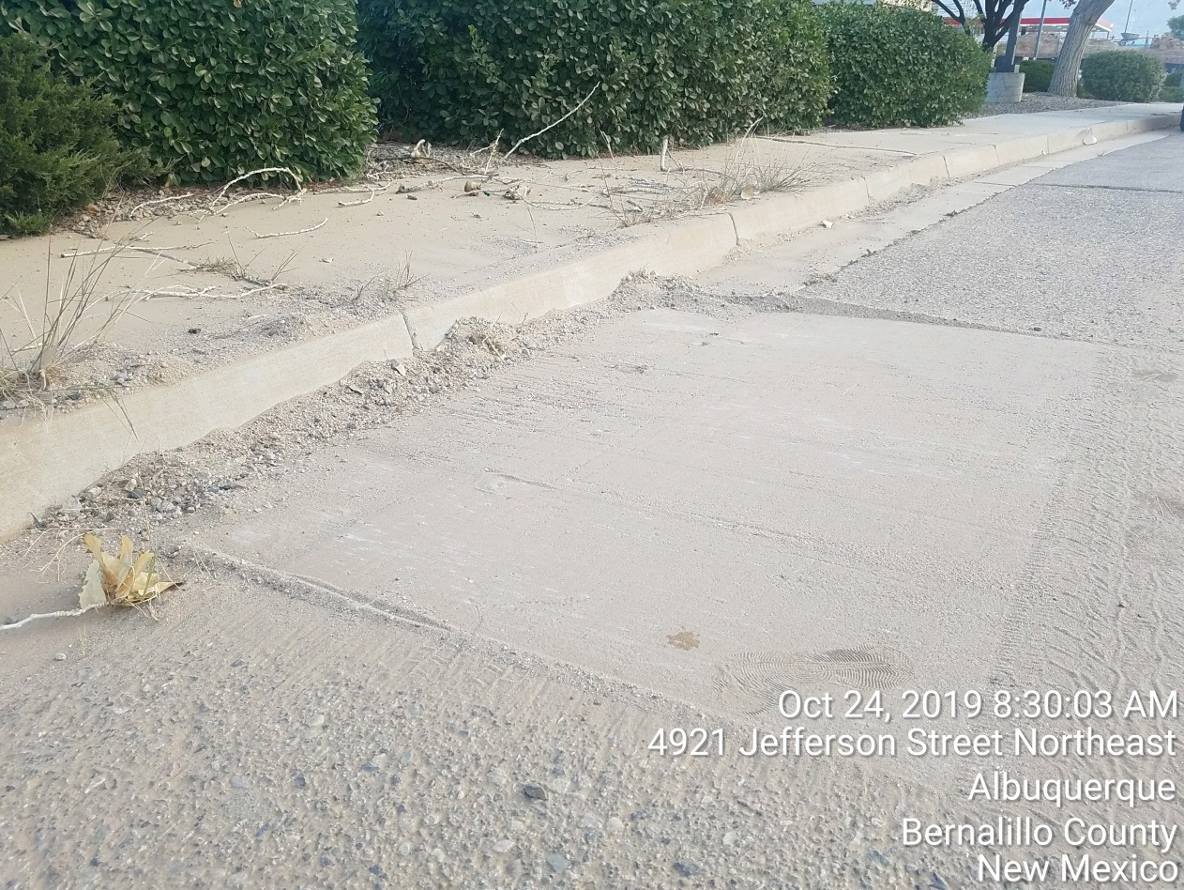

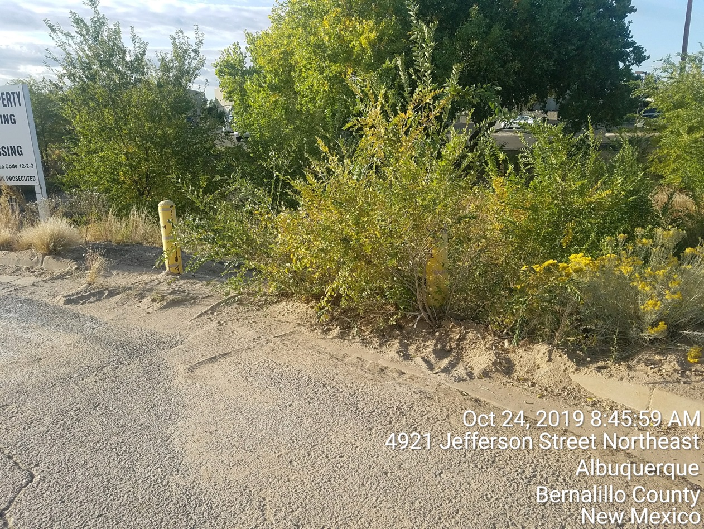

* Paint and Concrete wash water.

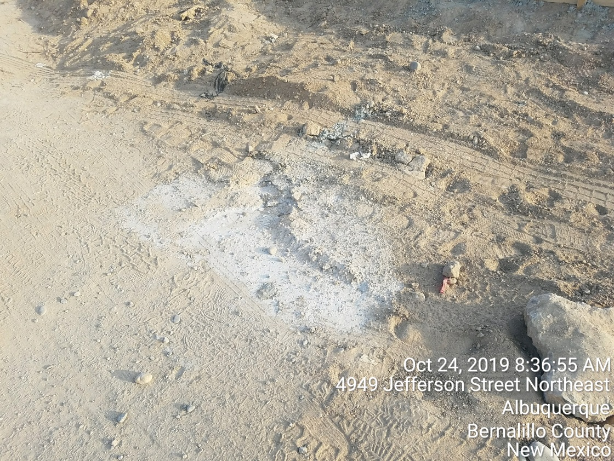

* Construction and domestic waste not in acceptable container

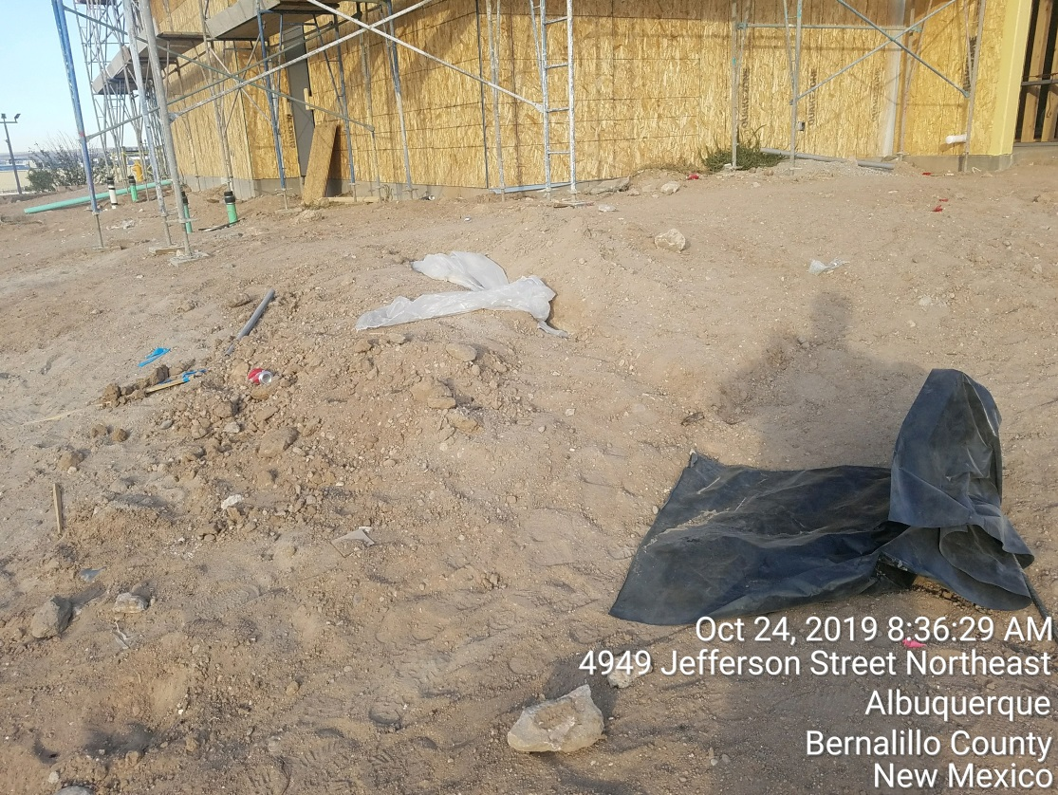

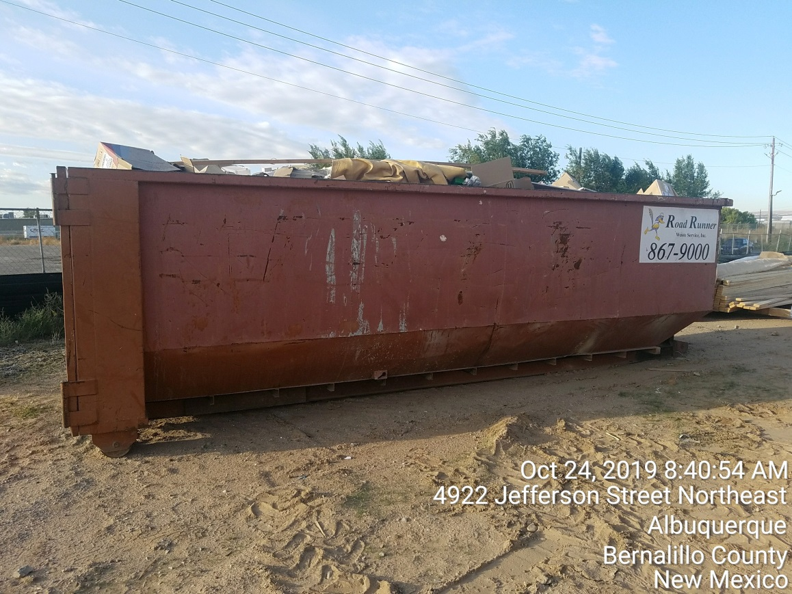

**Required Mitigation:**

* Remove and properly dispose of all offsite sediment and prevent sediment from leaving the site in the future.
* Direct wash water from stucco, paint and concrete into a leak-proof container or lined pit. Remove and properly dispose of existing washouts.
* Dispose of construction and domestic waste in acceptable containers and use lids or tarps to cover waste containers when not in use.

If the violations are not mitigated within 7 days, the property owner is subject to a fine of $500/day per the City’s Drainage Control Ordinance.

If you have any questions, you can contact me at 924-3420 or jhughes@cabq.gov

Sincerely,

James D. Hughes, P.E.

Principal Engineer, Hydrology/Stormwater Quality

Planning Dept.