October 24, 2019

RAJ Holdings, Sujay Thukar, [sujay.thakur@gmail.com](mailto:sujay.thakur@gmail.com)

Site: The Goat Brewery, 3421 Coors Blvd. NW, G11E071

**Re: Drainage Ordinance (14-5-2-1) Violations for Erosion and Sediment Control**

Dear Mr. Thukar,

The following violations were observed at the inspection today.

* Stormwater controls are missing (Silt Fence & Construction Entrance).
* Self-inspection report and SWPPP are not on site
* Your EPA permit coverage is not posted for public inspection.
* Sediment was being tracked offsite.

Photos are shown below.

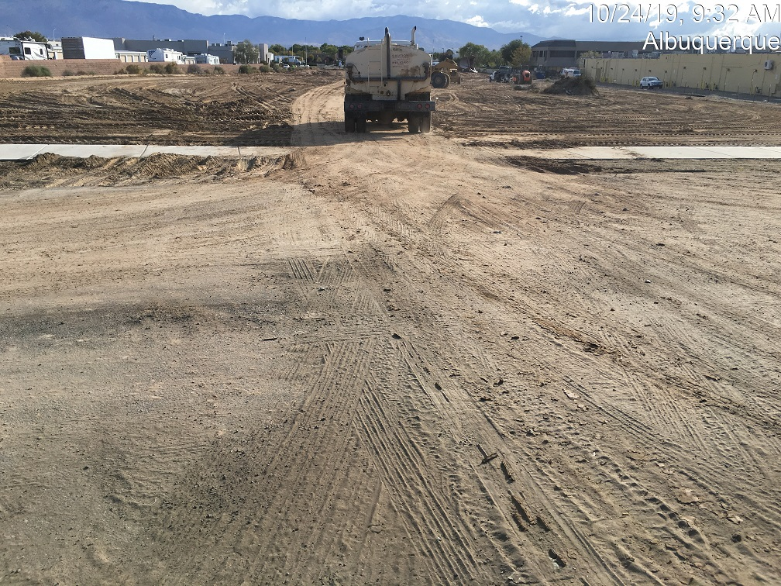

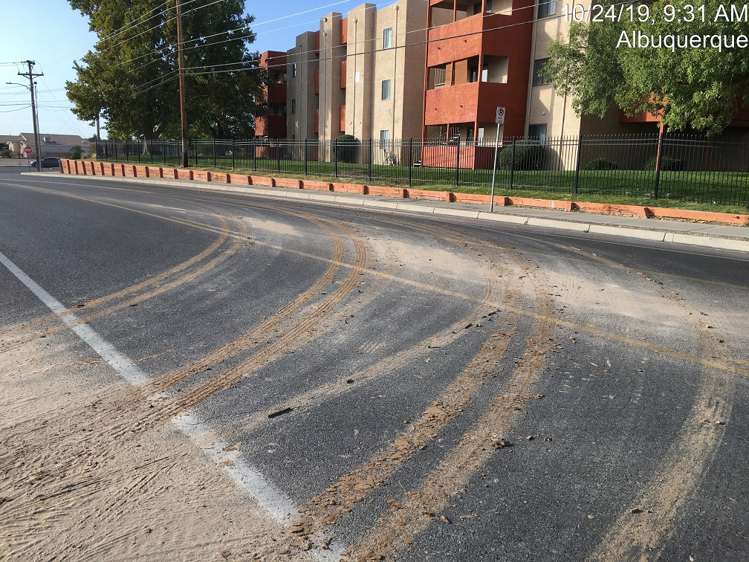

**Required Mitigation:**

* Post a notice of your permit coverage.
* Install and maintain stormwater controls (BMPs) per the approved plan.
* Remove and properly dispose of all offsite sediment and prevent sediment from leaving the site in the future.
* The SWPPP must be readily accessible at the job site. Provide self-inspection reports every 14 days and after each rain>0.25". The first report should have occurred prior to any land disturbance to insure that the site is posted and the BMPs have been installed correctly. Please e-mail to [jhughes@cabq.gov](mailto:jhughes@cabq.gov) .
* Remove and properly dispose of all offsite sediment and prevent sediment from leaving the site in the future.

If the violations are not mitigated within 7 days, the property owner is subject to a fine of $500/day per the City’s Drainage Control Ordinance.

If you have any questions, you can contact me at 924-3420 or [jhughes@cabq.gov](mailto:jhughes@cabq.gov) .

Sincerely,

James D. Hughes, P.E.

Principal Engineer, Hydrology/Stormwater Quality

Planning Dept.