October 25, 2024

Vivi Investments LLC – Steve Chavez – [steve.chavez505@](mailto:steve.chavez505@)yahoo.com - 505-415-9533

**Sites: Cinnamon Morning Subdivision – 2700 Rio Grande Blvd NW (G12E024) - NMR1003QQ**

**Re: Drainage Ordinance (14-5-2-11) Violations for Erosion and Sediment Control**

The City conducted an ESC Inspection on 10/22/24 to verify mitigation of the violations observed 5/10/2024 and reported on 5/13/2024. The City found that the site has become active again with earth moving equipment. None of the previous violations were mitigated before the activity began. The violations are as follows:

1. **NOI –** Your CGP coverage, NPDES ID# NMR1003QQ, expired on 2/17/22 before the construction and stabilization were complete in violation of CGP Part 1.4.3. Any stormwater discharges from this site have not been permitted since 2/17/2022.
2. **Posting** of the CGP coverage for your site was missing in violation of CGP 1.5.
3. The **SWPPP** and self-inspection reports were unavailable at the time of inspection in violation of CGP Parts 4.7.3 and 7.3. The personnel on-site were sub-contractors with no knowledge of the location of the SWPPP, and the location was not posted on a sign near the entrance.
4. On-site land disturbing activities have resumed, but no **BMP**s were installed prior to the start of the activity in violation of CGP Part 2.1.3.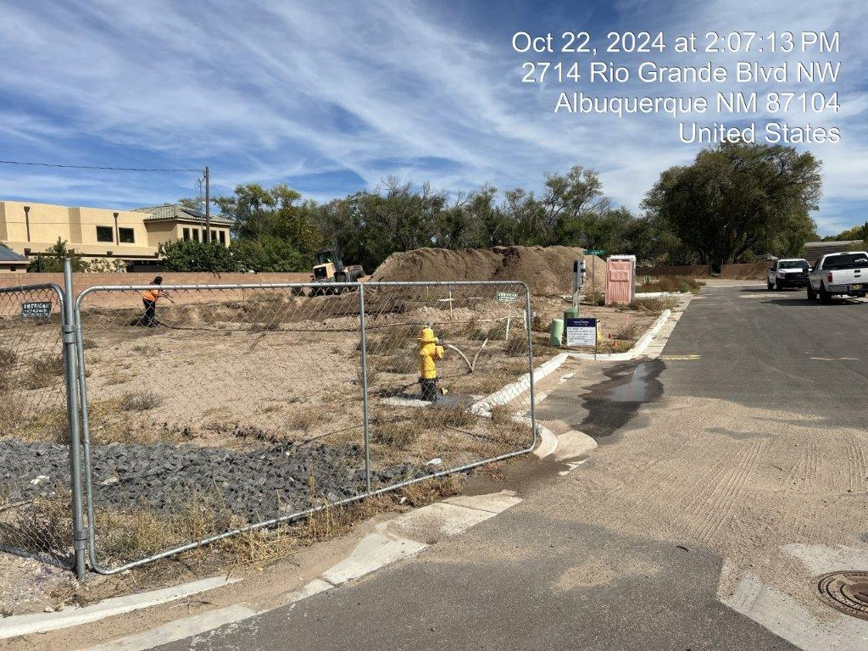
5. It appears that the pond was installed before 10/2022, but it was never stabilized as shown in the landscape plan submitted to the City in 4/2021 in violation of CGP Part 2.2.14.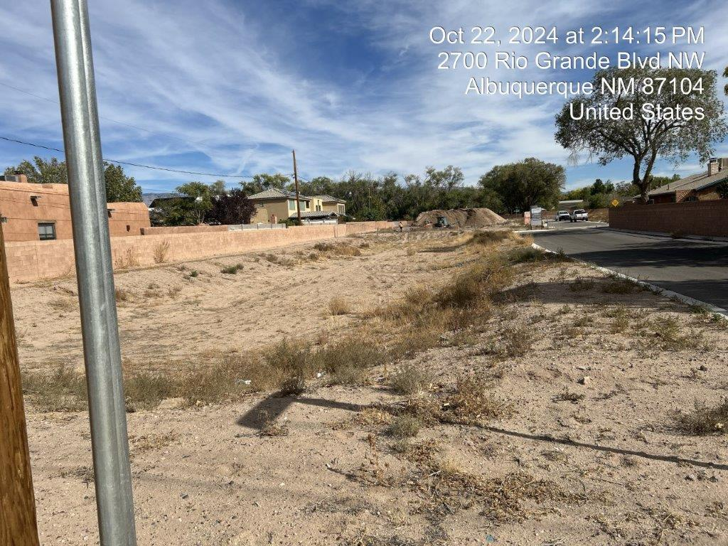
6. Sediment discharge into pond??? In violation?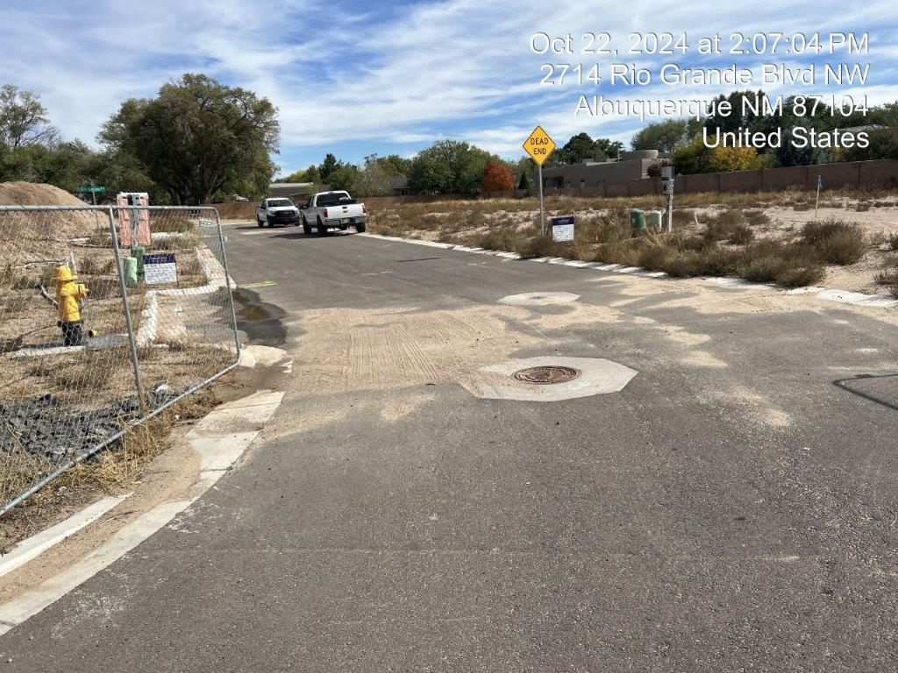

**Required Mitigation:**

1. The deadline for an operator of an existing site, i.e., a site with 2017 where construction activities commenced prior to February 17, 2022 to submit a **NOI** for 2022 CGP coverage was May 18, 2022 per CGP Part 1.4.3.
2. **Posting** - You must post a sign or other notice of your permit coverage at a safe, publicly accessible location in close proximity to the construction site. The notice must be located so it is visible from the public road that is nearest to the active part of the construction site, and it must use a font large enough to be readily viewed from a public right-of-way per CGP 1.5.
3. The **SWPPP**, including Self Inspection Reports and Corrective Action Reports, must be kept up-to-date per CGP 7.1 and available on-site per CGP 4.7.3, 5.4.3, and 7.3. If an on-site location is unavailable to keep the SWPPP when no personnel are present, a notice of the plan’s location must be posted near the main entrance of your construction site per CGP 7.3.
4. Complete installation of stormwater controls by the time each phase of construction activities has begun per CGP Part 2.1.3.
5. You must initiate the installation of stabilization measures immediately in any areas of exposed soil where construction activities have permanently ceased or will be temporarily inactive for 14 or more calendar days, and complete the installation of stabilization measures as soon as practicable, but no later than 14 days per CGP Part 2.2.14.

**History of violations:**

Notice of the following types of violations was sent on the dates noted below:

1. NOI - 5/10/24 (Level 2), 10/25/24 (Level 3)
2. Posting - 4/8/21, 5/10/24 (Level 2), 10/25/24 (Level 3)
3. SWPPP – 7/1/21, 5/10/24 (Level 2), 10/25/24 (Level 3)
4. Weeds - 5/10/24 (Level 1)
5. Stabilization – 5/10/24 (Level 1), 10/25/24 (Level 2)
6. BMPs - 10/25/24 (Level 1)
7. Sediment? (L1)

The City Escalation Process (attached) describes four levels of escalation based on the number of repeats and/or recalcitrant violations of each type.

**Per the previous Violation letter dated 5/13/2024, the city is assessing a fine of $500 for the current level 3 violations, and the non-compliance is being reported to the EPA. This fine is for one day, 10/25/2024. Additional days may be added if the violation is not mitigated within 7 days. Progressive enforcement escalation procedures will be used and strictly enforced for recalcitrant or repeat offenders.**

If you have any questions, you can contact me at 924-3325, cenglish@cabq.gov.

Sincerely,

Chancellor English, CPESC

Erosion and Sediment Control Specialist, Stormwater Quality

Planning Dept.